(Dec.2016)
N.K.E.T.N.S. NEWS
www.nketns.ie

Good health and happiness to all members of our school community as 2016 comes to a close!

Our Student Representative Group organized World Food Day in early December and thanks to the many parents who cooked/baked we had 17 countries represented on the day. This is a multi-cultural event that is thoroughly enjoyed by pupils and staff. Many thanks for your support in making it a success again this year.

Our 5th class pupils entered the Young Scientist Competition (held by INTEL) and displayed their fantastic projects in the school hall in November. The judges were once again impressed with the high standard of entries and the pupils’ understanding of the work done. Thanks and well done to Lydia and 5th class.

Our Wonderful World of Music Concert was held in the school hall to packed audiences on Thursday 8th December. Everyone enjoyed the many genre of music performed by our pupils. Thanks to our hard working staff for putting on a great show.

I’d like to give special thanks to our hardworking PTA who held many events this term to raise funds for the school. We look forward to more fun events in the new year.

Our annual Music Week was, as usual, very enjoyable with many talented parents coming into the classes, talents shows and discos. My thanks to Pat for organising the week.


Lastly, I would like to thank Pat for filling in for me so ably over the last few months during my recovery. Thanks to the In School Management Team and all the staff for being their usual enthusiastic and support selves during this time also. The many good wishes and welcome back from pupils and parents were much appreciated; after a day I felt like I was never away!

On behalf of all the staff I’d like to wish you all a lovely Christmas break and may 2016 be filled with happy times. See you back @8.40.a.m on Monday January 9th 2017.

Thank you to our parent body for all your help and support all year.

IMPORTANT NOTICE – We wish to remind parents that during low temperature/icy weather conditions the roundabout leading to the school can be treacherous to drive on! Even when temperatures are above freezing, the roundabout area still remains very icy – so please drive with extreme caution upon approach from St. Wolstan’s Community School, and again when leaving the N.K.E.T.N.S.
Dates for your Diary
- Offer of Junior Infant places for 2017/2018 will commence on Monday 9th January.
- Last swimming lesson for Sinead’s Senior Infants will take place on Tues 10th January.
- Our annual visit by storyteller extraordinaire, Niall de Burca takes place on Friday 13th January.
- Swimming Lessons for Cathy’s Junior Infants will commence on Tuesday 17th January.
- N.K.E.T.N.S. Science Week takes place from 23rd – 27th January 2017
- 6th Class trip to Places of Worship – Tuesday 24th January 2017 (details to follow)
- 4th & 5th classes will performance at the Peace Proms on Saturday 5th February 2017 @ 8.00pm in the RDS, Dublin )
- As previously advised in our October newsletter, Parent-Teacher meetings will take place on Friday 10th February and Thursday 16th February 2017. You will be notified of your appointed time approximately two weeks before either of the above dates. These meetings will be held after school hours on both days.

CHRISTMAS HAMPERS
Thank you all for your generous contributions to our annual Christmas Hamper Appeal. Since we started our appeal back in 1998, we have donated 366 hampers. This year we managed to make up 25 hampers! Thanks to the following volunteers who assisted with packing and wrapping the hampers – Terri O’Brien, Jean Auden, Francis Mullany, Lynn O’Connor, Julie Melia and Mary Walsh.

We would like to express our sincere thanks to Colourtrend who have donated boxes and tape to the school to make up our hampers, since 1998.

HELPERS
It cannot be stated enough how much all our helpers/volunteers are appreciated. By having parents in to help, the teachers can draw on a wealth of talent and skills for their classes. Visitors add excitement to the class and they are always well received.

SCHOOLBAG POST
We would like to remind parents to check your child’s schoolbag on a very regular basis (at least twice a week) to ensure that you do not miss any notices from the school. Please remind your child that when given any note from a teacher to immediately place it in their schoolbag – we do remind them of this but it would assist us if this could be reinforced at home too.

Notices (including those distributed in the schoolbags) are also placed in our Community Noticeboard which is situated opposite the main Reception door.

TEXT-ALERT
Please ensure that you notify the school office if you change your mobile number. In order for the text alert communication system to work effectively, it is necessary to ensure we have up-to-date mobile numbers.

MUSIC WEEK 2017
Music Week took place this year during the second week of December after our very successful Wonderful World of Music concert. The week was greatly enriched by the visits of parents and relatives to the classrooms to share their musical talents with the children. Damien Farrell, father of Ryan in 6th class came in to sing and play the guitar. Thanks to Damian for being a consistent performer down through all the years his children have been attending NKETNS. Vincent Dickson’s father Jonathan (Vincent 3rd, Theo JI) brought both his electric guitar and steel guitar into 3rd class and was accompanied by Vincent himself on the fiddle. Paul Melia (Bea 5th, Thea 3rd, Catherine 2nd) came into 3rd class to play the guitar and also gave a presentation to 5th class on the history of music. Declan Twomey (Dillon, Outreach) came into the Outreach Class with his guitar. Barbara Skuratowicz, whose son Jonasz is in Arlene’s class brought some friends with violin and guitar and entertained the children in Junior Infants. Junior Infants also had a visit from Penny Woods whose daughter Poppy is in Cathy’s class, to read a story and play the recorder. These classroom visits are greatly appreciated by the children and constitute the real highlight of the week.

The class discos were great fun and the teachers spotted some talented and creative dancers. The week was rounded off by the Junior and Senior talent shows. We had singing, a range of instruments played, jokes and riddles. We also had dancing, drama and even a quiz! All in all, it was another successful Music Week in NKETNS.

GREEN NEWS
During the festive season, don’t forget to hold on to any wasted batteries, old mobile phones/chargers and printer cartridges and bring them into school for our various recycling banks. .

Keep an eye on your local newspapers for details of where you can bring your Christmas Trees after the festivities are over for shredding and recycling.

Don’t Forget to keep your paper and card waste for our Recycling Bins – the more we give the more we get!

GO RAIBH MAITH AGAIBH…..
Donations: Thanks to Paul McCourt for his donation of colouring pencils for our two sets of Junior & Senior Infant classes. Thanks also to Julie Myers for purchasing two outdoor sand trays for our Senior Infant classes. Lorna Green donated card games for our older classes.
Helpers: Thanks to Sonia, Leona and Caitriona, parents in 3rd class, who came in to class to make Christmas crafts with the pupils. Have you seen their Snowmen?

Thank you parents for taking the time to come in and work with the classes and teachers. It is greatly appreciated.

COFEE MORNINGS
Our annual coffee mornings for all our classes are now complete. We would like to thank the PTA for organizing them and for their assistance at the coffee mornings.

SCIENCE NEWS
On Monday 29th November, fifth class once again took part in the annual Intel Young Scientist Competition for fifth classes in local schools. The competition complements the Science curriculum for the senior classes in primary school and children can work in groups or present an individual project.

The whole project takes about one month to complete with work being done both inside and outside of school. When the projects are complete, they are put on display in the school hall and judges come from Intel to view the projects and to talk to the children. This gives the children the experience of explaining their work and answering questions about it. There was a great range of projects exhibited and the Intel judges were very impressed at the high standard and had great difficulty deciding on the winners.
1st Place: Liam Folan-Healy, Conor Jean and Rachel Murray with their project which involved ‘Programming a computer to water a plant using coding’
2nd Place: Amy Auden and Anna Herron
3rd Place: Bea Melia, Csenge Janossy & Eabha Hourihane

The finalists went forward to the Regional Finals on the 8th December in Intel with other schools from the area. Intel commented that the standard this year was particularly high with many very impressive projects. Although our school was unsuccessful at the regional final, one of our parents at the final said that our pupils ‘were mannerly, articulate, enthusiastic and eager to share their knowledge and
ideas/project with the judges, as well as other visitors’. A very high compliment indeed.

Well done to all the children who worked very hard and thank you to their parents who drove the children to and from Intel. (See Children’s Corner)

SCHOOL INFECTIONS
We would like to remind parents to let us know if your child becomes ill with a contagious infection e.g. chicken pox, measles etc. It is necessary for us to inform parents of other children in your child’s class to be aware of such an infection, and to avoid it spreading throughout the school.

Please ensure that your child brings their towel into school each day, and don’t forget to change the towel regularly.

HEALTH & SAFETY NOTICE
For reasons of health and safety we would like to remind parents and guardians that no medication of any kind is to be brought into school in children’s schoolbags. These include strepsils, calpol fast melts, cough sweets, lozenges, medicated creams etc. In keeping with our medication policy – no medicines of any description are allowed in schoolbags. It is not possible for staff to monitor the consumption and possible sharing of over-the-counter medications and is therefore a health and safety issue. Please DO NOT send in any medicated products with your child, to protect all pupils.

Please DO NOT send your child to school if they are feeling unwell BEFORE we open. Your child may transmit their illness to the entire class and/or the class teacher. . Your cooperation with this request is appreciated

WORKSHOPS
5th and 6th classes had a workshop on electricity called ‘Bright Sparks’ on the 10th November. They learned about its discovery, why the famous scientists Galvani and Volta fell out, how to make the best batteries using readily available household materials and what frogs and coke cola have in common! They also learned about static electricity and the unusual things that can be used as electrolytes, circuits, magnetism and how when combined with electricity gives interesting effects.

BOARD OF MANAGEMENT NEWS

VOLUNTARY CONTRIBUTIONS – The Board of Management would like to thank all parents for your financial support for this year. The voluntary contributions by means of standing orders give us a guaranteed income and open the door to raising money via the tax refund scheme. If you wish to contribute to your school this way, please contact the school office for a Standing Order Form, or you can also give by cash or cheque.

CONGRATULATIONS to Jenny who gave birth to her beautiful daughter Sophie-May during November.

We would like to extend our sympathies to Arlene on the death of her father and to Adrienne on the death of her mother, during November.

N.K.E.T.N.S. PARENT TEACHER ASSOCIATION UPDATE DECEMBER 2016

Since our last update in October two fundraising events have taken place. In October we had the cake sale, with over €850 raised. Thanks to all those who baked, helped out on the day and bought the delicious treats.

You all had a good clear out in November, because 1075Kg of clothes were donated during the cash for clothes fundraiser and €400 raised. Well done and thank you.

Watch out for the 2017 school calendar featuring a photograph of every class, which is being sold throughout December . Further copies of our calendar will be available to buy at the school office after this date.

The Christmas raffle takes place on Wednesday 21st December. This raffle would not have been possible without the generosity of the donors - SuperValu Bumper Christmas Hamper, €100 off Windsor Motors Car Service, €50 Canteen Voucher , €50 Michelangelo’s Voucher, €50 Dunnes Stores Voucher, Selection of board games , Hop Scotch Voucher, Bottle of Brandy, Cinema Voucher, Playzone family pass, Peppermint Health voucher, Jewellery Gift Set.

If you were not lucky in the raffle there is another chance to win. Please like and share the NKETNS Parent Teacher Association Facebook Page by 31st December 2016 and be in with a chance to win a 30 euro food hamper. https://www.facebook.com/NKETNSPTA/

2017 will continue to be a busy year. Keep an eye out for details about our upcoming events. We hope to hold an Internet Safety Talk for parents early in the year and the annual Cinema Club, a Cooking Demonstration and Children’s Disco.

The PTA Committee would like to wish all the teachers, parents, guardians and children a very Happy Christmas and thank you for your support throughout the year.

Maria Kane, Ciara McCarthy, Gordon O'Connor , Mike Mullally, Pam Hull, Jean Auden, Shane O'Neill, Aoife Hogan, Maria Alcazar, Enda Martin. Email: nketnspta@gmail.com.
Children's Corner
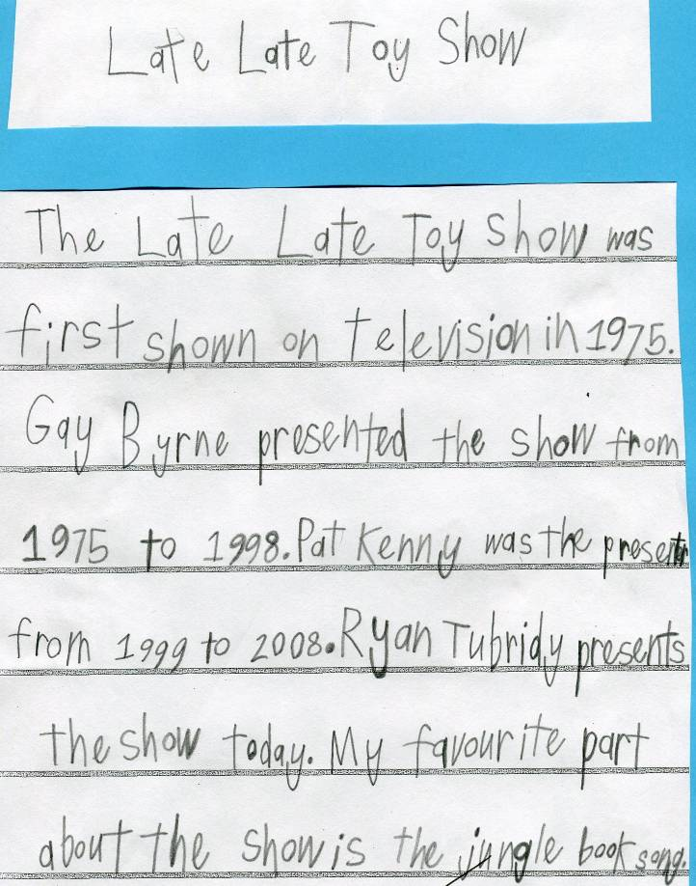
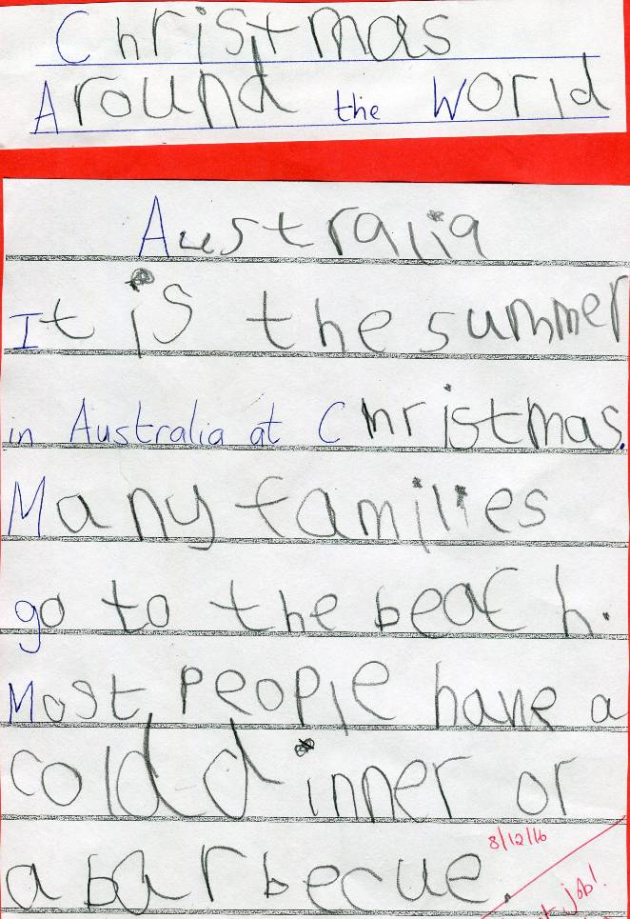

Written by Darragh Brett (Aine’s Outreach class)
Written by Aidan Siaudvytis (Aine’s Outreach class)

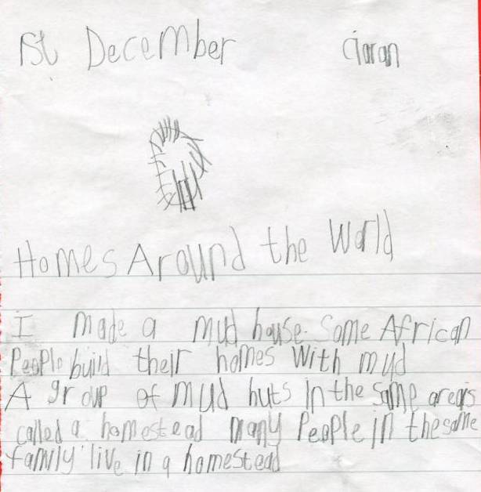
Achievements
Please remember to tell your child to come to the school office to tell Adrienne about their achievement, so that it can be put into our newsletter. We are always happy to hear about the children receiving certificates, medals, trophies etc. in any competition.

Congratulations to the following children
Lily Thi received 3 gold regional medals, 2 silver regional medal and 1 silver and 1 bronze national medal when she attended Gymnastics Ireland, Women’s Artistic National & Regional levels 2/4 Apparatus Finals in UL Sports Arena, Limerick on 19th November.
Sisters Katie and Amy Auden and Isabella Gleeson are members of Excel Gym, Celbridge and they took part in their floor gymnastic exams on the 13th November. Katie and Isabella achieved Level 3 and Amy, Level 7. Earlier in the month, Isabella was presented with an Excel Award 2B from her gym club.
Celbridge Athletics held ‘Firefly’s Fastest Feet’ competition in November. Maeve Wollmer did 10m in 1.60 seconds, and was presented with a lovely Certificate for her effort.
Some pupils who attend Geraldine O’Brien’s afterschool drama classes took part in a competition held in the Glenroyal Hotel on 27th November. Erin Kyle came 1st in poetry, 2nd in Dual-log and 2nd in In-prov at her level, Aoife O’Reilly came 2nd in Dual-Log, 2nd in In-prov and 3rd in poetry, again at her level and Bea Melia 2nd at In-prov.
Sophia O’Toole won an award for horse riding in show jumping for a clear round at Knightsfield Equestrian on 13th November.

Well done to all of you.

Written by Ciaran Brooks (Aine’s Outreach class)
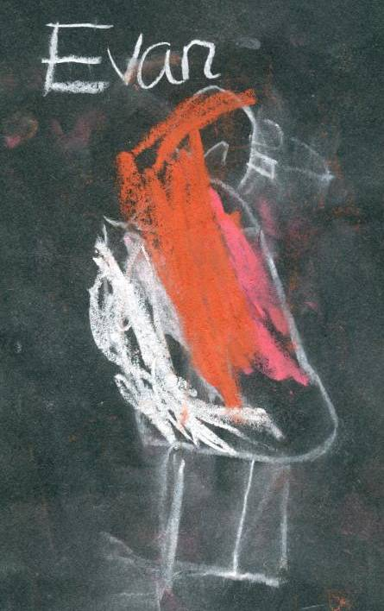
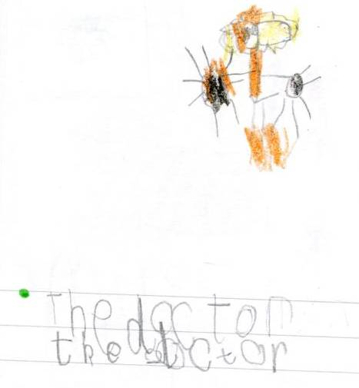
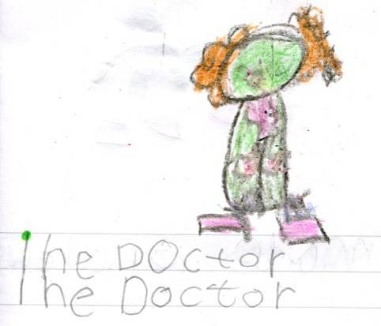
Children's Corner
Junior Infants drew Robin Redbreasts with chalk after listening to the story ‘The Christmas Robin’. Here is Evan Zhang’s (J.I.Cathy) lovely drawing.
Local doctor, Dr. Sean O’Brien, visited both Junior Infant classes recently, as they had been focusing on ‘At the Doctors’ during their Aistear play. He spoke to them about being a doctor.
Here are two beautiful drawings and writing by Isaac Sanders (above) and Janvi Patodi (below) both from J.I. Arlene’s class.

1st Class
We drew fruit bowls this month in art. We checked the shape of the bowl & the fruit & that it was in the right place on our page when we drew it.
We looked at the leaves on our fruit and how they were shaped. We had to draw exactly what we saw in the bowl. We had to make sure the pineapple was the biggest and that the passionfruit was the smallest thing we had drawn.
Lastly, we had to paint it. If we didn’t have a colour we had to mix the other colours to make it.
We loved it because they liked mixing the colours. It was tricky but we all persevered! We loved learning how to sketch.
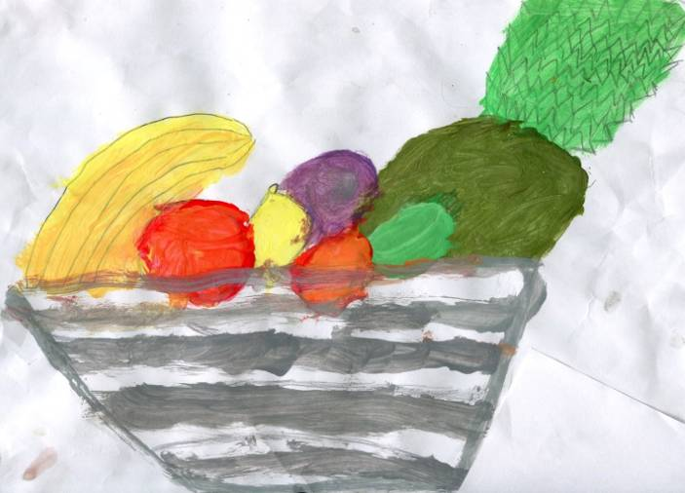
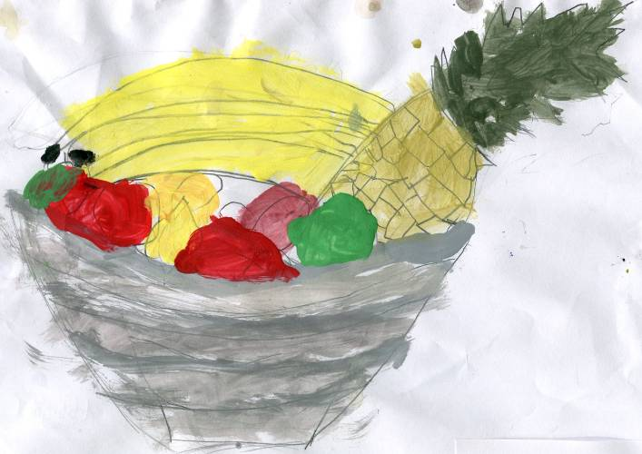
Abbigael
Cathal
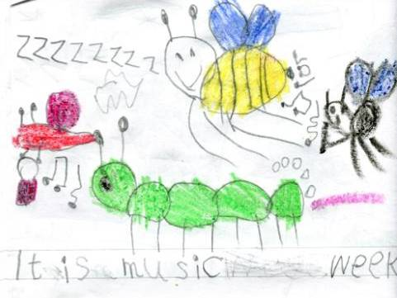
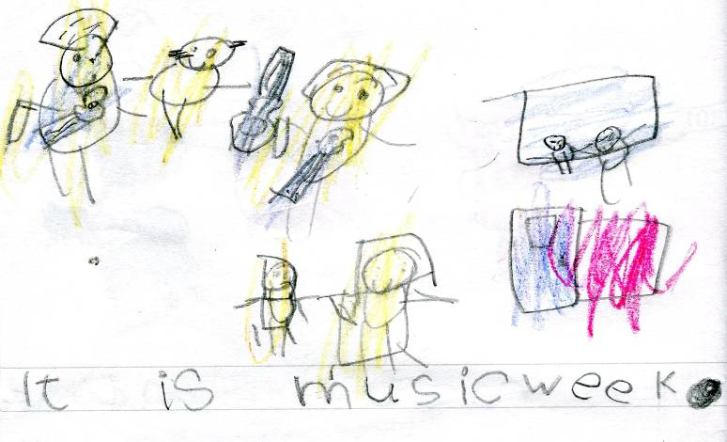
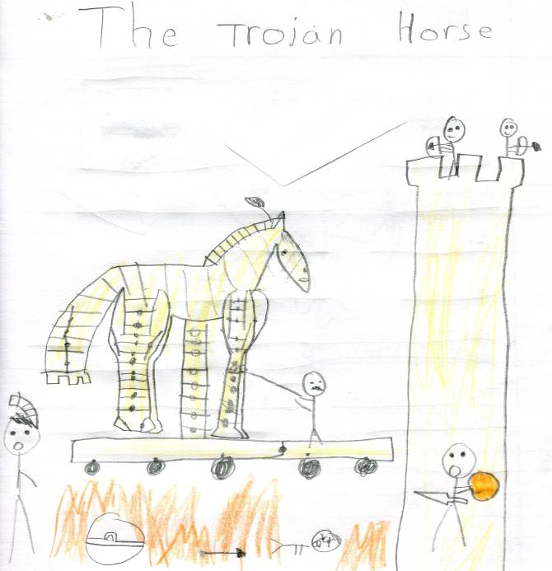
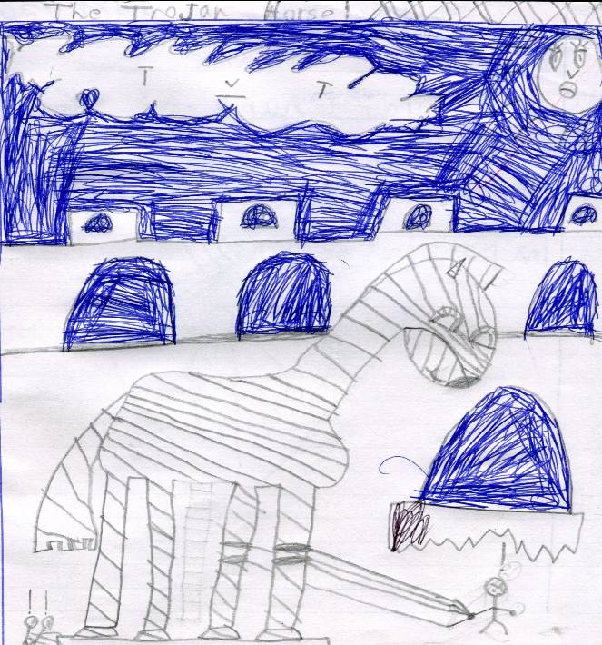
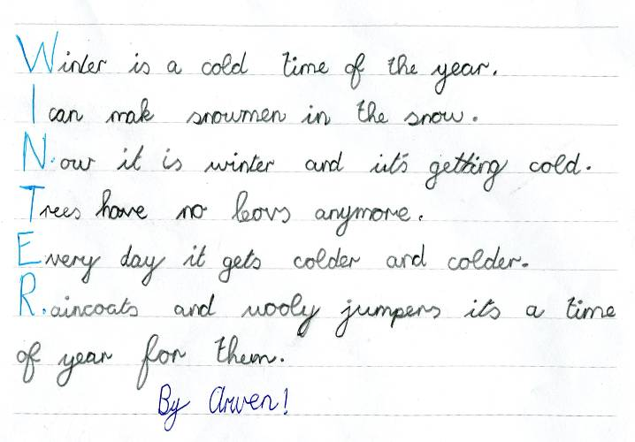
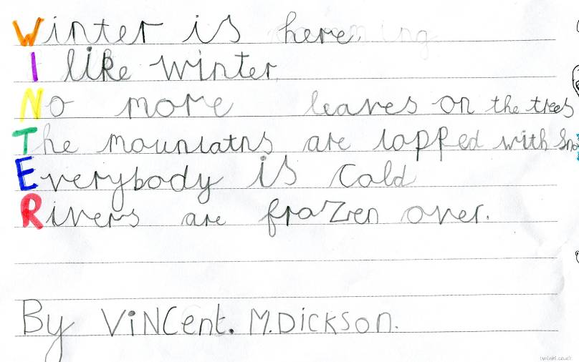
Junior Infants have enjoyed listening to lots of musical genres during Music Week. Emer Mullany and Finn Morley from Cathy’s class drew beautiful pictures about Music Week.
Emer
Finn
Jamie
Patrick
During this term 3rd Class looked at the Greek myth about Helen of Troy and how and why the Trojan Horse was used. Above are great pictures by Patrick O’Toole and Jamie Mitchell. As winter drew upon us, 3rd class wrote some acrostic poems, and they also made some amazing snowmen from socks!
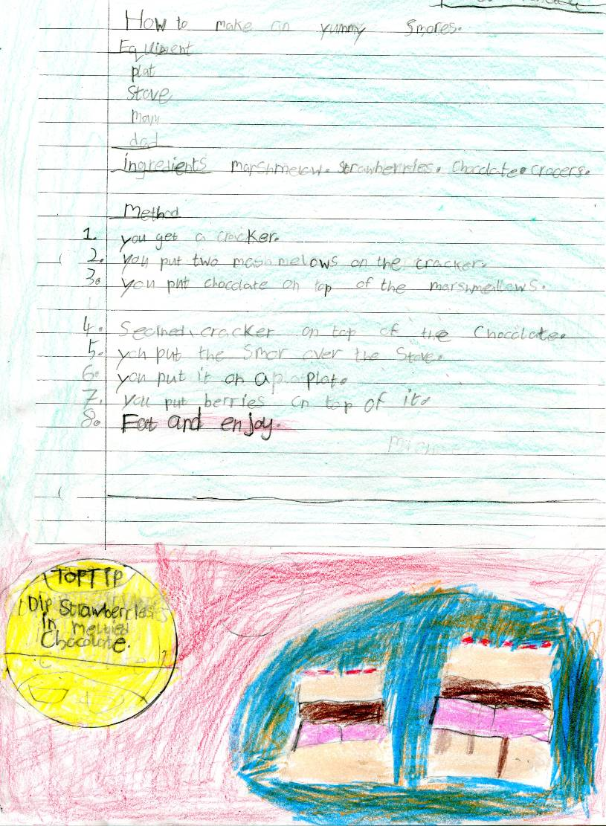
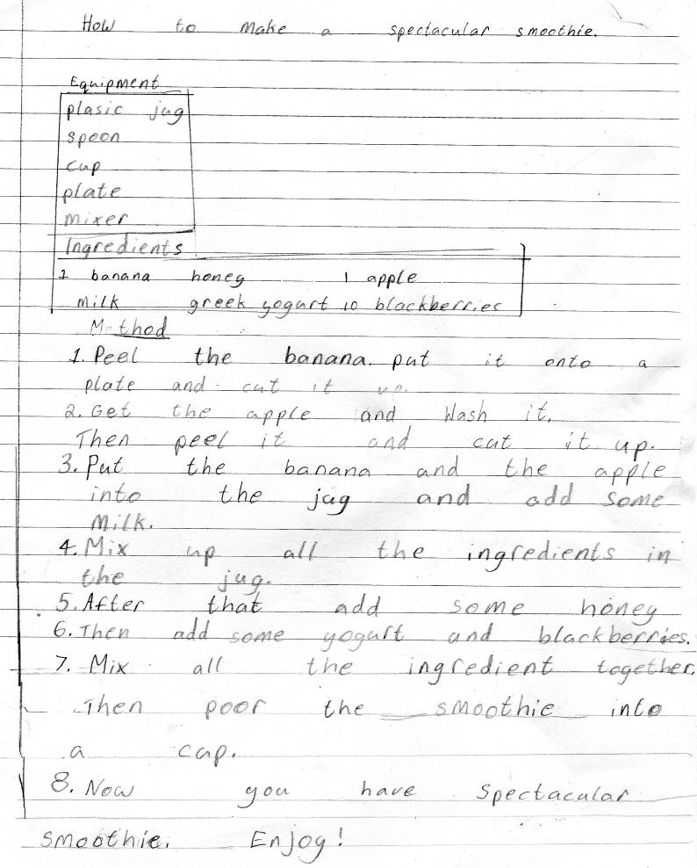
Catherine
Michaela
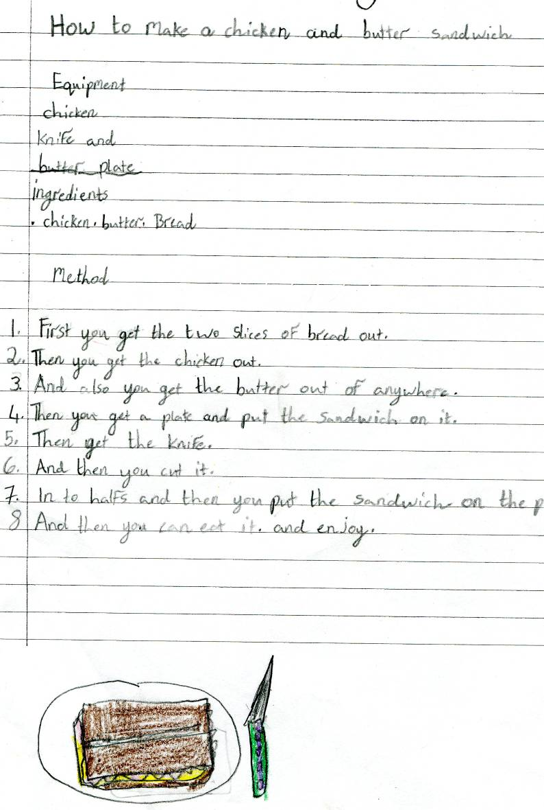
Gracie
With World Food Day in mind, our 2nd class worked on ‘How to make......’ ideas. Here are just a few of the wonderful recipes for you to enjoy.
Mini Scientist Experience
by Rachel Murray, Liam Folan-Healy & Cormac Jean

One day we were told about the Mini Scientist and instantly we had an idea of making a robot. At that point we weren’t sure what we were going to make the robot do. We got together one day and came up with the idea to make a robot that takes something out of our daily chores. We decided on watering plants with our robot. W e used a raspberry pi (mini computer). We used the computer language python. After weeks of work, we arrived at the school, our projected packed up in a bag. We walked down to the PE hall to set up our project and after 45 minutes, the judge walked in, and luck of the Irish, ours wasn’t working! Luckily, Liam found out that the wire was in the wrong spot. Although he was ages away, the nerves started to kick in. As he came around we got more and more nervous. We started to explain what our project was about and we were so hyped up when we came first in school. We were told the details of the mini scientist regional final in Intel, we were really excited.

We made our way to Intel on 8th December, and the size of the buildings amazed us. When we got into the building, we were amazed even more. All the people made us feel slightly nervous. We set up and tried to block all the people out of our minds and try to focus on our project. Rachel’s aunt came down and gave us maltesers when she came to see our project. The judges came and at this point we were nervous. They asked us all sorts of questions. We came 10th. All in all we loved the day.

