N.K.E.T.N.S. NEWS

April 2019 www.nketns.ie

Welcome to our second newsletter of 2019.

Our Book Fair in early March was a great success. It depended entirely on the donations of books to make it possible as well as the help of the parent volunteers to run the event on the day. Thanks to everyone who contributed.

This was followed by our annual La Glas, the culmination of Seachtain na Gaeilge. The school was a sea of green on the day which was particularly appropriate as it was also the day of the international children’s climate strike inspired by the actions of Greta Thunberg in Sweden. Many children had taken part in a climate demonstration that morning and they brought their placards and banners into the school assembly where Climate Change was discussed.

There is an account inside of the great turnout at the Celbridge St Patrick’s Day Parade and the favorable response of the judges to our school entry. There is also a report on the exploits of both our girls’ and boys’ football teams in the FAI 5-a-side competition. The week before the Easter break was dominated by school tours and the weather was thankfully kind!

The AGM of Educate Together was held at the end of March. This is an annual event where motions can be debated and adopted as policy which then directly affects any school under the patronage of Educate Together (such as ours). It’s a prime example of the democratic aspect of the ET ethos in action. Paul Rowe, the longstanding CEO of Educate Together announced that he would be stepping down later this year. We wish Paul well and thank him for his extraordinary dedication to the ET movement over more than 30 years.

The ET ethos also hit the headlines in a less complimentary manner when RTE reported on misleading statements being circulated within school communities in North Dublin who were resisting a possible change of patronage as part of the divestment project. In case anyone is wondering, it’s ok to say “Dia duit”, your children are perfectly safe on school tours and far from not celebrating Grandparents’ Day, our next one is taking place on 10th May!

Pat

DATES FOR YOUR DIARY
Grandparents’ Day – Friday 10th May
Active Flag Week – 7th to 10th May
Junior Infants x 2 school tour on Thursday 30th May – details to follow
6th Class school tour on Friday 31st May – details to follow.
New Junior Infants Parents’ Open Day – Thursday 13th June from 1.30pm – 2.30pm

STATIONERY APPEAL
As you can imagine we go through quite a bit of paper for worksheets, art, office administration work – so therefore, we are asking if any parent or a contact has access to paper, we would greatly appreciate it if some could be donate A4 and/or A3 size paper to us. We would gladly take pens, staples, paper clips, etc. Thank you.

NEW JUNIOR INFANTS
On 11th April we had our annual Information Meeting for our new Junior Infant parents. It was lovely to meet some new and old faces! Our Open Day takes place on Thursday 13th June when the children will get to see their classrooms, meet their teachers and each other.

VISITORS
March was a busy month for visitors, as follows:

Niamh Ryder (parent and Fashion Designer) answered the call from Senior Infants to come in to them to talk about fashion as they were looking at Clothes Shop during Aistear. Niamh visited them on 1st March and kindly donated materials to us too.

We welcomed Pat Ennis (parent and Intel employee) who came into 3rd class on 5th March to give a talk to the class about the workings of air propelled rockets. He worked with the children on making plastic bottle rockets which had air-filled balloons attached to them, and once the air was released, to see how far the rocket was propelled. 3rd class had a great time learning about and making these.

Also in early March we had four unusual visitors to the school – chickens! We had four chirpy chicks staying with us for a little while and we called them ‘The Beatles’. The children were thrilled by them and everyone got a turn to see them up close as they walked into school or during the school day.

Michael Swan (parent) visited 4th Class on 15th March to work with them in a cooking lesson. They made carbonara, pizza and pancakes, all of which was devoured!

Also on the 15th March, Caterina McNamara, parent, in her capacity as a Green Schools Travel Officer to support our Climate Action Day, gave a workshop to our 5th and 6th classes about Climate Change.

Brenda Manning (parent) visited Senior Infants 2 (Grace) to talk to them about Down Syndrome.

Thanks to our wonderful Garden Group who drop in from time to time to the classes to work with the children sowing seeds

EASTER EGG HUNT
Our annual Egg Hunt for our Junior Infants (hidden very carefully by 1st classes!) took place on 12th April. This is always a very enjoyable event and everyone is sure to get an egg (or two!)

ARTS EVENTS
During our Seachtain na Gaeilge in March we had our annual Ceili Mor with Rita Doyle. All the classes were given instruction for a variety of Irish dances.

We also opened up a ‘Siopa Gaeilge’ where the children earned ‘tokens’ by speaking Irish and were then able to ‘buy’ items from the shop. Well done to Cathy who organised this.

OUTDOOR SENSORY AREA
Our outdoor sensory area is nearing completion and will soon be ready for our children in the school with motor and sensory needs. We would like to thank the following for making it possible:
To Pete Butler-Rees for giving up his time to paint the sensory wall, for free.
To Colourtrend for donating the fungicidal wash, primer and paint.
To parents and children who have donated hosepipes which will be used to make very large flowers - to be fixed to the sensory wall; and for the windchimes that will be hung in the area.
To Julie Myers, Ian Mitchell and Norman Levine for also helping with ideas and practical help.

MUSICAL
2nd Class 2 (Niall) were very busy during March in preparation of their annual musical, which was held on Wednesday 3rd April. This year they staged ‘Jack and the Beanstalk’, and as expected, they gave a wonderful display of musical talent, to the classes here and to their parents. A word of thanks to the 2nd class parents who came in to work on the masks and supplied props. Thanks to Niall for preparing the children so well for their performance and members of staff Orla, Betty and Niamh for their help.

ST. PATRICK’S DAY PARADE
We had a great turnout from parents and children to walk in the Celbridge St. Patrick’s Day parade – thank you! We certainly impressed the Judges as we
were presented with a Certificate of Merit from the Celbridge Community Council at the Awards Night held on the evening of 27th March.

The Judges’ comments were as follows: “What a fantastic turnout from this school – from parents and pupils – you brought so much to the parade. And we wanted to give a special mention for your positivity and, really, just the sheer numbers and the happy faces that you brought to represent your school on the day. So well done, and thank you, North Kildare Educate Together”.

Thanks to our hardworking PTA who put out the call to our school community to walk in the parade.

FOOTBALL SUCCESS!
NKETNS recently had a lot of success in the FAI 5-a-side soccer tournament. During the North Kildare finals in Leixlip, 32 children represented the school superbly across 4 different teams. Our Girls A Team were silver medallists on the day and our Boys A Team won the tournament and received gold medals.

The boys then went on to represent the school at the County Finals in Kilcullen on Wednesday 27th March. They played superbly winning their three group games against Castledermot, Athgarvan and Scoil Eoin Phoil, Leixlip. In the final the boys lost a competitive game against a very strong side from Two Mile House.

We are very proud to have a team that finished 2nd in Kildare and very proud of all the children for their skills, determination and sporting behaviour. The boys received beautiful F.A.I. silver medals in presentation boxes. Medalists over the two days were Girls: Erin Kyle, Aoife O’Reilly, Emma Wallace, Maeve Wollmer, Ava Corcoran, Sienna Field, Alessia Miceli and Alannah Morley.
Boys: Kevin Kelly, Aidan Copeland, Paul Clarke, Cian McNamara, Kevin MacCourt, Aaron Worth-Kenny, Alex Browne and Owen Kelly.

GO RAIBH MAITH AGAIBH to the following:
Donations
Thanks to Caterina McNamara for her donation of colourful viz jackets, pencils, bike lights, stickers and for giving us a loan of a large walking banner which we displayed at our assembly on 15th March.
Thanks to Niamh Ryder for materials to add to our Fabric & Fibre art stock.

GREEN SCHOOL
Meabh Boylan (Green-Schools Biodiversity Officer, called into the school on 4th April and gave workshops to some of our classes on Growing Food and Biodiversity. She spoke about celebrating growing our own food and the benefits and satisfaction of eating home-grown fruit and vegetables.

HAND TOWELS
Remember that each child is to have a small face-cloth or small towel with them each day for the purpose of drying his/her hands during the day. These can be placed in a small plastic re-sealable bag or placed in one of your child’s side-pockets in their schoolbag. We would ask parents to ensure that this face-cloth/towel is replaced on a very regular basis. By doing this, we will ensure that infections do not spread throughout a class

TOURS
We were very lucky with the weather for our school tours – no-one got wet! Thanks to the parents who assisted with the Senior Infant and 1st Class tours – it was really appreciated. The Junior Infant classes and 6th class will have their tours at the end of May.

BOARD OF MANAGEMENT

New Parents’ Evening - Before Easter we held our information meeting for parents of children who will be starting school in NKETNS this coming September. They heard from Pat, Jenny, Kelly and Michael Costello, chairperson of the Board of Management. The meeting was well attended and parents got to visit the Junior Infant classrooms afterwards.
There have been a number of cancellations from people who accepted places in Junior Infants earlier in the year and this means that all children on the Junior Infant waiting list with an older sibling in the school now have a place in NKETNS for September.

Enrolment - As a consequence of the School Admissions Act, Educate Together have instructed all schools under ET patronage (including NKETNS) not to take names for pre-enrolment lists from 2024 on. There will be a new enrolment policy developed for all ET schools from the school year 2024/2025 which will probably be based on children’s ages. Any parents who wish their child to start school in NKETNS before 2024/2025 should continue to use the enrolment form on the website as before

Thanks - The Board would like to thank Ciara McCarthy (Alannah 5th, Finn 1st), Maria Kane (Tara 4th, Cormac 2nd), Terri O’Brien (Saoirse 5th) and Karen Caffrey (Caoilin 2nd, Oisin SI) for their work on the PTA and with the Cinema Club over the past few years. Your generous contribution of time and energy is greatly appreciated.

PTA UPDATE

The PTA committee wish to say a huge thank you to all Parents/ Carers, Children and School Staff who have supported our events since our last update in February.

Book Sale: The book sale was a great success as together we raised €630. Thanks to all the children who kindly donated their used books and to everyone who supported this great event on the day.

St. Patrick’s Day Parade: As you may already know our turnout for the St. Patrick’s Day Parade in Celbridge was amazing with over 100 Parents/ Carers and Children taking part. Huge thanks to everyone involved including Pat for being such a great sport on the day. The parade judges were so impressed with us all, that the school was awarded a Certificate of Merit. They commented ‘What a fantastic turnout from this school – from parents and pupils – you brought so much to the parade. And we wanted to give a special mention for your positivity and, really, just the sheer numbers and the happy faces that you brought to represent your school on the day. So well done, and thank you, North Kildare Educate Together.’ A few suggestions have already been made to enter a theme and or float in 2020. Watch this space and as always get in touch if you have any suggestions/ ideas.

Women’s Mini Marathon: Speaking of large numbers there is a team(!) of NKETNS Mammies participating in the brilliant Women’s Mini Marathon this year. Don’t hesitate to get in contact if you wish to get involved. Please support this great fundraiser by logging on to the team’s go fund me page https://www.gofundme.com/nketns-mini-marathon-team-2019 .

Raffle: Another great success was our Easter raffle which took place on the 11th April. Together we raised €610.

Wearable Junk Art: The wearable junk art fashion show has been postponed until the 2019- 2020 school year. Apologies for any inconvenience or disappointment. If you wish to get involved with this novel event in the next school year let us know by sending an email.

PTA AGM: Thank you to everyone who came along to our AGM earlier this month. We are delighted to welcome our new committee members: Lisa Freeman, Jim Tattersall, Robert Burke and Laura John. Thanks to Maria Kane, Terri O’Brien, Ciara McCarthy and Karen Caffrey who all stepped down from the committee on the night. The minutes will be available shortly on the school website.

Please contact us at nketnspta@gmail.com.

Children's Corner

UPCOMING SUMMER CAMPS 2019 IN N.K.E.T.N.S.

Let’s Go from 1st to 5th July
Designer Minds 8th – 12th July (morning and afternoon camps)
Craft Corner from 15th to 19th July
Learn It from 22nd – 26th July AND 19th – 23rd August

We are delighted to be able to make our grounds available to them and it is much needed income for the school. Details on each summer camp will issue as soon as flyers are received.

Your support in spreading the word will ensure a good take up of participants and if it proves to be a success, we hope these organisations will continue to use our premises on an annual basis.

Pupils’ Achievements Congratulations to the following :
6th Class took part in the Write-a-Book Project this year and we are delighted to say that Alessia Miceli received a Book of Merit Award for her book called ‘Tip the Bar’. She and her parents were invited to attend the presentation ceremony on 1st April in Killiney. Well done Alessia!
Charlie Colton loves her gymnastics and on the 9th March received 3 medals, silver for Vault, bronze for floor and a participation medal. She also took part in the Gymnastics Ireland National Series on the 31st March in the NAC, Blanchardstown and came away with two medals, one for Floor & Vault U8 and for participation. Charlie received a Ladybird of the Week Certificate during March.
Maria McGeown achieved her Snowflake grade when she went skiing in February
Oggy Panchev achieved his Green belt in Taekwondo, with his club in Celbridge on 9th April
Aisha McNamara made her own go-kart and then raced it during the month of January. She came 2nd and received a Casdo 2019 trophy for her efforts.

Without giving too much away – our 6th Class Graduation Project has begun! Work on filling our plastic bottles is carried out each day by 6th class. Each bottle has to be filled to capacity, to the point that it resembles a solid brick i.e. no movement when pressure is applied. We look forward to presenting our project to the school next month.
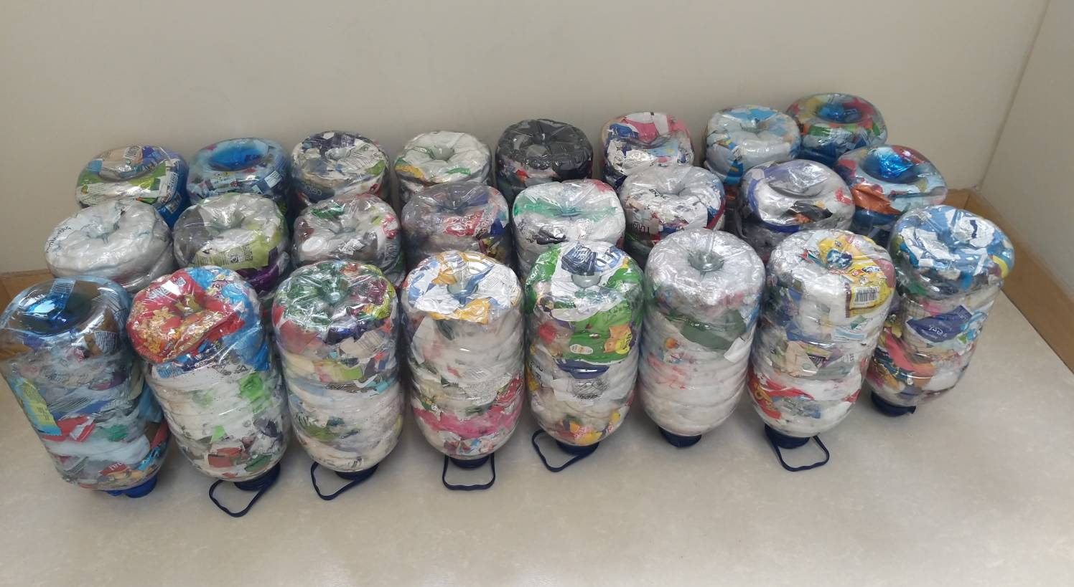
Áine's class from the outreach have been busy making 3D junk art insects for their fabric and fibre Secret Garden display.
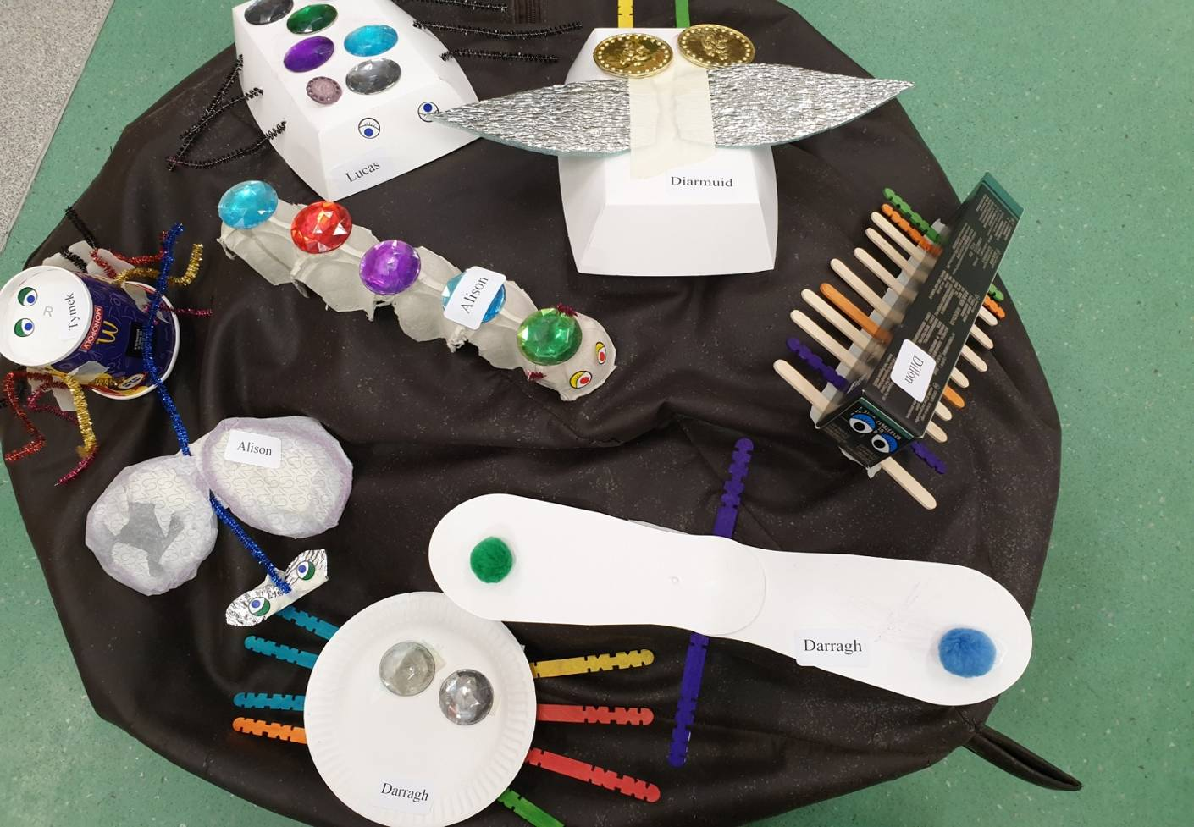
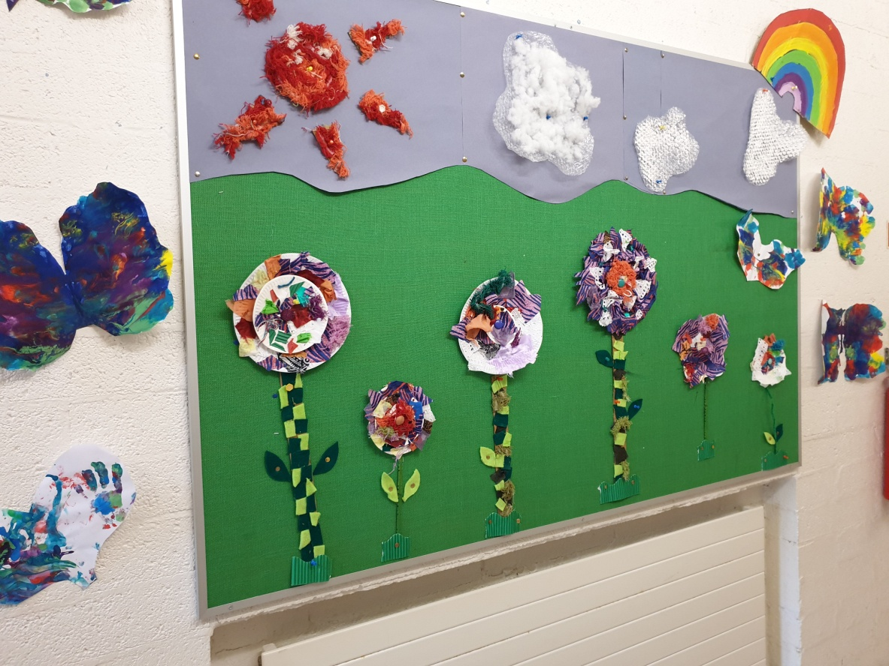

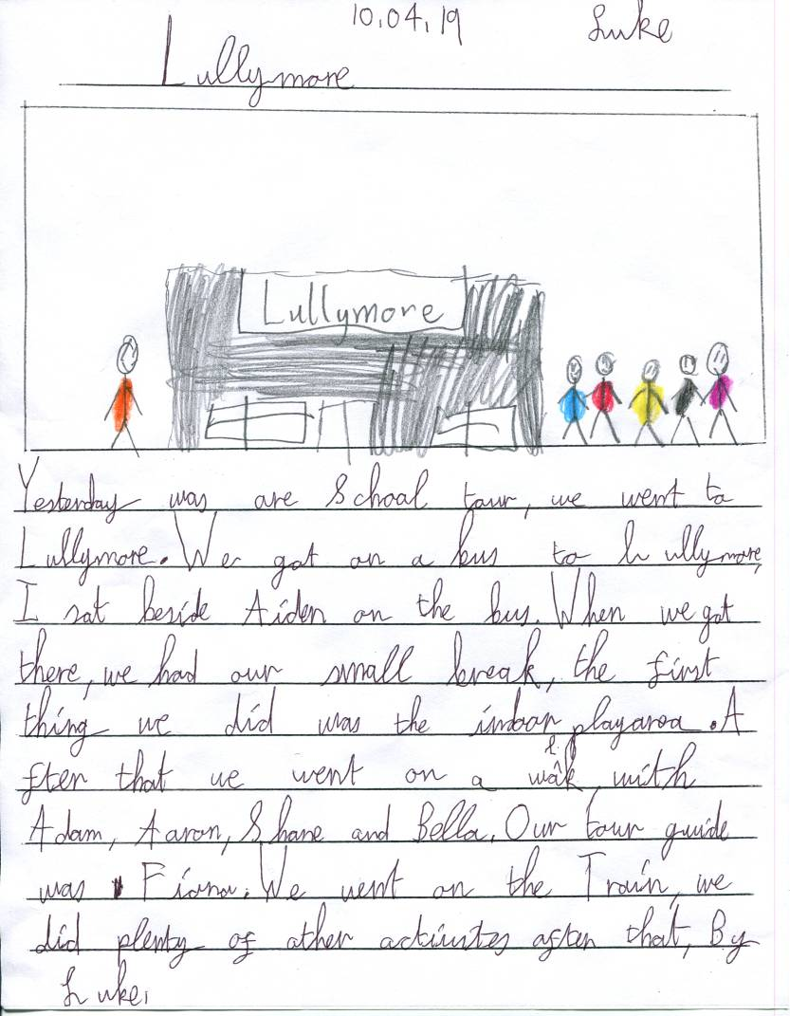
Sinead’s Outreach class went on their tour to Lullymore and here are two articles by Shane Kelly and Luke Keogh.
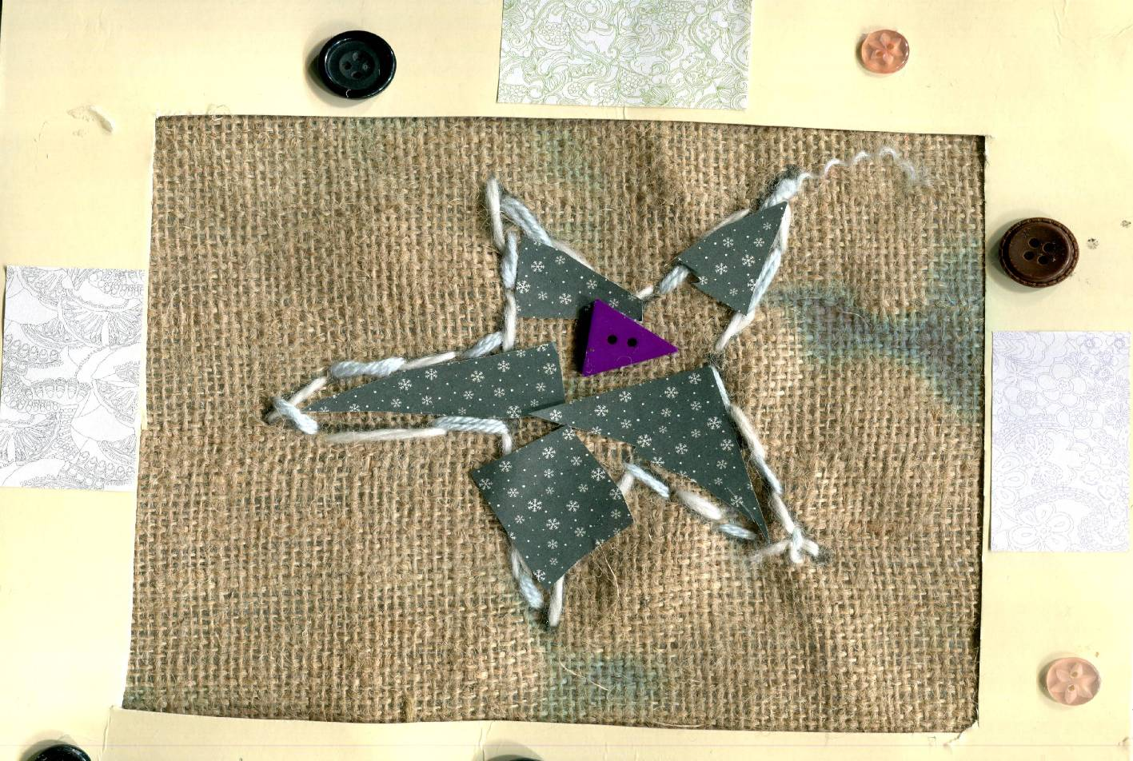
Also in Sinead’s Outreach class during March, the children worked with Fabric & Fibre in their art lesson. Here is a picture of Aidan Siaudvytis’ beautiful artwork.
School tour

Yester was our school tour.
We went on a bus to lullymore.
When we got there we had our snack.
Next we went to the play area.
I went into the ball pool.
Then we went for a walk.
We saw pigs, donkeys and chickens.
After that we went on the train.
Next we had our lunch.
Then we played outside in the playground.
It was time to go home after that.
I had a super day!

By Shane
Senior Infants Tour of Dublin Zoo
On Wednesday, Senior Infants went to Dublin Zoo.
First, we went to see the lions. They were walking around together. They were cool!
Next, we saw grey wolves walking on all fours. They walk differently to us.
Later we saw the tigers and then a gorilla. The gorilla did a wee while he was up in a tree! Some people thought it was so funny and some thought it was just disgusting!
Then we went to the farm area. We saw a chubby pig and some noisy chickens.
Lastly we went to Zoorassic. Some of us got such a big fright when we saw the T-Rex. He was huge! Some of us wished he had come alive let a big roar!!!
On our way back to the bus, we spotted some dinosaur footprints and a few of us wondered was there a real dinosaur lurking around the zoo somewhere…
By Reuben, Lucas, Haydn and Lewis
Junior Infants 1 (Jenny) read the story of the Salmon of Knowledge. Below is Eva Finnegan’s beautiful picture and writing
Scríobh Harry a nuacht! (Harry McNiffe – 3rd Class)
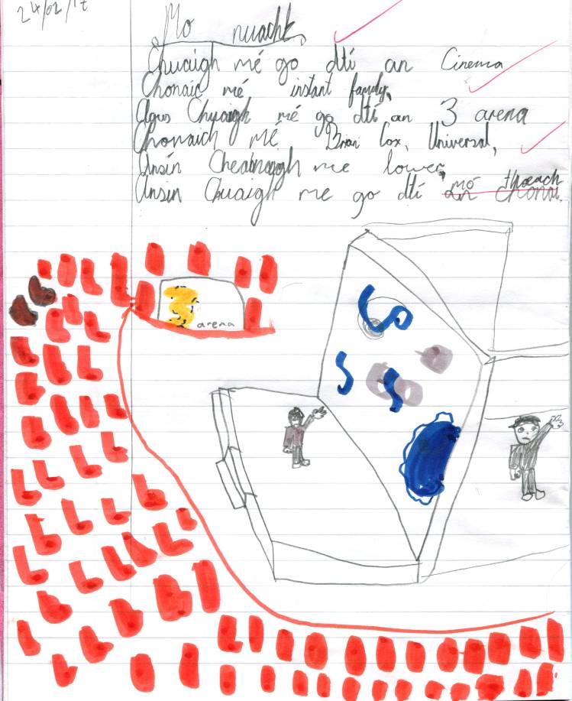
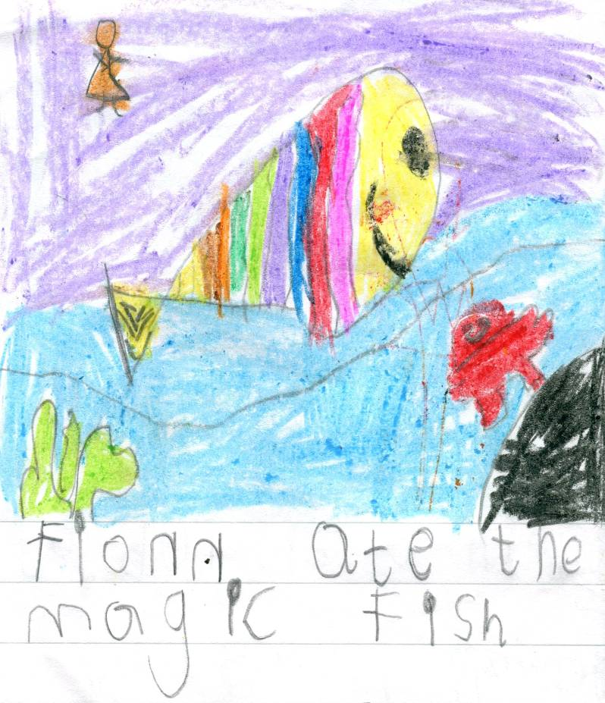
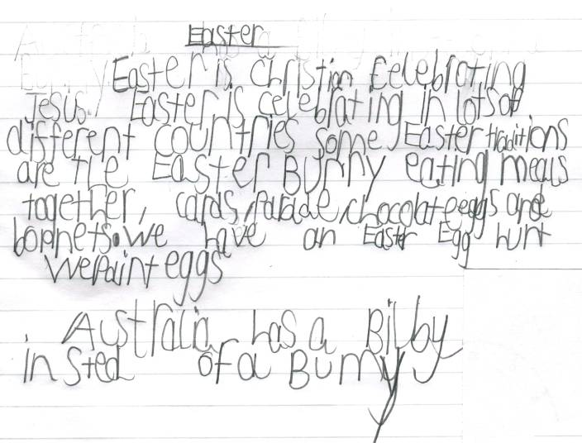
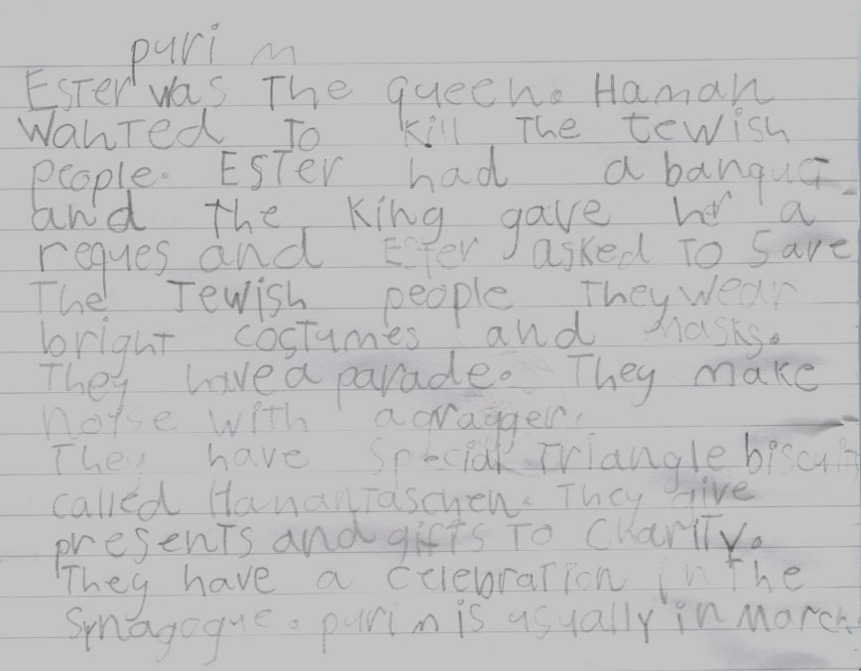
Here are two pieces of writing from Charleigh Colton (Easter) and Kallen Gaynor (Purim) both from 1st Class 1 (Arlene)
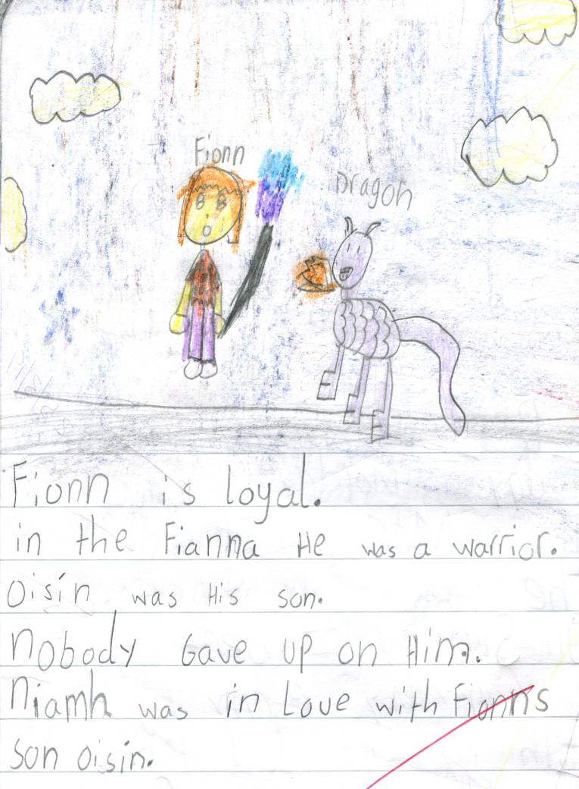
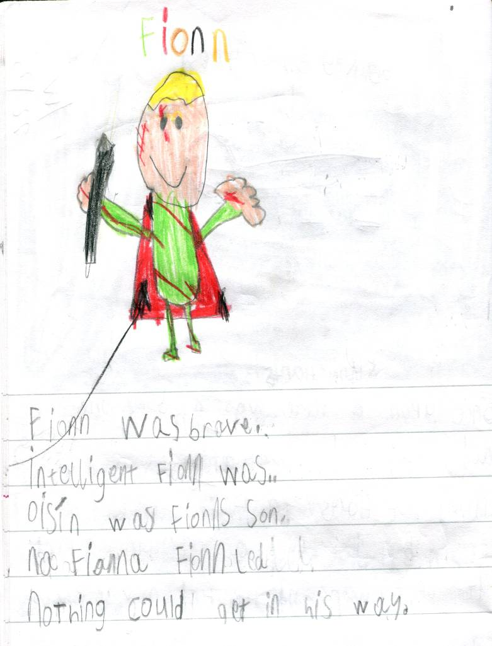
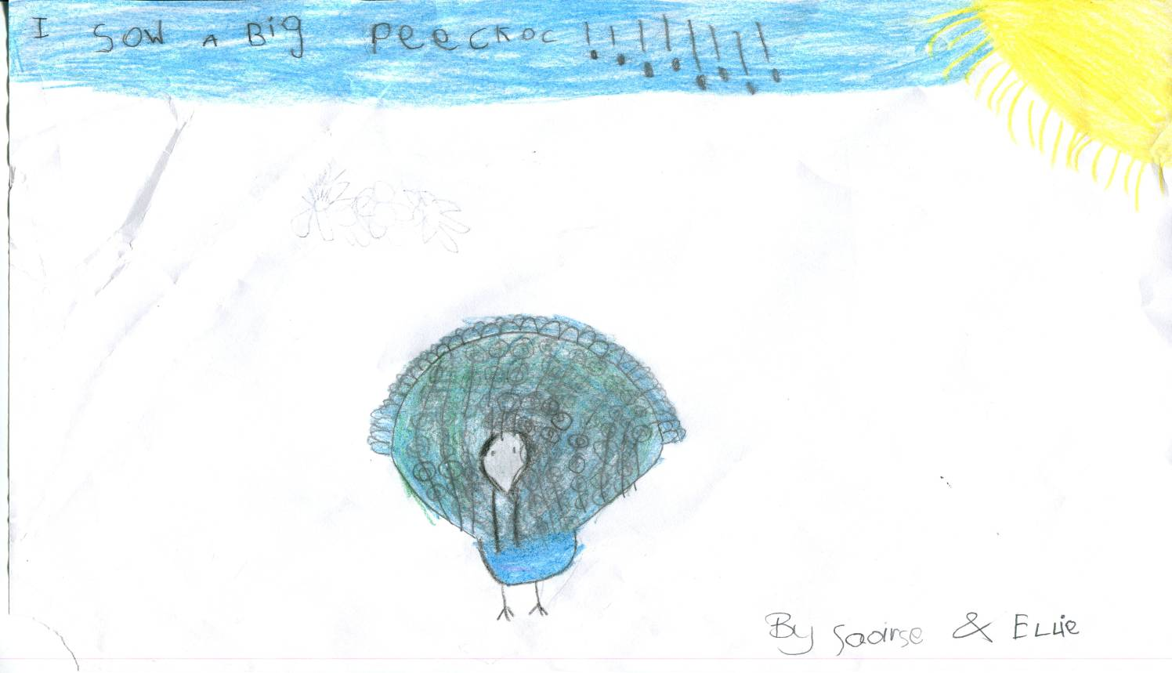
1st Class 2 (Sharon), were looking at Irish legends recently – one of which was ‘Fionn and the Dragon.’ Here are two acrostic poems, spelling ‘Fionn’, together with beautiful pictures from Ruby Tighe (left) and OllieConnolly (right)
Saoirse Martin and Ellie Hollingsworth (both from Senior Infants 2) visited the Zoo recently. Here is their lovely picture of a peacock that they saw there.

