Monday | Maths:  - MM Week 27 Monday  - Tables: -8 tables (9-8= , 10-8 =… etc)  - Practice subtraction with renaming (3-digit). Watch the video in your email.  English:  - EIP Day 88  - Spellings Group 2 week 8  - PAT sound: atch  - Come up with 7 words that have ‘atch’ in them  - Spelling activities: Colour code the words, make a word search with them, use scrabble tiles, make sentences or a story, practice saying and writing them  - Writing (Optional): Penpal letter activity.  Gaeilge:  - Practice the words for clothes on page 50 and 51 in Abair Liom.  - Draw a picture of a bathroom and label it using Irish words
Tuesday | Maths:  - MM Week 27 Tuesday  - Tables: -8 tables (9-8= , 10-8 =… etc)  - Subtraction with and without renaming. Complete the worksheets at the end of the page.  English:  - EIP Day 89  - Spellings Group 2 week 8  - Dictation sentences (based on atch) (See below for dictation ideas)  - Spelling activities: Colour code the words, make a word search with them, use scrabble tiles, make sentences or a story, practice saying and writing them  Gaeilge:  - Play Simon says in Irish with your Family. You instructions could be like this:  Deir Simon, Bígí ag rith (run) / Bígí ag léím (jump) / Bígí ag canadh (sing)  Bígí ag siúl (walk) / Bígí ag snámh (swim) /Bígí ag rothaíocht (cycle)  Bígí ag damhsa (dance) / Bígí ag gáire (laugh) /Bígí ag rith (run)
Wednesday | Maths:  - MM Week 27 Wednesday  - Tables: -8 tables (9-8= , 10-8 =… etc)  - Write these sums as tens and units and complete them in your spare copy  - 92-44=  - 99-56=  - 344-123=  - 124- 77=  - 161-140=  - 87-66=  - 560- 330=  - 323- 176=  English:  - EIP Day 90  - Spellings Group 2 week 8  - Find yourself a nice reading corner/area inside or outside and read one of your favourite books for 20 minutes or more  - Handwriting: Write these sentences using cursive writing:  - I lost a football match  - I have to catch the ball  - There is a patch on my dog  - I made a batch of bread  - My mom watched a movie.  - Spelling activities: Colour code the words, make a word search with them, use scrabble tiles, make sentences or a story, practice saying and writing them  Gaeilge:  - See if you can remember any Irish songs. You can look some up online and have a go at singing them.  - Practice naming the words associated with the bathroom in Irish.
Thursday | Maths:  - MM Week 27 Thursday  - Tables: -8 tables (9-8= , 10-8 =… etc)  - Subtraction Frenzy! (See below) This can be done repeatedly and the children can try and beat their time each week. Change the 5 minute limit to 8 or 10 minutes depending on the child.  English:  - EIP Day 91  - Spellings Group 2 week 8  - Reading (10 minutes or more)  SPHE/Learn Together:  Mindful activity (with parents)(Attached Worksheet): Talk about each of the emotions listed (Love, Fear, Anger, Sadness, Happiness) with a parent and discuss what they feel like. For example, what do I feel in my body when I’m angry/sad/happy? Pick a colour for each emotion and put that colour where you feel the emotion in your body.
Friday | Maths:  - MM Week 27 Problem Solving and Friday Review  - Tables: -8 tables (9-8= , 10-8 =… etc)  - Subtraction Frenzy! Try and beat yesterdays time.  English:  - EIP Day 92  - Spellings Group 2 week 8  - Reading (10 minutes or more)  - Spelling activities: Colour code the words, make a word search with them, use scrabble tiles, make sentences or a story, practice saying and writing them  Gaeilge:  - Play musical Statues with Irish songs. You can look up some songs on youtube like https://www.youtube.com/watch?v=3YDBVOYnUfE or use the “seactain na gaeilge” playlist on spotify.
Additional  activities | Art Exhibition: The theme for this week’s piece of art is “Butterflies and Bees”. When you have completed your art piece, you can email it to website.nketns@gmail.com and we will post it to the gallery on the school website.  This is totally optional. We had a few pictures in last week and they were super. All the pictures from last week’s theme are in a video on the website in the Kid’s Corner.  Website of the day: http://www.nketns.ie/?p=6693  All previous websites of the day have been archived here for you to go back on if you like http://www.nketns.ie/?p=6695  Possible extra activities  - Make a poster project on a topic of your choice.  - Keep a diary of what you have been up to throughout the week.

Maths sums and answers:
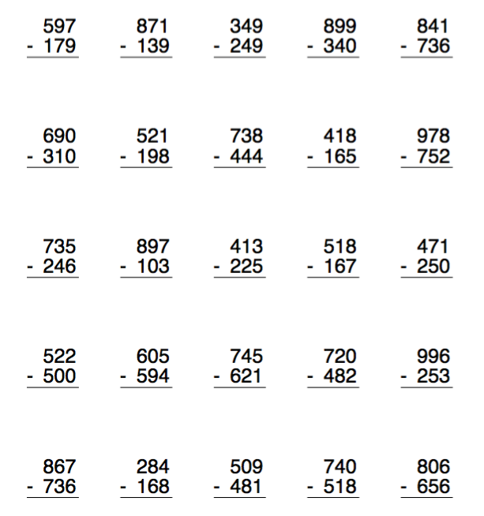
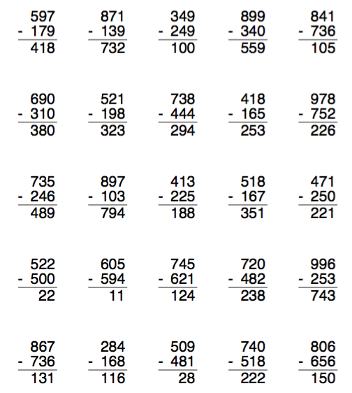
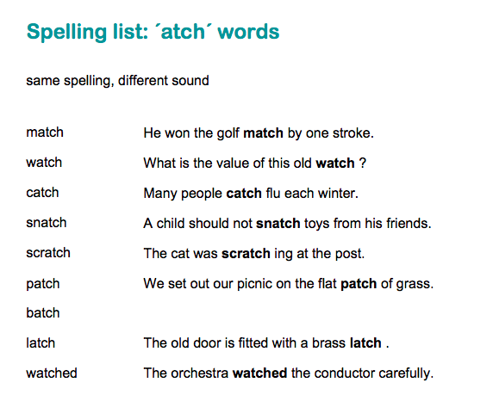

Subtraction Frenzy 