Week 11 08/06-12/06
Hello everyone 😊 We hope everyone is keeping healthy and safe. This week we are continuing work on your Space project. You can pick one or more areas to work on and present it in any form. In Irish we would like you to listen to the powerpoint to help revise. We will be sending out a few resources and as always, these are guidelines, we do not expect you to print all these out, so all we ask is for you is to do your best. If you were in school we would be trying to spend lots of time outside and get lots of fresh air.
Orlaith, Mary & Ronan 😊

Monday | Gaeilge: Power Point  Maths : Mental Maths next day . Planet Maths Time p.162 answer orally  English: Solar System Fact Hunt (email). Look at the Riddles below and see can you figure them out  SESE: Space Project
Tuesday | Gaeilge: Power Point  Maths: Mental Maths- next day. Planet Maths p.163 B.2,4,6,8 C1,3,5,7  English: A Postcard from Space (email). Riddles  SESE: Space Project  P.E.: Just Dance “Happy” (Active School) (Watch on You Tube)
Wednesday | Gaeilge : Power Point  Maths: Practice Tables on www.topmarks.co.uk . PM p164 A answer orally  SESE: Space Project  Well being Wednesday: 10 things I would take to space in my rocket (email)
Thursday | Gaeilge: Read Turas Campála and answer questions below  Maths: Mental Maths- next page. PM p.165 A&B orally  English: Reading Comprehension First man on the moon(email)  SESE: Space Project  Music: Listen to and sing “Walking on Sunshine” by the Katrina & the Waves
Friday | Maths. Worksheet-practising tables (email)  Science: Try one of our space experiments Bubbling Planets or Craters on the moon (email)  Art: Solar System Art colouring -Colouring in the planets (email)  P.E.: Just Dance “Ghostbusters” (Active School) (Watch on You tube)

We are inviting all classes to send some art work to the school website which will be displayed altogether. We will choose a different theme each week. This week the theme is “Family Time”. If you want to take part this week email a picture of your artwork to website.nketns@gmail.

Astronauts Douglas Hurley
& Robert Behnken
The astronauts were accelerated to approximately 17,000mph (27,000kmph) - 22 times the speed of sound

Riddles
- What travels around the world but stays in the same spot
- What begins with T, finishes with T and
has T in it
- What becomes wetter the more it dries?
- Mr. Blue lives in the blue house, Mr. Yellow lives in the yellow house, Mr. Orange lives in the orange house. Who lives in the White house?
- Davids parents have three sons Snap, Crackle and………
- You can see me once in June twice in November but not at all in May. What am I?
- What word is spelled wrong in the dictionary?
- What kind of cup doesn’t hold water?

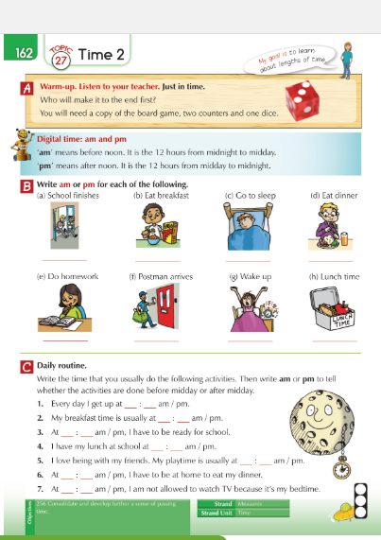

Answers to the Riddles
- A Stamp
- A Teapot
- A towel
- Donald Trump
- David
- The letter E
- WRONG
- A hiccup

