Week 11
Hi Everyone,
Hope you are all well and keeping busy. One Wednesday we are going to do a Zoom assembly together and on Thursday I am doing my graduation delivery run, I’m looking forward to seeing you all. I’ll visit everyone’s house and hand deliver the equipment you need. I’ve put together a video to help with the art project. You have two to make, one for school and one for home. Everyone has their own colour and you can make your own design with the tape, maybe have a couple of practice runs first before you use the frame. Your designs will all be unique. Try to follow the technique on the video so they will work as an art piece when we put them all together.
This week I would like you to send me your written speech for graduation. (English) Only a few people let me know their choice last week. The art topic for the gallery website is “Family Time” (Art) Remember to send your pictures to website.nketns@gmail.com I’m looking forward to seeing them in the gallery. I have included a worksheet for transition to secondary school this week. If, you have any questions about secondary transition, let me know in your emails. Have a good week, see you on Wednesday and Thursday.
Take care and keep safe
Arlene

Mental Maths – Week 27 English in Practice – p. 79 & 80 (Revision)
Gaeilge – use resources on Folens website Abair Liom H – An bhliainiris
- Abair Liom lth 146
- Briathra – Clois/ Déan/Faigh AC/AL/AF – (use worksheets and p.128)
- Abair Liom lth 142 (Déan)
- Two worksheets (Clois + Faigh)
- This is revision
- An Aimsir Chaite – inné (past, yesterday, last night, last week, last month, last year)
- An Aimsir Láithreach – gach lá (present, every day)
- An Aimsir Fháistineach – amárach (future, tomorrow, next week, next month, next year)
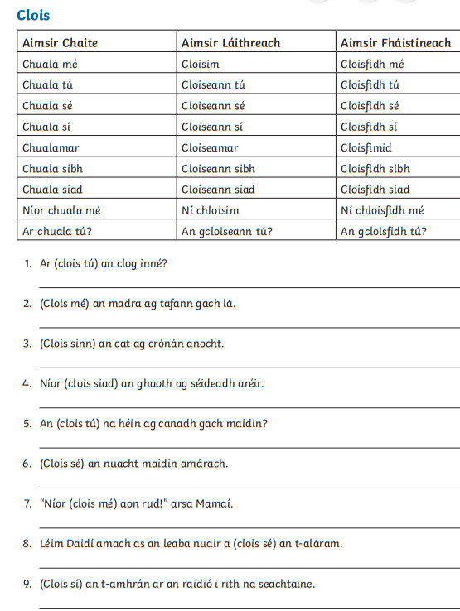
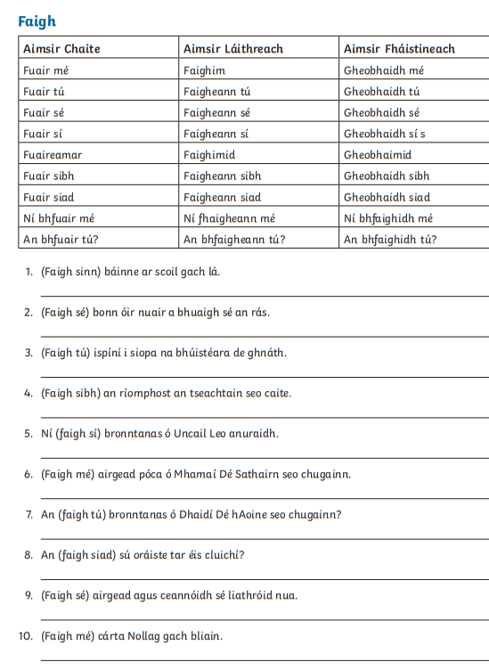

Maths
Averages
Add all the numbers together and divide by how many digits(numbers) there are
What is the average? 6, 9, 8, 2, 5
6+9+8+2+5 = 30 then, 30 ÷ 5 = 6 The average is 6
The answers p. 174-177 are at the end
Variables
Variables are when you have an unknown in the equation. This is usually represented by a letter. Think of area
A = l x w, where A is area, l is length and w is width. If you know A = 6 and l = 3, then using the equation
A= l x w
6 = 3 x w
W = 2
Have a go at p.181
When you are solving an equation the two sides must be equal, they must be kept balanced. Whatever you do to one side you must do to the other.
For example
6x + 3 = 27 (you must take 3 away from both sides to get rid of the 3)
6x + 3 - 3 = 27 - 3
6x = 24 (you must divide both sides by 6 to get rid of the 6)
6x ÷ 6 = 24 ÷ 6
x = 4
Try p. 182
There are two extra worksheets at the end if you want to try some more.

English
This week I would like you to write out your graduation speech. Let me know which one you are doing. This is for graduation in September but I’d like us to write them now and I will keep them. If you need any help just send me an email.

SESE – Draw the parts of a flower
- Name 10 summer flowers (Ireland)
Music – revise graduation songs
- Dabbledoo

Art – This week the theme is “Family Time” Art about things you and your family have shared during your time at home: walks, games, baking, painting, gardening. Remember to email your art work to website.nketns@gmail.com for display in the school gallery.

PE
- Continue with 2k a day, if you wish.
- lots of core exercises (you know what to do)
- GoNoodle
- Walking/Running/Cycling
- PE with Joe, The Body Coach TV 9am live on YouTube
- Dance
- Active Week activities

LT/Wellbeing/SPHE
Transition worksheet
Lockers, Clothes and Phones
Lockers
- Will you have a locker in your school?
- Do you know where it is?
- What times will you be able to go to it? (Check timetable)
- What happens if you lose your key?
- TIP – attach a spare key and pin it to your bag for emergency. Lots of people buy a stretchy key attachment from the cobbler near Supervalu
Clothes
- School Uniform: Most secondary schools have one.
- Do you know what your uniform will be like?
- Will it be ok to wear your PE gear to school?
- What happens if you forget your PE gear?
- What are you not allowed to wear?
- Does your school have a policy on jewellery? Make up?
Phones
- Most schools have a policy on mobile phones: they must be put away, turned off and kept out of sight at all times during the school day.
- What is your school’s policy on mobile phones?
- Are there any times it is ok to use it?
- What happens if you use your phone during school times without permission and the teacher sees you?
Help
In secondary school you’ll be dealing with a lot more teachers through the subject classes. However, there is one teacher whose job it is to look after your class in particular. S/he may be called the form tutor/ class tutor/ caomhnóir. If you have a problem or if you are worried about anything s/he is the person to go to first.

- Try making a gratitude jar. Everyday write something you are grateful for on a slip of paper and put it in a jar.
- Help in the garden
- Play board games or cards
- Jigsaws
- Exercise
- Yoga
- Baking
- Helping at Home

Useful Websites
- topmarks.co.uk
- Scoilnet.ie
- Séidéansí
- Twinkl
- GoNoodle
- Dabbledoo
- Website of the Day on school website
Maths Worksheets below
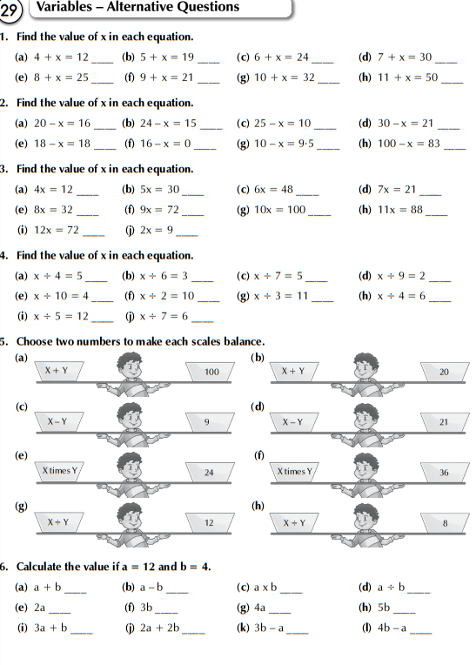
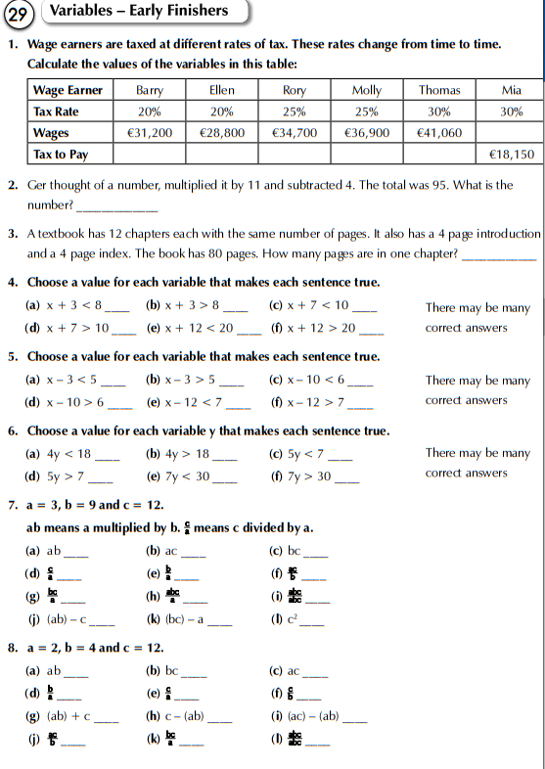

Answers to MM week 26, EIP Revision 1-10,11-20, Maths textbook p.174-177
