Week 12
Hi Everyone,
Hope you are all well and keeping busy. Delighted to see you at our Zoom meeting and on Thursday. The posters were amazing. You are all fantastic. Keep sending me your written speeches for graduation. The art topic for the gallery website this week is “View from my Window” (Art) Remember to send your pictures to website.nketns@gmail.com I’m looking forward to seeing them in the gallery. On Saturday, it is the start of our virtual sponsored run, good luck and enjoy. Hope you enjoy your scavenger hunts this week. If, you have any questions about secondary transition, let me know in your emails. Have a good week.
Take care and keep safe
Arlene

Mental Maths – Week 28 English in Practice – p. 81 & 82 (Revision)
Gaeilge – use resources on Folens website Abair Liom H
- Briathra – Feic/ Ith/Tabhair AC/AL/AF – (use worksheets)
- Three worksheets (Feic + Ith + Tabhair)
- This is revision
- An Aimsir Chaite – inné (past, yesterday, last night, last week, last month, last year)
- An Aimsir Láithreach – gach lá (present, every day)
- An Aimsir Fháistineach – amárach (future, tomorrow, next week, next month, next year)
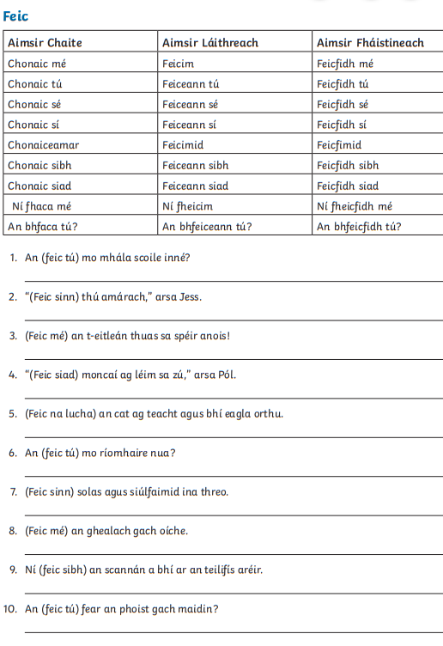

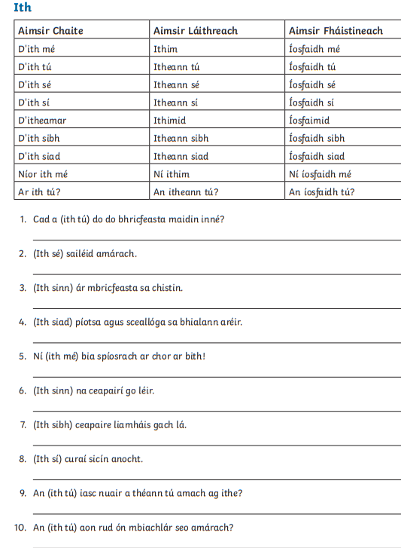

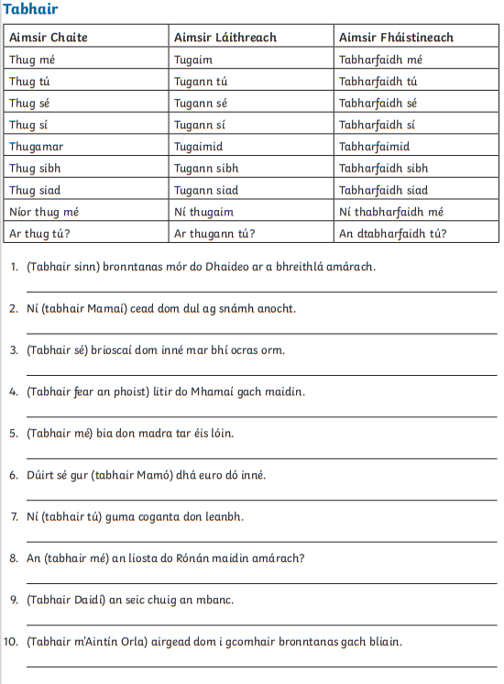

Maths
Revision - Variables
Variables are when you have an unknown in the equation. This is usually represented by a letter. Think of area
A = l x w, where A is area, l is length and w is width. If you know A = 6 and l = 3, then using the equation
A= l x w
6 = 3 x w
W = 2
Capacity and Volume
Capacity is the measurement of the amount of liquid. The measurement is in litres and millilitres. There are 1000ml in 1l
1000ml = 1l
8300ml = 8l 300ml = 8.3l or 8.300l
4236ml = 4l 236ml = 4.236l
5067ml = 5l 67ml = 5.067l
2008ml = 2l 8ml = 2.008l
For fractions, make the fraction out of 1000. Denominator = 1000
Remember, whatever you do to the bottom, you must do to the top.
Try C and D p.184 (you don’t have to do them all, try a few different types)
Try p.185 and 186
Remember when adding, subtracting, multiplying and dividing, you must work in millilitres or litres (NOT a mix) Also put into either decimal or litres and millilitres form. Decimals often the easiest.
2l 85ml + 5.436l = 2.085l + 5.436l = 7.521l
ml = millilitres
l = litres

Volume
Volume is the amount of space taken up by a shape. Volume is measured in centimetres cubed, cm³
Volume is calculated by
Volume = length x depth/width x height
V = L x D x H or V = L x W x H
Try p. 187 and p.188
Two worksheets at the end if you want to try

English
This week I would like you to make a scavenger hunt for 4th Class. It can be about nature, everyday objects, at home, at school, your choice. I’ll use them next year.
SESE – Scavenger Hunt, a flower scavenger hunt and a house scavenger hunt.
Worksheets below at end
Music – revise graduation songs
- Dabbledoo
Art –The art theme this week is “View from my Window” Remember to email your art work to website.nketns@gmail.com for display in the school gallery.
PE
- Sponsored Virtual Run
- lots of core exercises (you know what to do)
- GoNoodle
- Walking/Running/Cycling
- PE with Joe, The Body Coach TV 9am live on YouTube
- Dance
- Active Week activities

LT/Wellbeing/SPHE
- Send me any questions about secondary school transition
- Have a think about any extra- curricular activities you would like to get involved in. There is usually a list on the school website.
- Try making a gratitude jar. Everyday write something you are grateful for on a slip of paper and put it in a jar.
- Help in the garden
- Play board games or cards
- Jigsaws
- Exercise
- Yoga
- Baking
- Helping at Home

Useful Websites
- topmarks.co.uk
- Scoilnet.ie
- Séidéansí
- Twinkl
- GoNoodle
- Dabbledoo
- Website of the Day on school website

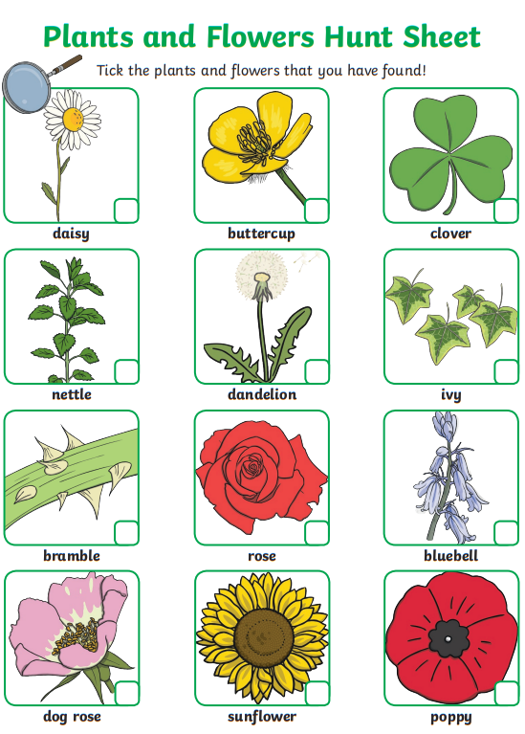

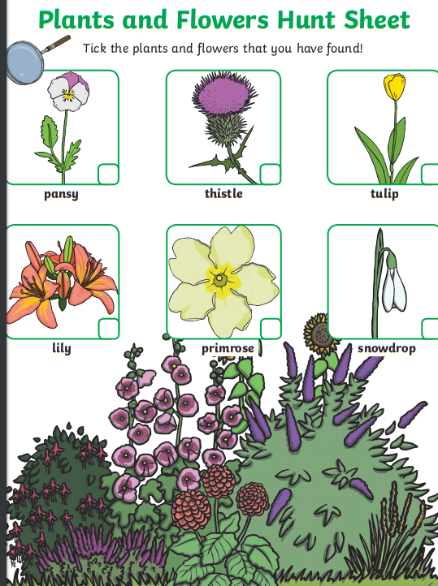
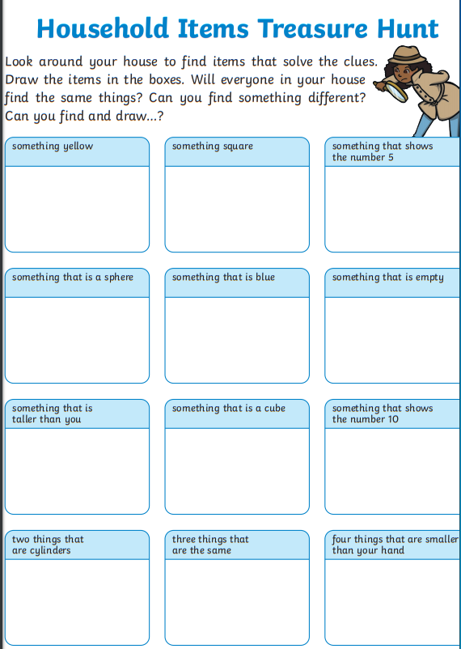

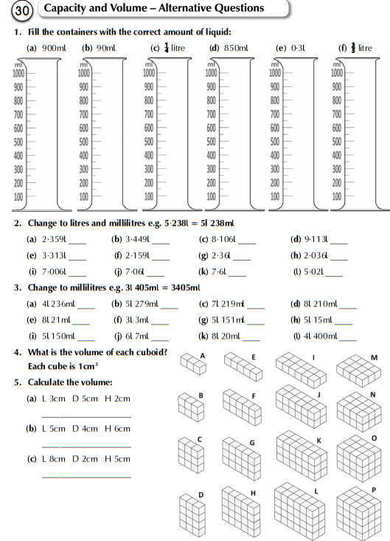

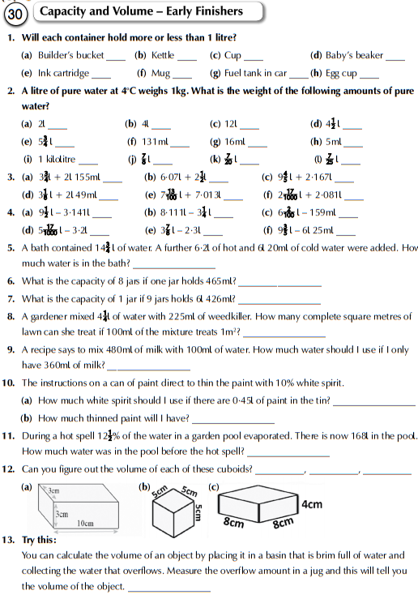

Answers to MM week 27, EIP Revision 21-30, 31-40, Maths textbook p.181-182, worksheets
