Sept./Oct. 2020 www.nketns.ie
email: office@nketns.ie landline: 6274388 school mobile: 0894433500

Dear Parents and Guardians,

The first part of term one has come to a close and the new normal of a school open in the midst of a pandemic has become embedded in all of our lives.

This has been a concerted effort involving all the partners in the school community: children, parents, staff, PTA and Board of Management. Everyone has been asked to make significant changes to the way they normally operate but because there has been such a collaborative and cooperative approach from all concerned, we have managed to settle into the rhythm of a new way of working.

Thanks to that high level of cooperation, we have been able to meet our twin targets of reopening the school and returning the children to a large semblance of normality while simultaneously keeping everyone in the community as safe as possible. With the worsening of the viral environment outside the school gates, we will need to be even more vigilant on our return after the mid-term break.

I want to thank parents for their help in implementing the new procedures throughout the school and for their consideration in sometimes keeping a child out of school rather than taking a chance. We know this isn’t easy with work obligations and it is very much appreciated.

Thanks to the children for their good humour and positivity in adapting to new things like frequent hand sanitising, remaining in their seats more than usual and implementing the small but important changes like handling books and art materials in a different way.

Thanks to the staff for their help and involvement in completely redesigning the way the school runs while all the time trying to keep the experience as normal and as nurturing for the children as we could.

And thanks to the PTA and the Board of Management for continuing their hard work on behalf of the school community in spite of the many challenges put in their way.

We have come a long way together since the days of the prolonged school closure and I think it is safe to say we all hope we won’t be returning to the days of extended remote learning.

But for now, enjoy the mid-term break and we will see you all back here between 8.35am and 8.55am on Monday 2nd November.

Pat

We wish to remind parents that all nut products are banned from the school, due to a number of pupils having life threatening nut allergies (this includes Nutella)
Parent-Teacher Meetings will take place on Friday 5th February and Thursday 11th February 2021. These meetings will be held after school hours on both days. You will be notified of your appointed time approximately two weeks before either of the above dates. The precise format of our PTMs this school year will be decided closer to the time.

If your child has Covid 19 symptoms e.g. a cough:

- Please don’t send them in to school
- Consult your GP by phone (this is free)
- Follow your GP’s advice on the return to school
- It helps if you let the school know what the GP advised
- If they need to stay off for some time on medical advice, contact the school and we will organise work to keep them in touch with the class

PARENT CONTACT DETAILS
Our text-a-parent and email communications systems work very well as long as we have parents’ up-to-date mobile numbers and email addresses. If you have changed your mobile number within the past number of months or you wish to clarify the mobile numbers we have on our records, please contact the school office. Likewise, if you have changed your email address recently, please contact the school office. For those of you who are unfamiliar with the text-a-parent communication system, it is one way i.e. school to parent only – no response facility. Please ensure that the mobile number we have for both parents is always switched on, is reachable, and in the case of us leaving a message, that you check your voicemail often. It has already been the case that we could not get in contact with both parents, and we had not been supplied with an alternate person to contact. There was a delay of a few hours before contact was made, which as you can appreciate given the nature of Covid 19, was worrying. Please keep your phone with you at all times. Thank you.

ABSENCES FROM SCHOOL
Some of you may be concerned regarding your child being absent for more than 20 days, and it being reported to the National Education Welfare Board (NEWB). Due to the ongoing pandemic, this will not be the case this year and you do not need to be concerned as days are not being counted by them.

If your child is absent from school please remember to complete the pink coloured ‘Absent Slip’ and give it to your child’s teacher (via school bag post or drop it to the main front door) upon his/her return to school. You were given a few sheets of absent slips on your child’s first day back in school. If you require extra absence slips, please contact the school office.
The school is required to have these absent notes for insurance purposes and for the NEWB.
Please do not use the absent notes in your child’s homework diary

DROPPING FORGOTTEN ITEMS TO SCHOOL
If your need to drop any item to the school, you can do so by leaving it at the ‘Drop Zone’ which is located just inside the main front door of the school – it is clearly marked. Your child’s name and class should be clearly written on the item OR it is placed in a bag, again with their name and class.
If Adrienne is at the office at the time, she will take it from you. If not, place it at the Drop Zone and she will get it upon her return, and give it to your child.

SIGN OUT/SIGN IN
When you come to the school to collect your child, please come inside the main front door and wait. Your child will then be collected by Adrienne and brought to you and she will sign out your child on your behalf. If your ‘signed out’ child is returning to school during the day, again come to the main front door with your child and Adrienne will escort them back to their class. Please do not collect/drop your child at any other entrance in the school e.g. Classroom entrances

CHANGE TO PICKUP
If you need to collect your child early from school or there is an alteration to their usual going home arrangements, either email us or leave a message on our landline, the evening before.

If there is a sudden change to pick up arrangements during the school day, please ring the school no later than 1.00pm for the junior classes and no later than 2.00pm for senior classes.

LATE ARRIVAL/LATE PICK UP
If you arrive late to school, please bring your child to the main front door – NOT the classroom entrances.
Likewise, if you are late in picking up your child go to the main front door (NOT the classroom entrances) and wait. Your child will be brought out to you.

If you have forgotten to complete your ‘GOING HOME ARRANGEMENTS FORM’ please do so and return it to your child’s teacher as soon as possible. If you need another form, please contact the school and your child will be given one for you.

ESSENTIAL ITEMS
Hand towel – each child must bring in their own labelled hand towel. This should be placed in a ziplock plastic bag, and returned to the ziplock bag after use, and needs regular replacement. Please ensure your child knows how to unzip and zip their plastic bag.
Water bottle – each child’s water bottle should be clearly labelled and can be opened, and closed by your child. If your child forgets to bring in their water bottle we shall ring you to drop it to the school. As we have no glasses or cups available to us in the school, we cannot give children water ourselves.
Spoon (if necessary to eat their lunch) – Again we cannot give your child a spoon if they have forgotten theirs.
Suitable clothing – As you are aware that one of the safety measures we have implemented to restrict the transmission of the virus in school is to keep classrooms well ventilated. As winter approaches it the children will notice that the rooms will feel cold sometimes. When dressing your child for school, please keep this in mind and dress them more warmly than you normally would. We also need to maximise the time they spend outdoors, so if there is a light, hazy drizzle they will still be going out to the yard. Make sure they have a coat with a hood or a hat in school with them every day.

The Lunch Bag Company: If your child is out of school for a number of days, please remember to ‘turn off your calendar’ with Lunch Bag for those days.

We would ask parents/children that before leaving their home for school, to check that they have everything they need, such as a water bottle, lunch box, books, hand towel, coat etc.

LABELLING
We cannot emphasise this enough! EVERY ITEM should have a label. Please take time to check that items in your child’s school bag has their name on it, and in particular, their coat/ jacket, jumper/cardigan, tracksuit – and in the coming weeks their hat, scarf and gloves (each hand).

LOST PROPERTY
The hope is that if everything was labelled then we should have no lost property! However, if your child has mislaid an item and it is in the lost property box, please come to the main front door, describe the item lost and Adrienne will search the box for you.

MEDICATIONS
We would like to remind parents that children are not permitted to bring in
- personal hand sanitisers (unless by prior arrangement with the Principal, and due to a skin condition e.g. eczema etc.)
- strepsils
- calpol melts
- painkillers,
- or medicated creams

Medications kept in the office for your children
BOARD OF MANAGEMENT NEWS
The Board of Management would like to welcome Karen Corbet, Hannah Lyons and Joanne Flynn to the staff. Karen is working as one of the teachers in the Outreach Class and Joanne is working as an SNA. Hannah is teaching Senior Infants and is our first past-pupil to join the school staff.

We would also like to welcome back Bearach Ó Casaide who rejoins us this year after teaching abroad.

Congratulations to Lisa and Kelly who both had their first children this year. We wish them both well as they join the ranks of the parents!

We would like to formally thank children, parents and staff for their cooperation with the new procedures put in place by the Board to address Covid-19. Your ongoing support is very much appreciated.

You will receive an email from Adrienne to remind you when your child’s medication expires. Bring the medication to the office and the expired medication will be given to you. We cannot dispose of medications on the school premises and we cannot give it to your child to bring home. Please DO NOT put medication in your child’s school bag.

The onus is on parents to be prompt in delivering the medication to us and ensuring that it is in date.

AFTER SCHOOL CLASSES
All after-school classes are cancelled until further notice. The Board of Management will keep this under review as the year progresses.

Hopscotch is an afterschool service not an afterschool class. This will run in accordance with our school closure calendar and other emergency closures, if any.

BIRTHDAY TREATS
As we are an Active Flag School and in keeping with our Healthy Lunch Policy, no treats of any kind are permitted during school hours, except for exceptional events like our dress-up day this week. Therefore, please do not send in to the class cakes, sweets, treats on children’s birthdays. Please keep ‘celebrations’ to outside school.

INFECTIONS/VIRUSES (NOT Covid-19)
Should your child become infected with a contagious ailment e.g. chickenpox, impetigo, measles, slapped-cheek syndrome etc., please inform the school office immediately so that we can inform the parents in your child’s class with information on the infection, and when it is advisable for infected children to return to school.
Rest assured, NO child is identified as being the infected person.
(Please remember to complete an Absent Slip for absences).

HEAD LICE
Head lice generally makes an appearance in all schools! They can spread rapidly in the school unless all affected children are treated promptly. Head Lice do not reflect standards of hygiene in the home or in school. We would advise that long hair is tied back at all times in school, and that you check your child’s hair very regularly. If your child has head lice, please inform us immediately, as it will be necessary for us to notify other parents of an outbreak in their class. NO child is identified as having head lice.

PE TIMETABLE 2020/2021
Class | Mon | Tues | Wed | Thurs | Fri
Jnr. Infs. 1 (Jenny)
Jnr. Infs. 2 (Lydia)
Snr. Infs. 1 (Hannah)
Snr. Infs. 2 (Orla)
1st 1 (Cathy)
1st 2 (Aoife)
2nd 1 (Sharon McC.)
2nd 2 (Niall)
3rd 1 (Bearach)
3rd 2 (Peter)
4th 1 (Ronan)
4th 2 (Arlene)
5th (Grace)
6th (Aine)
OR 1 (Karen)
OR 2 (Sharon C.)

PTA Update October 2020
Well it is great to be back and welcome to all the new families. It has been a quiet start to the year for us all!

In June we held a virtual Sponsored Run/Walk to mirror the Run/Walk the children normally do in school. We hoped this would bring the school community together again after such a difficult year whilst fundraising for the school. It was extremely successful and a huge thank you to you all for supporting this event. It was great to see all the photographs/videos and was a brilliant opportunity for the kids to say goodbye to the 6th Class just gone. Together we raised an amazing total of €2,200!

As you probably have guessed by now, several of our usual events can’t go ahead this year. We would usually have the Stationary Cycle at Supervalu taking place early in October and we would be gearing up for the mid-term cake sale as we speak. However, these events are difficult to hold given the current climate. We are also losing our Cinema Club event this year, which we normally hold in November.
Whilst the PTA are still working in the background trying to help with the social calendar and modifying fundraising events, it is inevitable that this year it will be a slimmed down version of previous years. We know this has been a difficult year for all. We will continue to do what we can for NKETNS and if you are able to offer your support to us that would be wonderful, but we really do understand that it may not be possible and everything is entirely voluntary.

Upcoming Events:
- We are currently in the process of organising our annual NKETNS 2021 Calendar and this should be finished and on sale just before Christmas. The photographs will be taken on Thursday 5th and Friday 6th November by Michael Grubka. Please note all precautions necessary will be taken whilst the photographs are being done and the children will only be photographed in their pods this year. A link to our consent form was sent home via email for each child to participate in the photograph that will be used for their class. It is essential that all forms are returned by Monday 2nd November, for your child to appear with their class in the calendar. As always, our most sincere thanks to Michael Grubka for his photography and the design of the calendar year on year.
- In place of the Annual Winter Raffle we are hoping to host a Prize Draw instead. There will be more information on this available shortly.
- We are also in the process of organising a Cash for Clothes drop. If you are doing any clearing out and you have items in reasonable condition to recycle, please keep our cash for clothes event in mind. We will update you with more details as soon as we can.

Other News
The PTA committee wish to say a huge thank you and goodbye to Jean Auden and Caitriona O’Connor who have both served on the committee and recently left. Thanks so much to you both for your hard work, you will be greatly missed!

Please contact us at nketnspta@gmail.com or visit our Facebook page NKETNS-PTA.

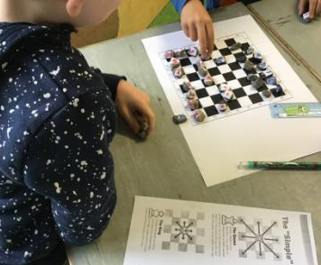
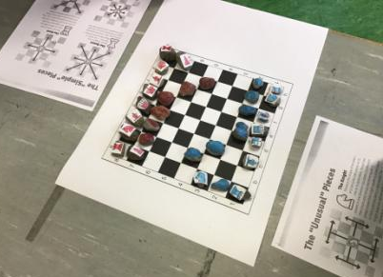

Sharon's 2nd class have set up a weekly chess club. At the moment we only have space for 10 children but there was such a huge level of interest that one of the students, Reuben made a video on how to play and the whole class made their own chess set to play in their pods. Thanks to Reuben's parents Andrew & Susan for sending in chess sets for the club and information on chess.
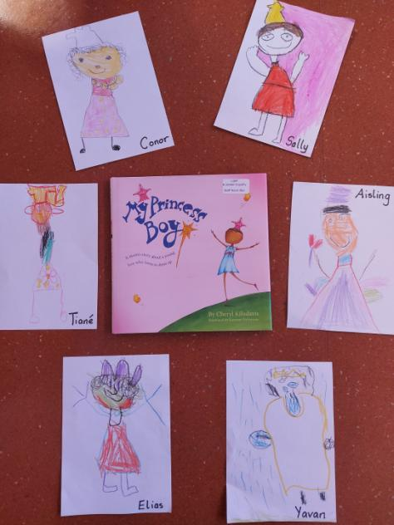
Junior Infants have been reading the book My Princess Boy.

The children in Jenny's class talked about being kind to everyone and celebrating difference.

They drew some pictures of the princess boy from the story and here is a selection of them from :

- Conor Austin
- Aisling Leech-Glasheen
- Sally Wales
- Yavan Kaushik
- Tianè Grimbeek
- and
- Elias Law

Early Christian Ireland Project Recount
At the start of our class’ early Christian Ireland project, we planned out what we knew and what we wanted to learn and we had a part left blank for what we learned. Additionally, during the early parts of it we discussed with the members of our pod what we wanted the art part to be like what, buildings, figures etc. for when we were near finishing the it.
During the middle of making our project we primarily focused on learning lots of stuff about saints, monks, nuns, how people dressed, how they built houses and round towers and how they would hide their treasure from Vikings during raids on the monastery. It helped us fill in “the what we learned” column from the start of it.
The third part of the project was the art part of it everybody got to work on their art, which was made from all sorts of recycled things like cardboard boxes and toilet rolls, there was also quite a bit of clay being given out by Aine (the Teacher) which some people used to make little clay figurines of monks and Vikings which all looked really good! Once everyone’s art was done we displayed it outside of the class.
This was a recount of what happened at 6th class’ Early Christian Ireland Project. You can see our artwork on the school website. Written By Jordan Gaynor

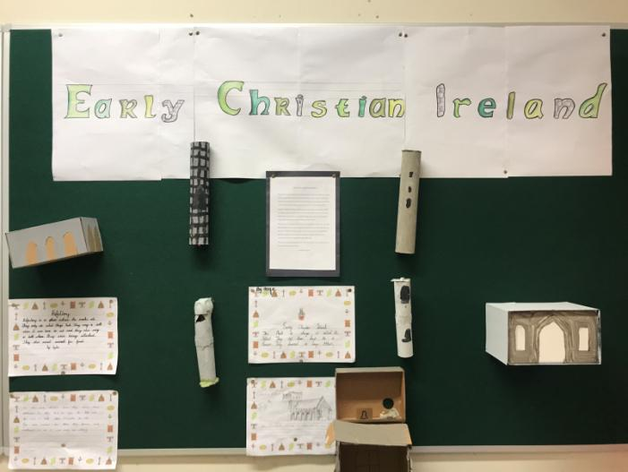
Early Christian Ireland continued
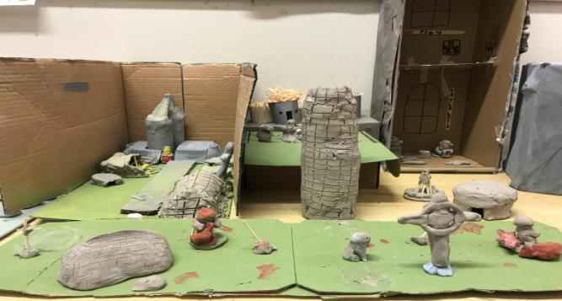

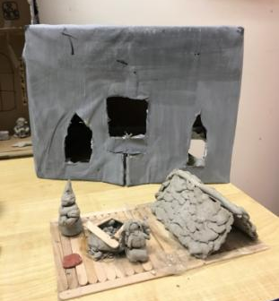
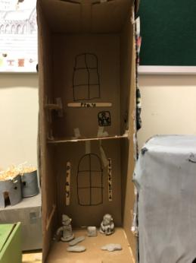
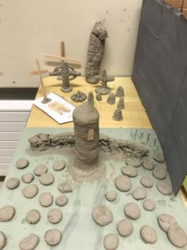
Senior Infants 1 (Hannah) were working on self portraits. Here is Olivia Dunne’s self portrait. During space week, we looked at rockets and below is one made Harriet Nolan
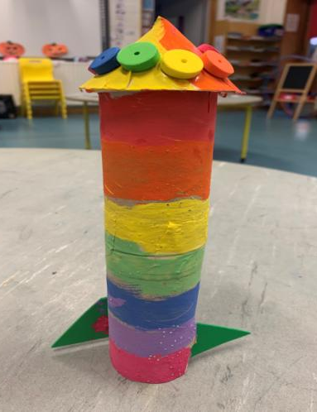
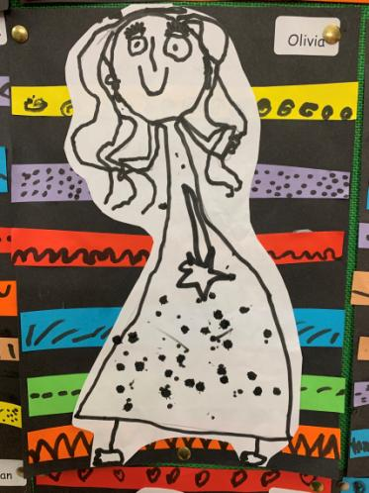

Outreach Class 1 (Karen) made clay hedgehogs while learning about Autumn.

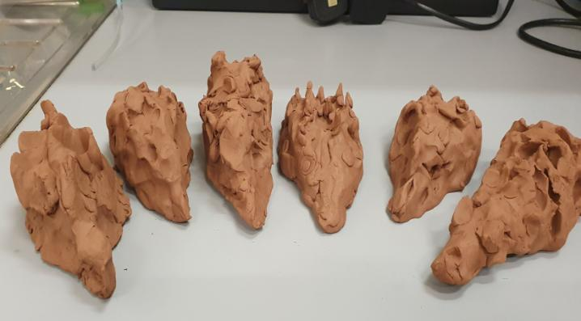
A selection of the projects completed by Peter and Bearach's 3rd classes. These were completed at home by the children as they were learning about Ancient Greece in school. Well done.

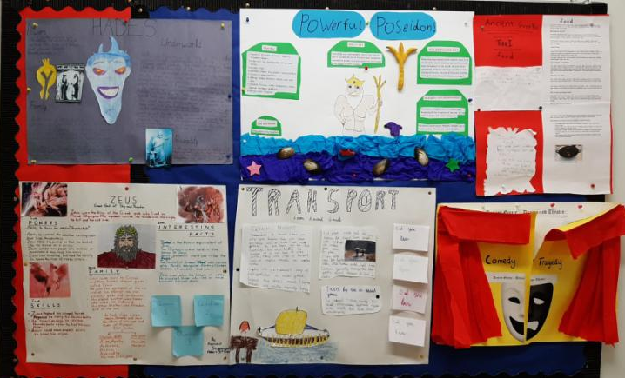
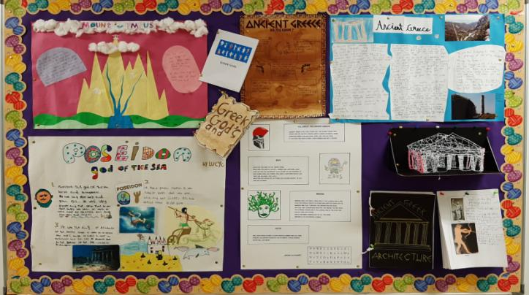
Ancient Greece continued
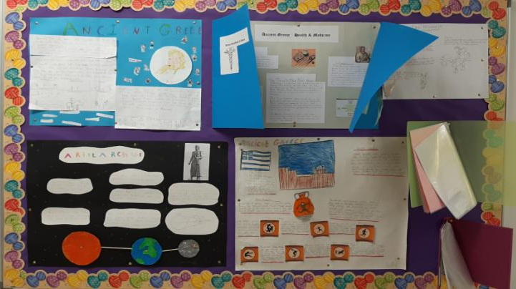

Pumpkin cut and stick by some of our Junior Infants in Lydia’s class - Anna O’Reilly, Ethan Murphy, Hazel Healy, Adam Daly and Megan MacNamara
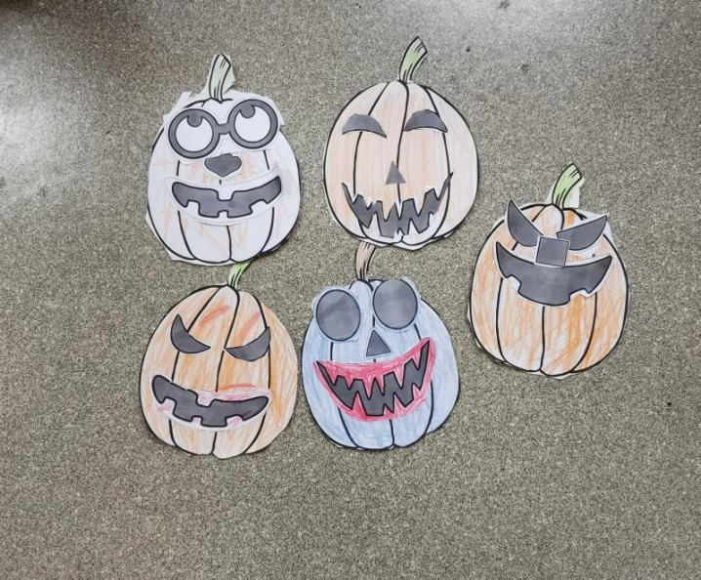
Mobilo by Philippa Cosgrove, Kai Ostoja-Bebnowski and Luke Levi Breen – all in Lydia’s Junior Infant Class
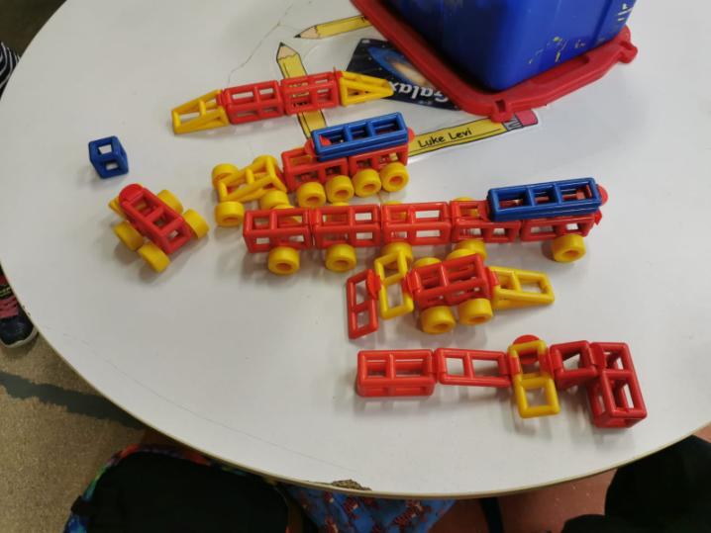

Senior Infants 2 (Orla) spent the month of September learning all about ourselves.
Here's Ethan Patterson's self portrait and Rebecca Morris Picasso inspired self-portrait!
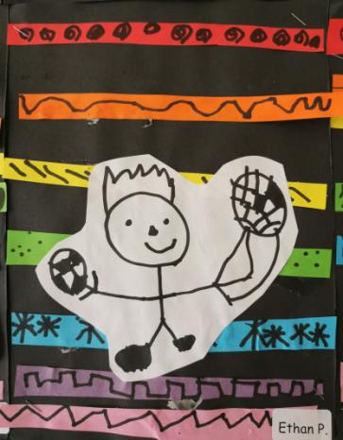
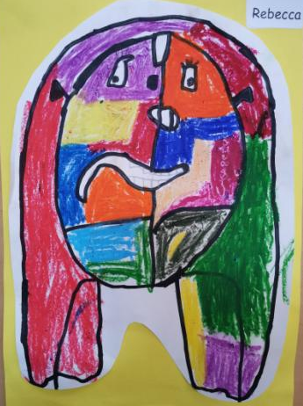

Cnámharlach (Skeleton) and Winnie the Witch Legs! by 1st Class 2 (Aoife)
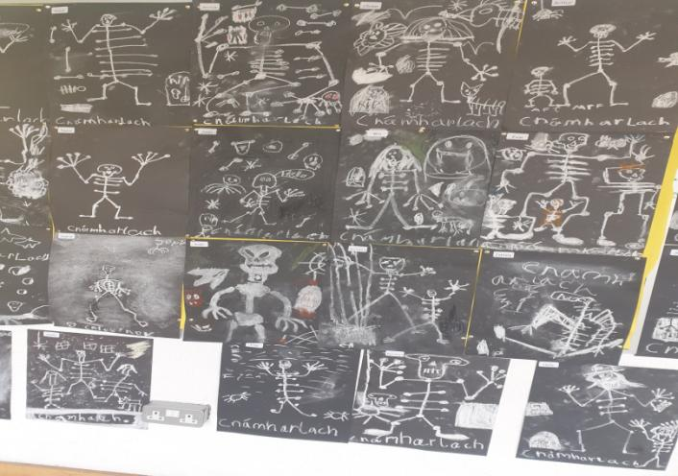
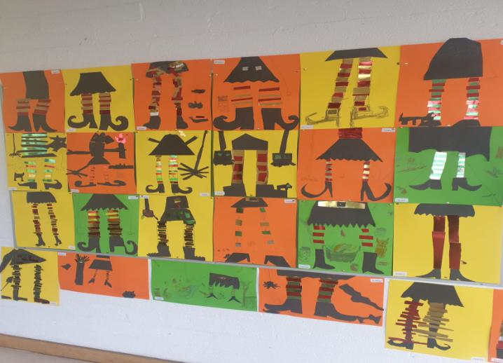

Artwork by 1st Class 1 (Cathy)
Autumn leaf art by: Eva Finnegan, Aaryan Kaushik, Niamh Breslin and Aoileann O’Rourke
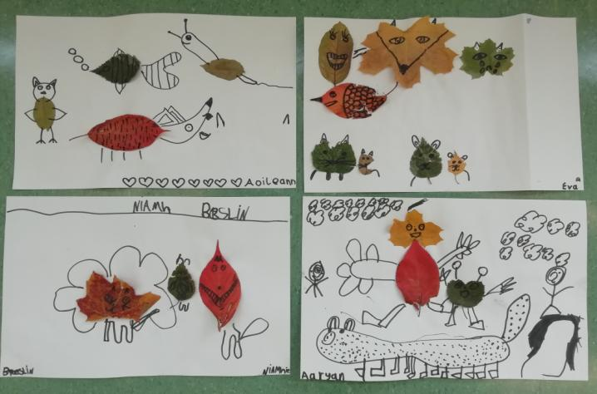

Oíche Shamhna by: James Galatanu, Aisling Ennis, Hannah Halligan and Hanna Stanley
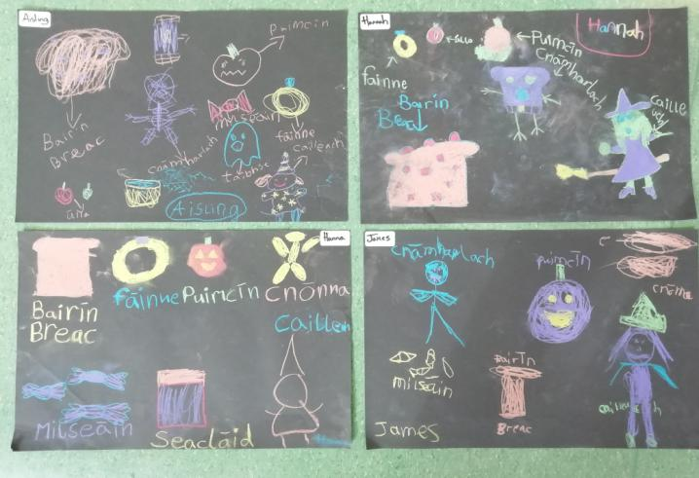

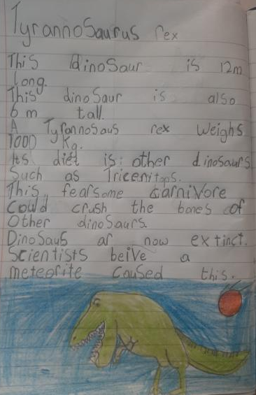
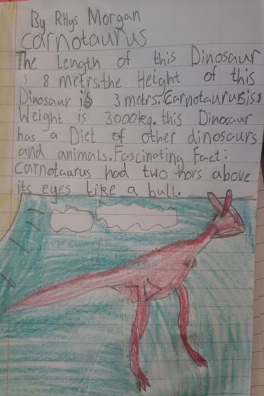
2nd Class 1 (Sharon) were busy working as Palaeontologists. Check out some of our Di nosaur fact files by Willow Nolan and Rhys Morgan……

……For space week we designed solar systems in our pods. We learned the order of the planets by memorizing - My Very Energetic Mother Just Served Us
2nd Class 2 (Niall) were also busy working as Palaeontologists. Here is Carolina Perciavalle’s fact file…….

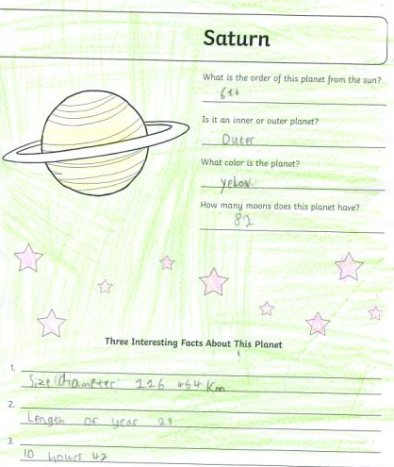
….and they also looked at our Solar System. Here is Jake Connolly’s face file.
The Kandinsky Circles were painted by Caoilin Caffrey and The County Brochure was made by Ben McNamara, both from 4th Class 1 (Ronan)

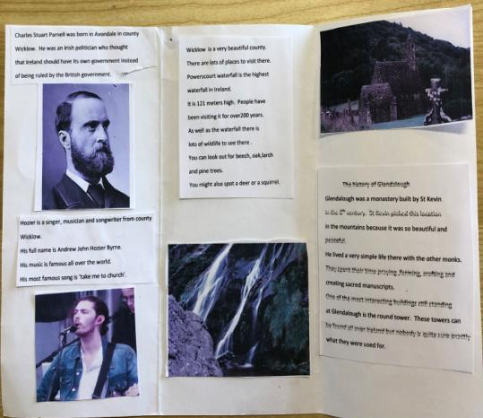
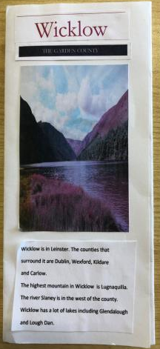

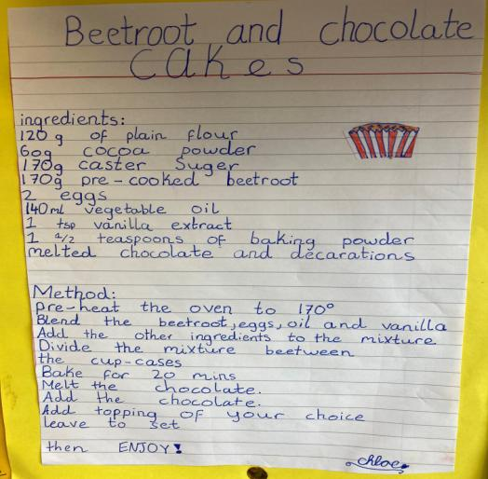
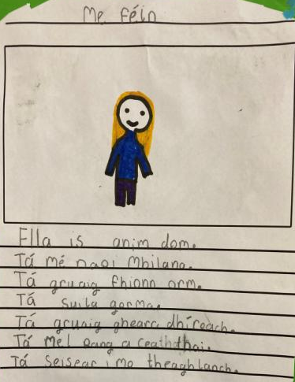
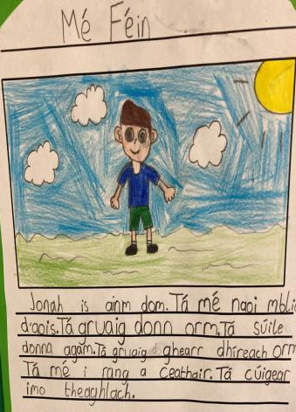
Recipe by Chloe Smyth and Mé Féin by Jonah MacCourt and Ella Molloy – all from 4th Class 2 (Arlene)

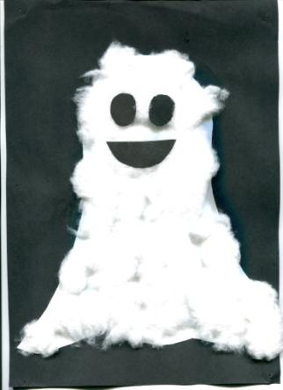
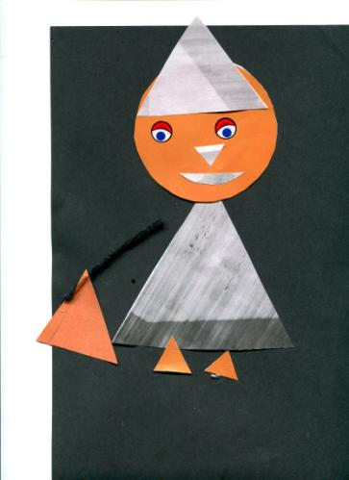
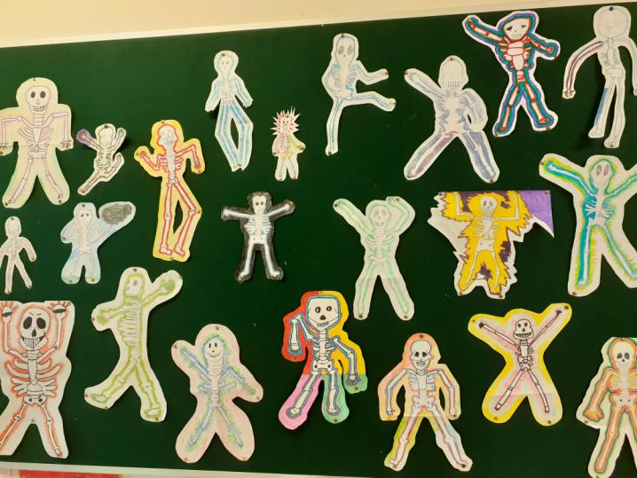
5th Class drew their own ‘dancing’ skeletons – here are just a few samples
Outreach 2 (Sharon C.) were looking at shapes recently, and in keeping with the theme of Hallow’en they made witches out of triangles and circles. Here is Alison O’Neill’s lovely witch. They also made ‘scary’ ghosts during an art lesson, and this lovely one was made by Tymek Kryszewski.

