(Dec.2020)

www.nketns.ie

**NOTES FROM THE PRINCIPAL’S DESK**

This has been a unique and unprecedented term. Looking back over the newsletter we sent this time last year, with references to a Christmas concert, talent shows in the hall and the annual Christmas hamper collection, it seems to have come from a very different time and place.

However, despite the unusual circumstances, the school reopened in September and has remained open ever since. This is a testament to the contribution of a large number of people. I want to pay tribute to and thank each group in turn.

Firstly our parent body who have cooperated fully with all the revised procedures and done so with good humour and understanding. Thank you to the parents who have kept their children out as a precaution and to those who have promptly taken their children to be tested when required. Thanks also to the parents who have kept us informed of things like test results even when the school was not directly concerned; the more information we have the better we are able to reassure parents that everything is in hand.

Thanks to the Board of Management for meeting throughout the summer to get everything ready for the reopening and for staying on top of a rapidly changing regulatory environment as the term has worn on. Thanks to the PTA for continuing to meet remotely and for their creative response to our fund-raising challenges culminating in the beautiful calendar that went home recently and the impressive prizes obtained for our Winter raffle.

Thanks to the school staff for adapting quickly to new working practices and getting on with it in a spirit of positive engagement for the benefit of the children. They have managed to make school an enjoyable place for children to be and to learn in spite of the obstacles that Covid-19 has placed in their way.

And finally, thank you to the children themselves. Ultimately a school is there to serve the children who attend it and this is particularly true in an Educate Together school which prides itself on being child-centred. They have shown great resilience and resourcefulness in coming to terms with a new way of being in school. It’s truly wonderful to hear the rooms, corridors and yard resound again with the sound of children’s voices after the eerie silence around the building from March to June.

So I hope everyone will have an enjoyable and relaxing and safe Christmas break. The new ways of being in school are probably going to be with us for most of this school year but hopefully with the commencement of the vaccine programme a return to normality may not be too far away.



I wish you all a very happy Christmas and hope 2021 will be filled with happy times. See you all on Wednesday January 6th @8.35.am.

PAT

**IMPORTANT NOTICE** – We wish to remind parents that during low temperature/icy weather conditions the roundabout leading to the school can be treacherous to drive on! Even when temperatures are above freezing, the roundabout area still remains very icy – so please drive with extreme caution upon approach from St. Wolstan’s Community School, and again when leaving the N.K.E.T.N.S.

**Dates for your Diary**

* As mentioned in our email of 19th November, having received guidelines from the Department of Education & Skills and parent teacher meetings will not be held face to face this year in the traditional way. Instead you will be receiving a phone call from your child’s class teacher. This will take place during the month of February and you will still receive advance notice of the date and time of the call.

**PHOTOMONTAGE**

Thanks to Peter for coordinating the photomontage which showed children at work and at play in their classrooms. It gave a good idea of what life is like within the school walls while parents are temporarily being kept outside.

**2ND CLASS MUSICAL**

Peter’s 3rd Class never got to do their 2nd class musical last year because of the lockdown. However, this year they became the first class in the history of the school to record their musical and send it home in digital format. Thanks again to Peter for all the work he put in to produce this socially distant production!

**CURRICULUM MEETINGS**

The curriculum meetings for JI, 1st, 3rd, 5th and 6th classes went online this year. It’s never too late to send in a question by email if there is something you weren’t sure of after watching the presentation.

**BIKE RACKS**

Thanks to Shaun Smyth (Chloe, 4th Class Arlene; Toby 1st Class Aoife) for getting his company BAM to supply new bike racks for the school. When these are installed they will significantly improve our capacity to park bikes and scooters.

Meanwhile, we just found out that our application for bike racks through An Taisce has also been approved! Thanks to Caterina MacNamara (Caleb, 4th Class Arlene and Megan, JI Lydia) for her help in processing this.

**HELPERS**

Carrie Martin – thanksgiving 4th 1

**GARDEN GROUP**

Thanks to Duncan Murtagh (Owen 2nd Class Sharon; Kieran JI1), Sarah Kelly (Will, 2nd Class Sharon), Helena McMahon (Ruairi, 5th Class Sinéad) and Caroline Leech (Aibhe, 1st Class Aoife and Aisling, JI Jenny) for reactivating our gardening group. They have done trojan work on cleaning up the class gardens and preparing them for planting in the spring, guided by Fiona Knox.

Thanks also to Duncan’s mother for her generous donation of bags of compost to be spread on then class gardens.

**SCHOOLBAG POST**

On the odd occasion, we need to send notes via your child’s schoolbag – in particular those that have a ‘reply slip’ attached. We would like to remind parents to **check your child’s schoolbag at least once a week** to ensure that you do not miss any notices from the school.

**TEXT ALERT/EMAILS**

Please ensure that you notify the school office if you change your mobile number. In order for the text alert communication system to work effectively, it is necessary to ensure we have up-to-date mobile numbers. Likewise if you changed your email address(es).

If you have changed email address recently, please inform the school office to update our records. Please remember to check your email regularly, to ensure you do not miss news/information from the school.

**MUSIC WEEK 2020**

Music week 2020 took place in the classrooms mainly as communal vents in the school hall are not possible for the time being. Thanks to Susan and Andrew O’Brien (Reuben, 2nd Class Sharon; Aileen and Eliana, JI Lydia) for the wonderful recordings of songs they sent in for the children to view. It was a creative way to get around the problem of parents not being able to come in to the classroom. Around the school there were class talent shows, dancing and listening to music and we also had NKETNS radio over the intercom each day with the songs chosen by 6th Class.

**GREEN NEWS**

During the festive season, don’t forget to hold on to any wasted batteries, old mobile phones/chargers (Smart phones only) and printer cartridges and bring them into school for our various recycling banks.

Keep an eye on your local newspapers for details of where you can bring your Christmas Trees after the festivities are over for shredding and recycling.

**GO RAIBH MAITH AGAIBH…..**

Science Week pencils & rulers for 1st-6th classes – John Regan (Finian, 1st Deirdre; Theo, JI Jenny)

Hi-vis vests for children – Mark Cribbin (Dylan, JI Lydia)

**HEAD LICE**

For the first time ever in the history of the school we have had no head lice reported during the first term! Clearly social distancing has some positive unexpected side effects.

**AMBER FLAG**

In May this year we advised you of the wonderful news that NKETNS had been awarded the Amber Flag by Pieta House. The Amber Flag is an award which recognises the schools commitment to promoting positive mental health.

We took delivery of the actual flag this term and are extremely proud to display it in a prominent position on the railings outside the main school door. The flag, and our involvement with the Amber Flag initiative, is a reflection of our commitment to supporting the mental health of all in our school community. In these unprecedented times we are mindful of the importance of this and we look forward to developing and maintaining the many initiatives which run in the school to support this.

**SCIENCE WEEK 2020**

We had a very busy Science Week in November. The children did lots of different STEM projects, repurposing plastic bottles, natural thermos flasks, magnetic boards, bird feeders, parachutes, walking on balloons, dancing raisins, making cars with motors, building houses, to name but a few of the activities. We also had Zoom presentations from John Regan and Frank Mullaly. The children thoroughly enjoyed them and thank you very much. Third and Fourth class had a Zoom science quiz, thank you Bearach.

**SCHOOL INFECTIONS**

We would like to remind parents to let us know if your child becomes ill with a contagious infection e.g. chicken pox, measles, impetigo etc. **It is necessary for us to inform parents of other children in your child’s class to be aware of such an infection, and to avoid it spreading throughout the school**.

Please ensure that **your child brings their towel into school each day**, and don’t forget to change the towel regularly.

**HEALTH & SAFETY NOTICE**

For reasons of health and safety we would like to remind parents and guardians **that no medication of any kind is to be brought into school in children’s schoolbags**. These include strepsils, calpol fast melts, cough sweets, lozenges, medicated creams etc. In keeping with our medication policy – no medicines of any description are allowed

in schoolbags. It is not possible for staff to monitor the consumption and possible sharing of over-the-counter medications and is therefore a health and safety issue. **Please DO NOT send in any medicated products with your child, to protect all pupils.**

**Please DO NOT send your child to school if they are feeling unwell BEFORE we open, particularly if they have been vomiting or feeling nauseous the previous night.** Your child may transmit their illness to the entire class and/or the class teacher. Your cooperation with this request is appreciated.

**BOARD OF MANAGEMENT NEWS**

VOLUNTARY CONTRIBUTIONS – The Board of Management would like to thank all parents for your financial support for this year. The voluntary contributions by means of standing orders give us a guaranteed income and open the door to raising money via the tax refund scheme. If you wish to contribute to your school this way, please contact the school office for a Standing Order Form, or you can also give by cash or cheque. We have noticed an increase in both standing order mandates and one-off contributions since our appeal in November and this really helps to keep the school’s finances on a secure footing.

STAFF CHANGES -

The Board would like to thank Deirdre Conway who is a shared special education teacher based in St Thomas’s Junior School in Lucan for covering First Class 1 for the last five weeks of the term. Deirdre agreed to change the dates she was due to come to NKETNS this year and to take on the class so they would not have a succession of short-term substitutes during that period. As previously notified to parents, Eoin Lally will be teaching the class after Christmas for the remainder of the year.

Thanks also to Karina Retief for filling the position of support teacher working mainly with 5th Class for the past five weeks. This position will be filled after Christmas by Elaine Barry who has worked in NKETNS before in a number of different roles.

The Board would also like to congratulate both Kelly Fitzsimons and Lisa Sutton, each of whom had their first babies around the beginning of the term.

**N.K.E.T.N.S. PARENT TEACHER ASSOCIATION UPDATE DECEMBER 2020**

Unbelievably, it is the end of the first term in what has been a very strange year! We as a PTA had a slow start to the year due to the cancellation of several our early fundraising events. However, our most sincere thanks to the whole school community for firmly backing our most recent events. Without your support and generosity, none of this would be possible.

Our **Cash for clothes** took place on the 4th December and over 500kg was collected. The event raised just over €200. Thanks to you all for your donations, we are sure it helped with the clear out in time for the holidays.

The **NKETNS 2021 calendar** went on sale early in December. We have had a fantastic response to the calendar. Although the calendar is quite different this year, your feedback has been amazing. Our sincere and heartfelt thanks go to Michael Grubka (photographer/ parent) who year on year spends a lot of time designing, photographing and producing this calendar and has completely excelled himself under the current circumstances. The calendar really does look amazing and will be a special memory of this year. Our thanks also to Castletown Press for coming onboard to print our calendar this year. There are still a few calendars available to purchase, please contact [office@nketns.ie](mailto:office@nketns.ie) if you require additional calendars.

Our Winter Prize Draw took place on Friday 18th December. The support for this event was huge! We had a vast array of wonderful prizes this year and our thanks to Vivienne O’Connor (Finn 1st Aoife) and her mum Lorraine for securing most of the prizes. Our most sincere thanks go to the following people/businesses for donating the prizes: Maynooth Book Shop, The Glenroyal Hotel Maynooth, Westgrove Hotel Clane, Michelangelos, The Orchard, Absolutely Fabulous Flowers, The Learning Lab, Dehli Darbar, Da Marios, Straffan Antiques, Burren Smokehouse, Rye River Brewery, Avoca, Elle No.5, Leonidas Chocolate Maynooth, Shoda Maynooth, Nally’s SuperValu Celbridge, Excel Dry Cleaners, Get Creative, Dough Bros Pizza, Maynooth Chocolate Bar, Leah’s Sweets and Treats, Louise B’s Cakes, Eddie Rockets Celbridge, Joanne Caffrey at Avoca, Chemco Chemists, Margaret Higgins for the Erin Hampers Hamper. Our sincere thanks to anyone who left in/donated prizes for our draw. Thanks to you all for your generosity. Together we raised over €2300!!

We are not working too far ahead with events at the moment, due to the on/off periods of restrictions. We are working on ideas and will communicate with everyone again in the new year regarding events.

Thank you so much for your ongoing support. We hope you have a fantastic holiday and let’s hope 2021 is a good one! Please contact us at [nketnspta@gmail.com](mailto:nketnspta@gmail.com) or visit our NKETNS PTA Facebook page.

Letterwriting in 6th Class by Grace Duffy

In 6th class over the last few weeks we wrote to different authorities. Some people wrote to Pat or our teacher, Áine, and some wrote to local representatives, like Michael Coleman and Ida Cussen. We wanted to change something. I asked Celbridge Community Council if we could have a skate park in Celbridge.

One of the boys named Daire wrote to Sweden to a gaming company called Mojang to improve he Xbox version of Mindcraft. We got so many great responses from different people. I highly recommend writing to them.

We even got to go on a Zoom call with local Labour Councillor Ciara Galvin who is proposing a motion to encourage the use of reusable face masks in Celbridge, on our behalf, at the next Council meeting!

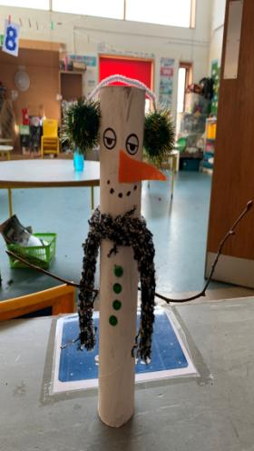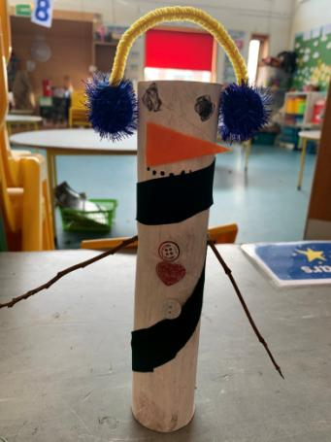Senior Infants 1 (Hannah) were busy making snowmen. Here are samples of just two from Stefano Sellors (L) & Cian Sheridan (R).

Amazing stair work from children in 5th Leo Laoise, Ruairi, Shane, Oisin and Holly with Karina!

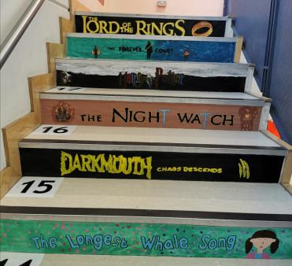

Stair Art - written by Ruairi Connell and Karina.

This project was inspired by a love for books. We had to think about our favourite book, which included audio books. Once we picked a book that we loved reading or listening too, we could design our own book spine. The first thing we had to do was to measure the step risers. Then we found some old wallpaper, we measured it and cut it out into strips, that would fit onto the steps. We were now ready to paint our background. Once the background dried, we traced the words onto the background, which left an indent, so we could see it. We had a lot of fun using very fine paint brushes to paint the words on. Some of us stuck some pictures onto the strips as well. When they were fully dry, we used double-sided sticky tape to attach the strips to the stairs. Now it looks like we’re walking up a stack of books when we use the stairs.

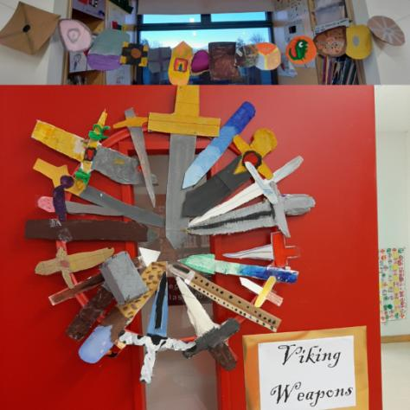

Peter's 3rd class worked very hard to construct Viking longboats and weapons after learning about the Vikings in History.

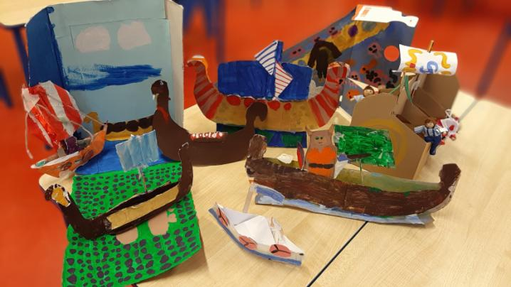

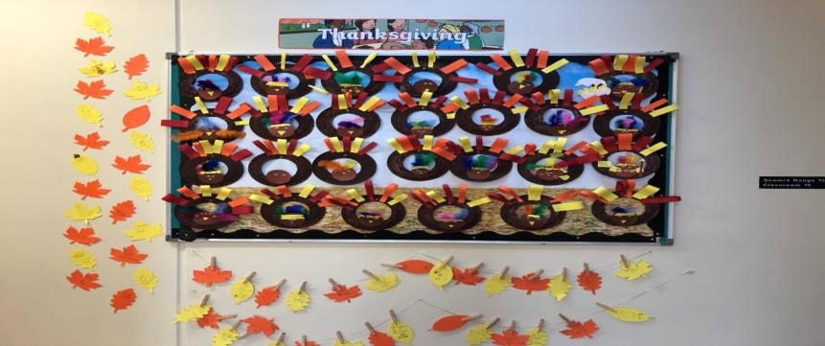Thanksgiving display with thanks to Carrie Martin (Emer’s Mam!) and Sa Bhaile 3D art by 4th Class 1 (Ronan)

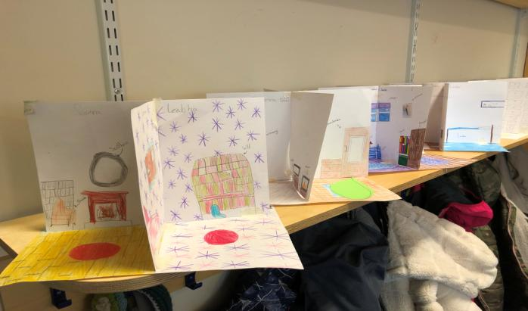

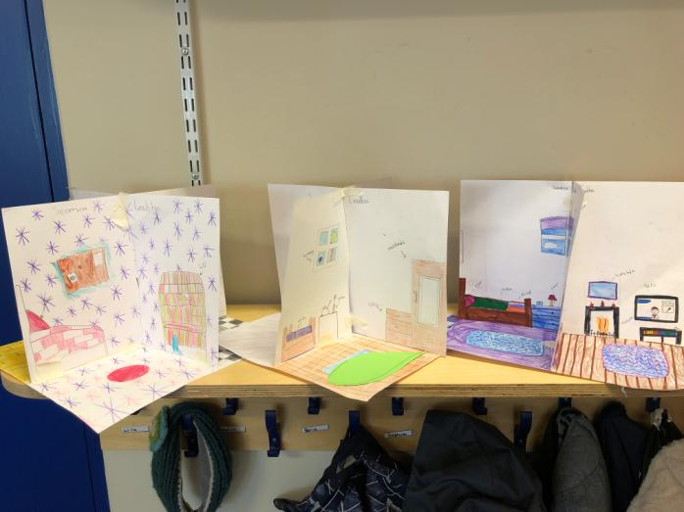

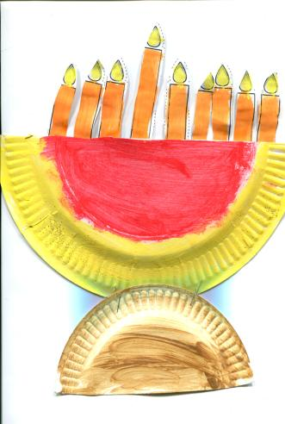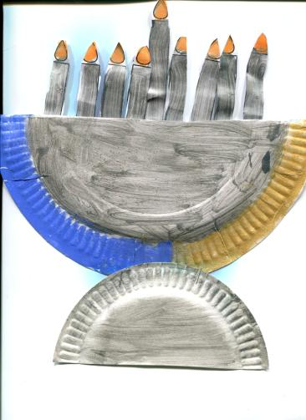

Senior Infants 2 have been very busy with their letter writing and artwork. Here are some samples

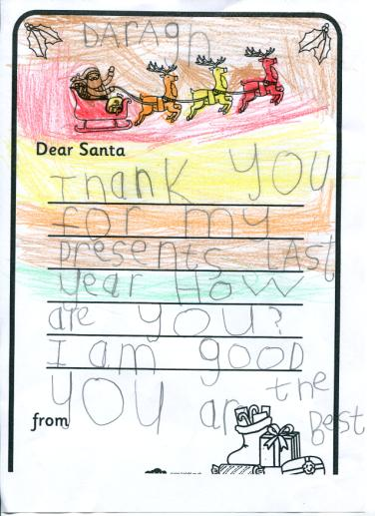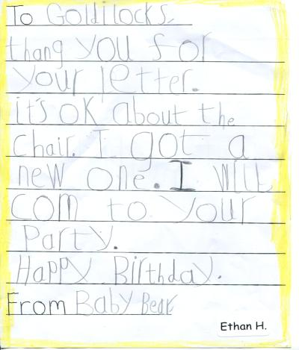Menorah candles by Smilte Gerulyte (L) and Rebecca Morris (R) and letters from Ethan Healy and Daragh Morgan

Junior Infants 1 (Jenny) have been learning all about Hanukkah. We drew pictures of menorahs. A menorah is made up of 9 candles. The candle in the middle is used to light the other 8 for the eight nights of Hannukah. Here are pictures drawn by Fatima Lotya, Michael Brennan, Robyn Harraghy, Danny Aliaga-Kelly, Cillian Allen and Craig Mullany.

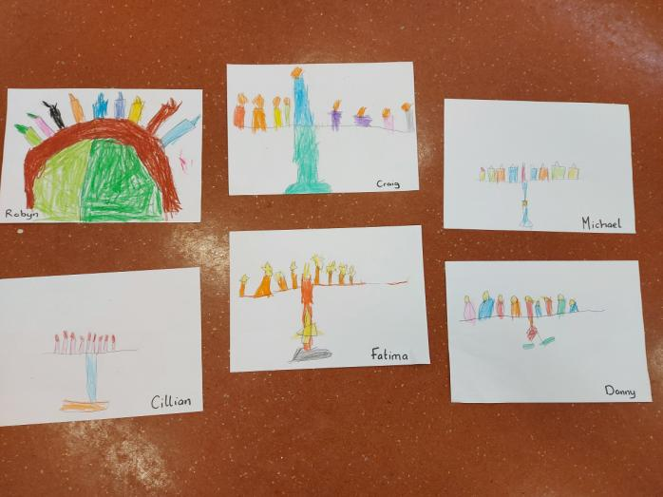

2nd Class 1 (Sharon) were learning about nocturnal and diurnal animals and created some snowy owls. They were also learning about wild and domesticated cats. Here are some lions that we drew by listening to and following directions.

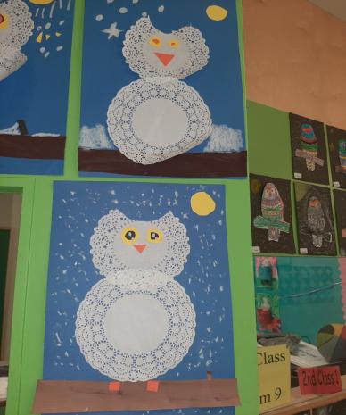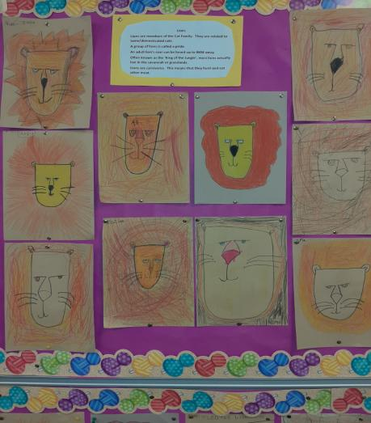

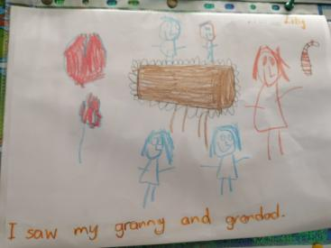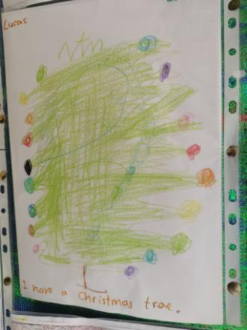

This is Junior Infants 2 news for the week of 14th December

with a close up pictures of Lucas, Austin, Lily and Dylan’s news.

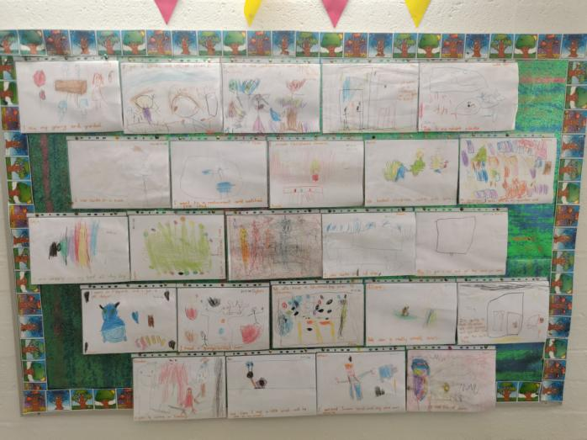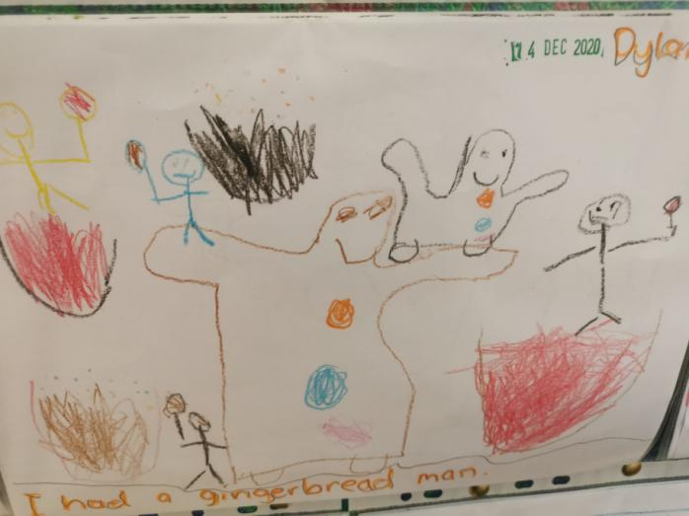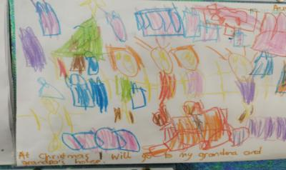

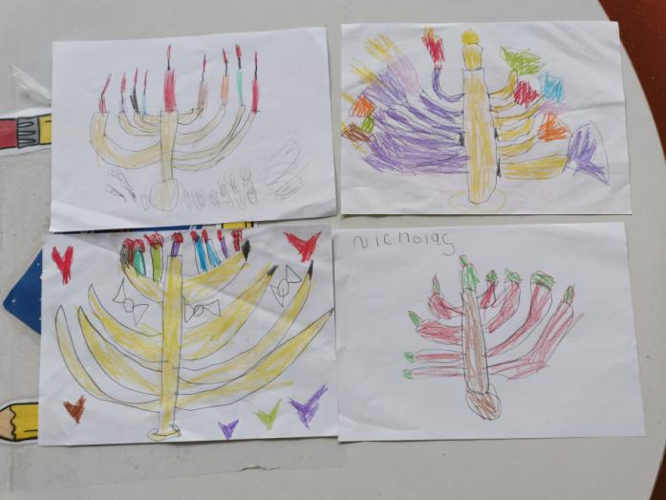

These are Hanukkah Menorahs beautifully drawn by Ethan, Aileen, Nicholas and Philippa from Junior Infants 2 (Lydia).

Christmas artwork by Outreach Class 2 (Sharon) Joshua O’Flynn’s Philip Treacy inspired hat (1st 2)

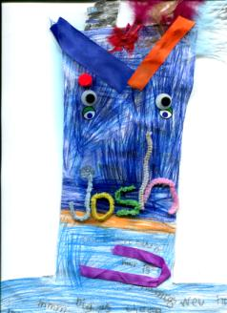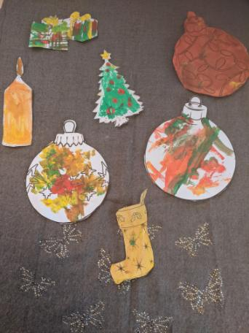

3rd Class 1 (Bearach) winter arkwork.

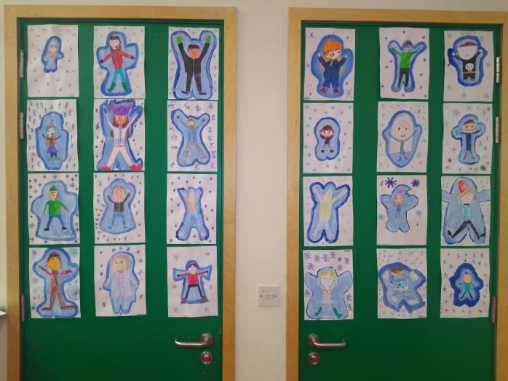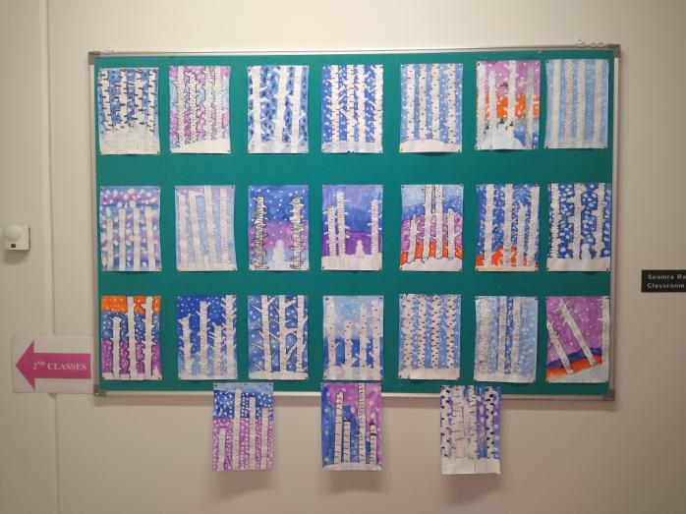

And they're off!

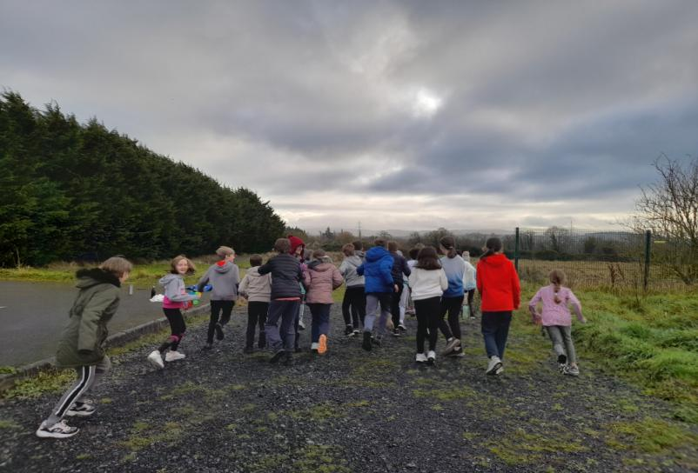

5th Class Focus Ireland Cross Country Run (written by Zach Field)

In school we are learning about homelessness and we wanted to help them by donating money. So, on Friday the 11th December we rang a cross country and in total our whole class ran 48,600 meters which is 48.6 kilometres. That’s longer than a marathon! The deadline to donate is Friday the 18th December so it would be able to be given in time before Christmas. All the money will be donated and counted on Monday the 21st of December to Focus Ireland. During the run we all had to dodge puddles and muck but all of it was worth it because it was a good thing that we were doing. I ran 1.8 kilometres which is 6 laps with my friends. We all really enjoyed the run and we hope to do another one in the future.

Medusa comic strips and personalised decorated masks geom 5th!

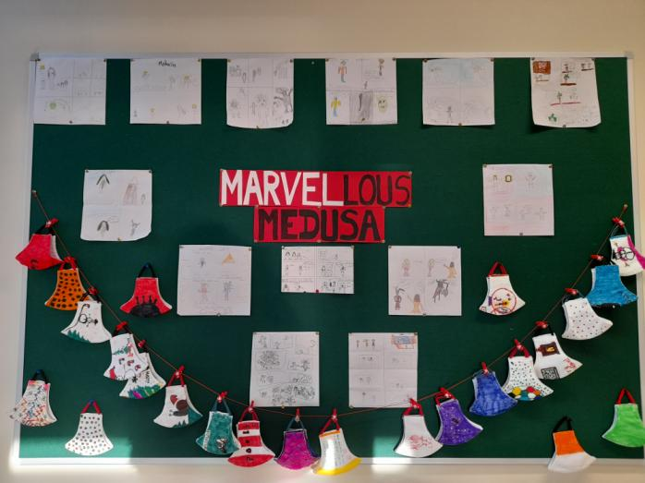

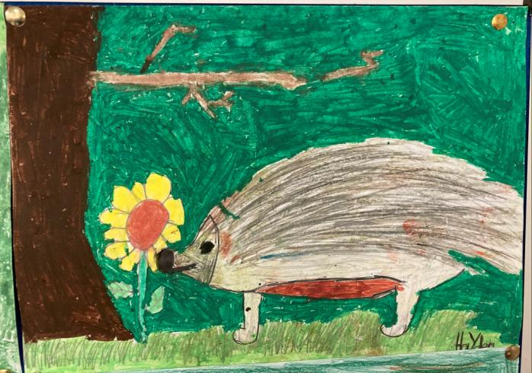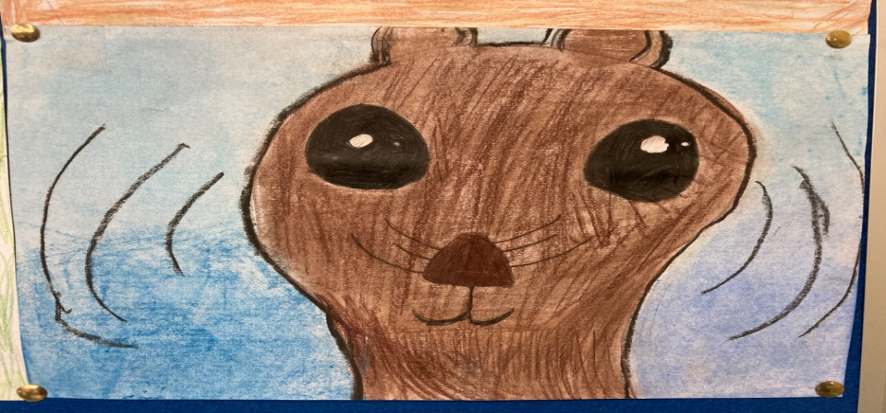

**Irish Wildlife** Haydn Gregor, Tanmay Pardeshi and Eabha King

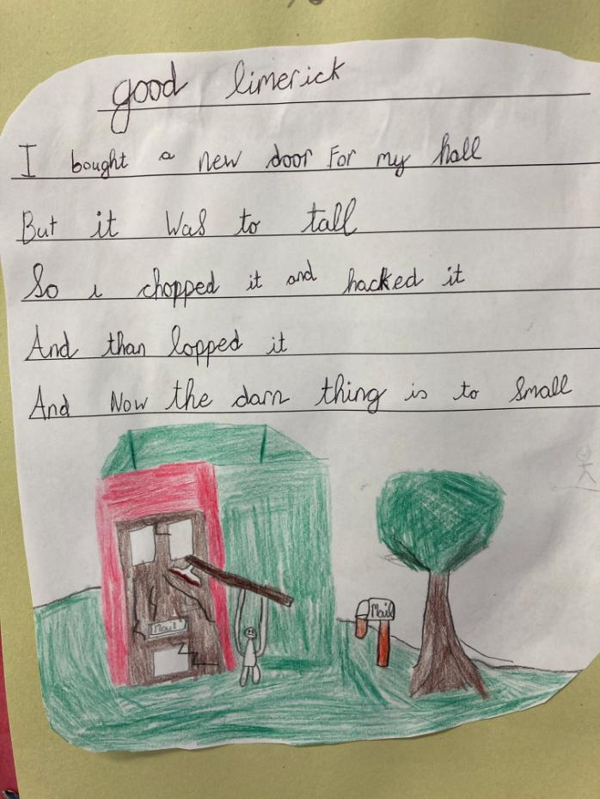

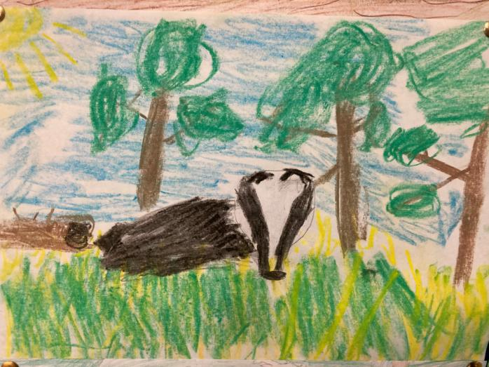

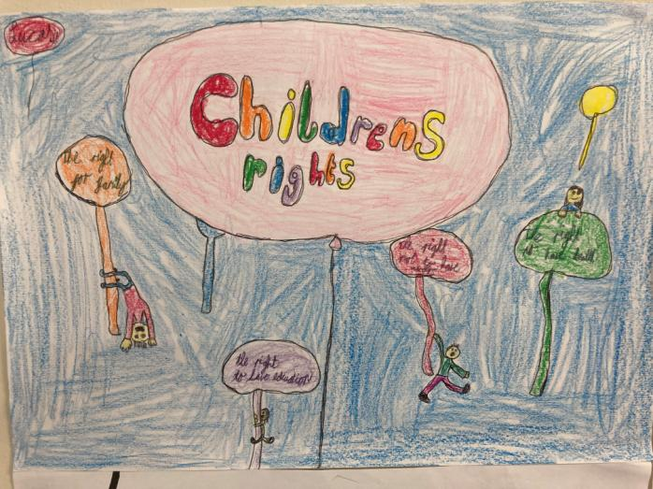

**Limerick** Sean Glasmacher (4th 2)

**Children’s Rights poster** Lucas Smith (4th 2)

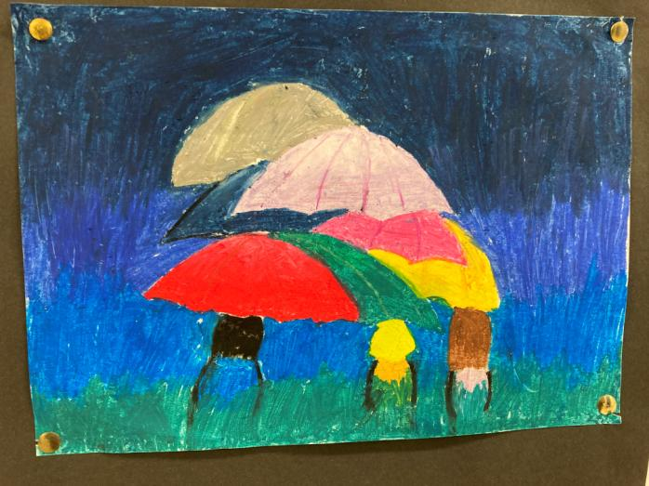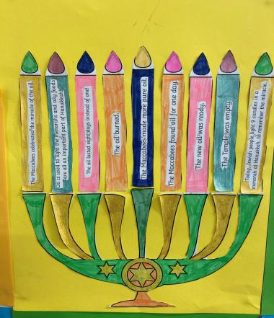

**Renoir Umbrellas** Keanna McKibbin, Nessa O’Neill, Sofia Farrelly (4th 2)

**Hanukkah** Luca Sellors (4th 2)

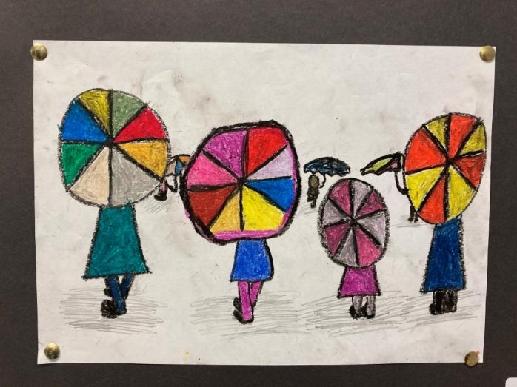

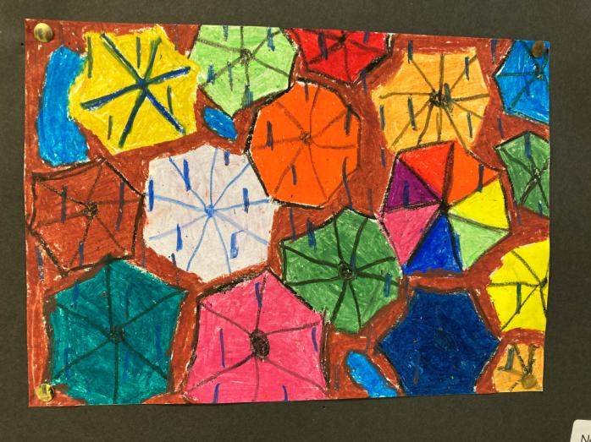

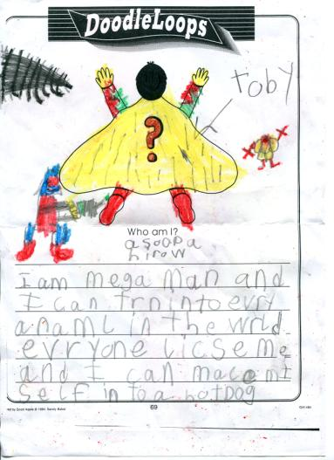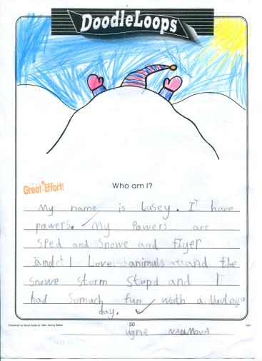

Free Writing by Toby Smyth (1st 2) and Ugne Naumova (1st 1)

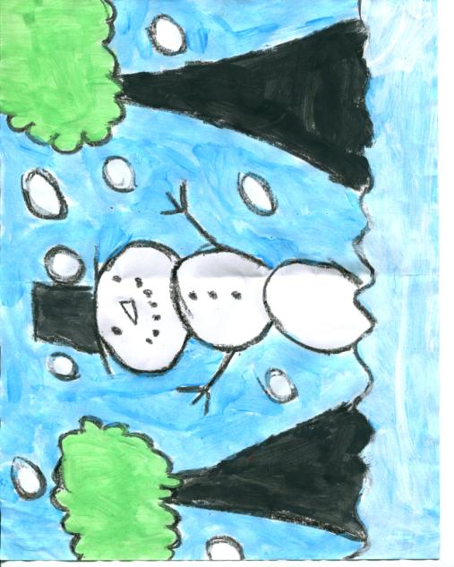

Snowman by Aoileann O’Rourke (1st 1)