Week 9 25/05-29/05
Hello everyone 😊 We hope everyone is keeping healthy and safe.This week you will be able to use some of your books, if you haven’t got them yet the pages are below.
As always, these are guidelines, so all we ask is for you is to do your best.
Orlaith, Mary & Ronan 😊

Monday | Gaeilge: Abair Liom lch 140-141 . Practice saying and finish the sentences at top of page. Is breá liom______Bainim taitneamh as bheith ag, Tá mé go maith ag___  An dtaitníonn_______ leat? Taitníonn/ Ní thaitníonn  Maths: Practice Tables on www.topmarks.co.uk. Division Planet Maths book p143 B1-8 E1,4,8.  English: Spellings Wk: 29  Poetry: Read how to write a Limerick below. Quiz-answer q’s 1-5  History: 18th Century Ireland: Powerpoint slide 1-4 (sent by email)
Tuesday | Gaeilge: Abair Liom lch 142. Léigh an scéal agus freagair na ceisteanna 1,2,3  Maths: Mental Maths- next day. Planet Maths p144 A1-5 B1,3,5  English: Spellings- Wk 29.  Poetry: Practice writing a Limerick. Quiz-answer q’s 6-10  History: 18th Century Ireland: Powerpoint slides 5-9  P.E.: Obstacle course: Create your own obstacle at home. See if someone in your family can complete it. Draw a diagram of the layout of the obstacle course if you wish.
Wednesday | Gaeilge : Abair Liom lch 142.Léigh an scéal agus freagair na ceisteanna 4,5,6  Maths: Practice Tables on www.topmarks.co.uk . PM p.145 A1-5  English: Spellings Wk 29.  Poetry: Write out the finished version of your Limerick and decorate it.  Geography: Counties of Ireland- Can you label all the counties in Ireland? Use your Atlas book to help if you need it.  Well being Wednesday: “Mind your Mind”-Mindfulness colouring sheets (sent by email)
Thursday | Gaeilge: Abair Liom 143 Léigh an comhrá  Maths: Mental Maths- next page. PM p 145 B 1,3,5  English: Spellings Wk 28. Handwriting Book- next page  History: 18th Century Ireland: p148-149 Book  Art Powerpoint- Exploring Famous Images-Look at the wonderful paintings created by famous artists. (sent by email)
Friday | Gaeilge: Tarraing 3 pictiúr. Is maith liom ____________  Maths: Practice Tables on www.topmarks.co.uk .  English: Spellings Wk 28.  Geography: Counties of Ireland- Can you put the counties into their correct Province? Leinster, Munster, Connacht, Ulster.  Art Powerpoint- Exploring Famous Images-Choose one of the images and re-create it using your own materials of choice-paint, crayons, markers, pencils..  P.E.: https://platform.imoves.com/users/login Register for free trial use. Choose age group suited to you. Have fun trying out the exercise videos 😊

We are inviting all classes to send some art work to the school website which will be displayed altogether. We will choose a different theme each week. This week the theme is “What we have started to notice around us during lockdown”. If you want to take part this week email a picture of your artwork to website.nketns@gmail.

How to Write a Limerick
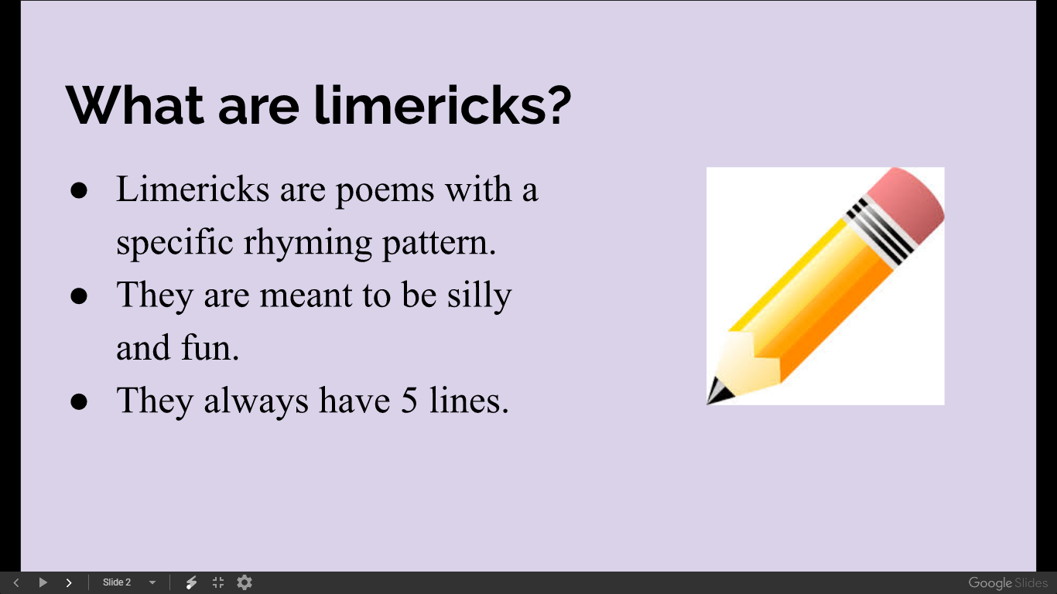

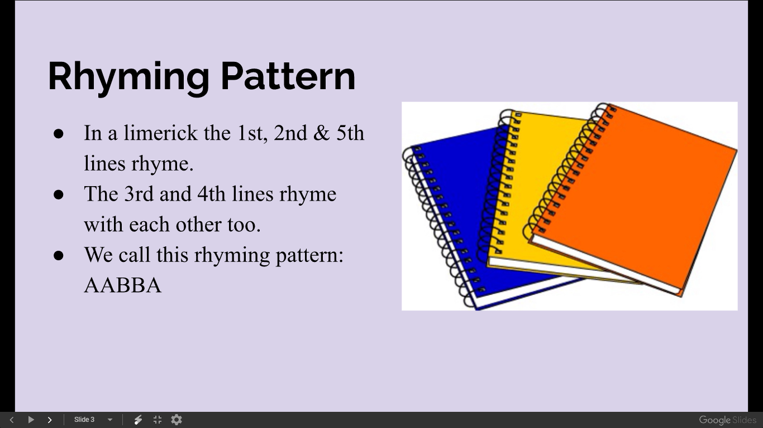
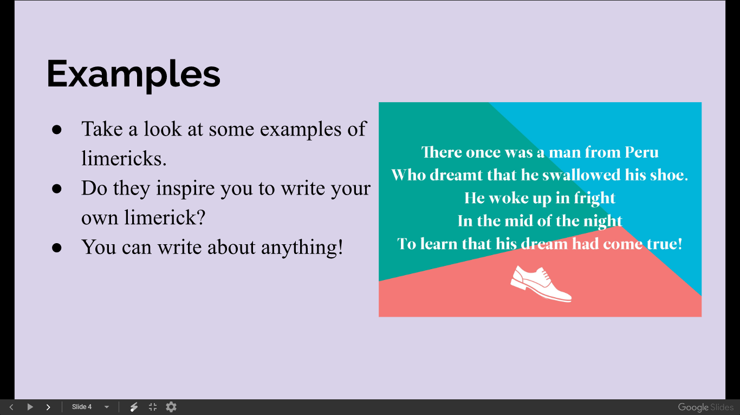
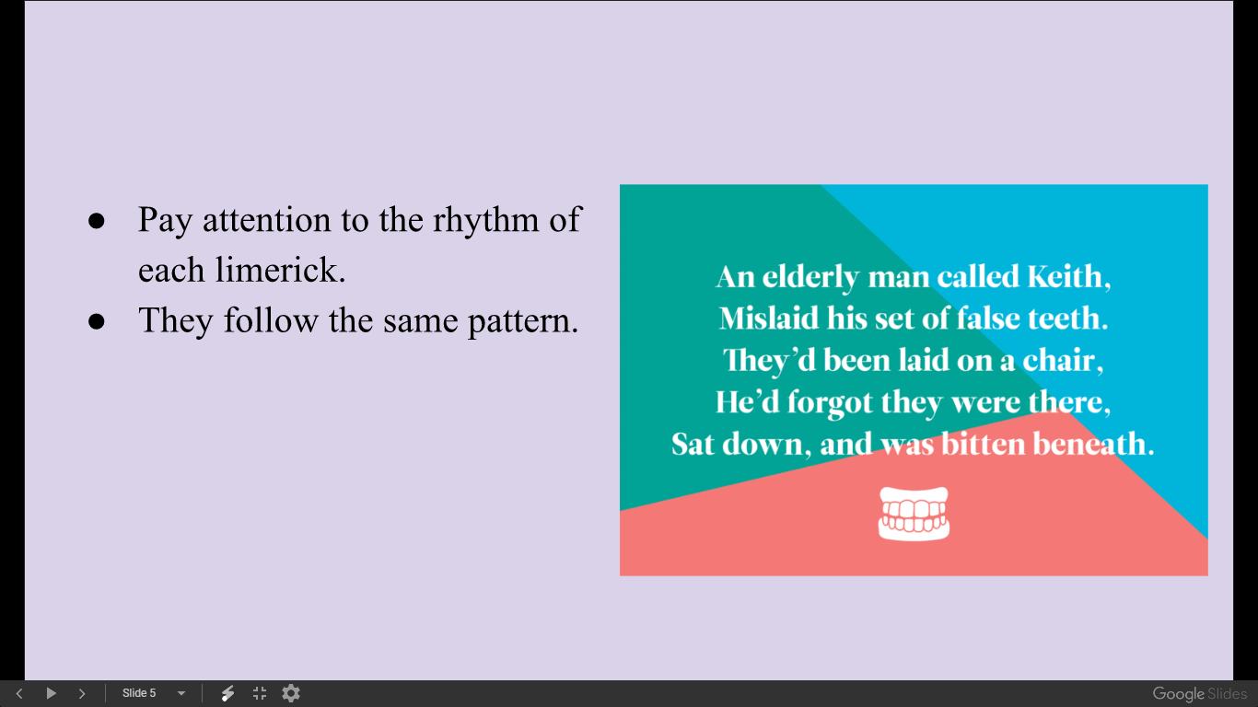
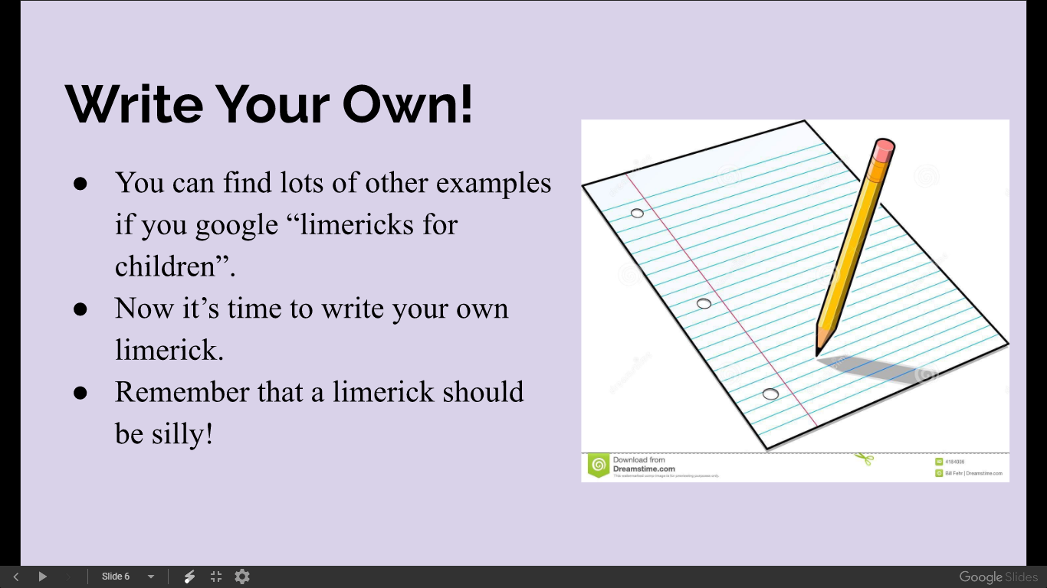
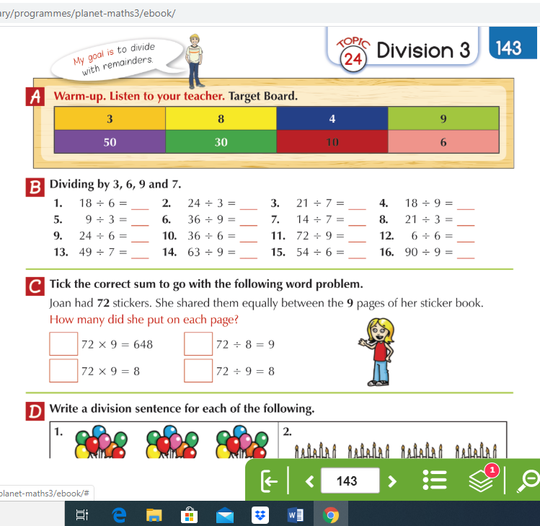

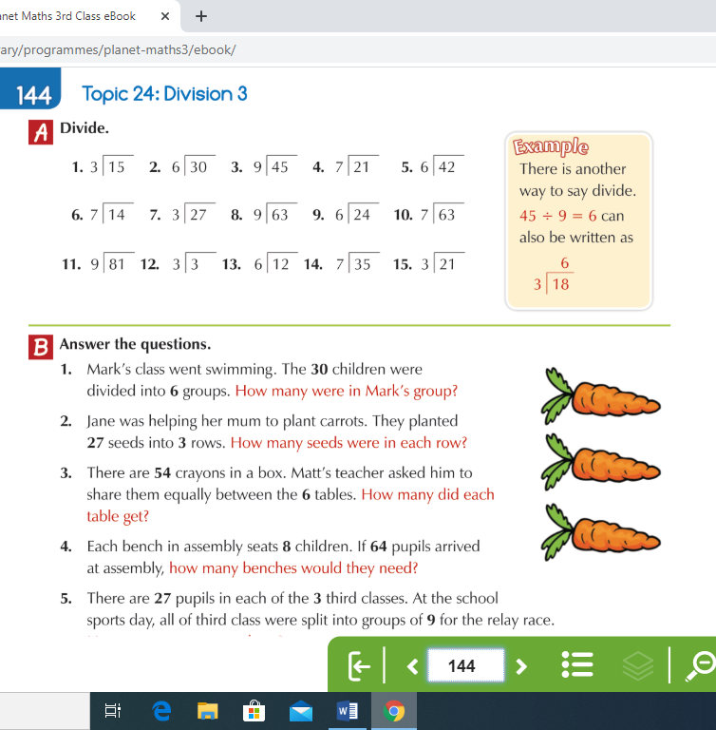
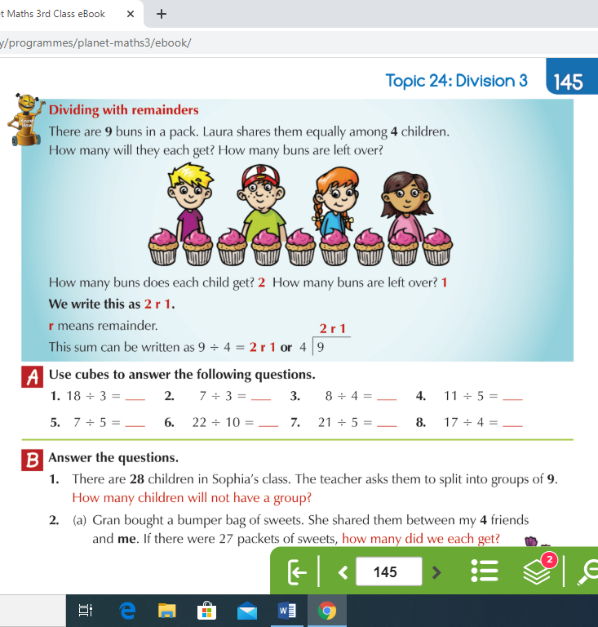

Quiz Time
- Who was the first woman to fly solo across the Atlantic Ocean?
- What is the capital of Finland?
- What is the only mammal that can fly?
- Who won the Premier Leagues Golden Boot for scoring the most goals last season?
- What county has won the most All-Ireland championships?
- Name two planets that begin with M?
- In Snow White which dwarf doesn’t have a beard?
- What colour is an emerald?
- In Star Wars what type of creature annoys Chewbaca?
- What river flows through Rome?

Quiz Answers
- Who was the first woman to fly solo across the Atlantic Ocean?
Amelia Earhart.
- What is the capital of Finland?
Helsinki
- What is the only mammal that can fly?
A Bat
- Who won the Premier Leagues Golden Boot for scoring the most goals last season?
Salah
- What county has won the most All-Ireland championships?
Kerry
- Name two planets that begin with M?
Mars and Mercury
- In Snow White which dwarf doesn’t have a beard?
Dopey
- What colour is an emerald
Green
- In Star Wars what type of creature annoys Chewbaca?
Progs
- What river flows through Rome?
The Tiber

