Week 9
Hi Everyone,
Hope you are all well and keeping busy. This week I have used book pages as you have your books at home now. This week the art topic for the gallery website is “What you have started notice around you during our time at home”. Remember to send your pictures to website.nketns@gmail.com I’m looking forward to seeing them in the gallery. I’m looking forward to reading your projects. I have nearly everyone’s favourite colours. I have included two worksheets for transition to secondary school this week (abbreviations and two timetables) One timetable is for classes 40 minutes long and the other is for hour long classes. If you have any questions about secondary transition, let me know in your emails. Have a good week.
Take care and keep safe
Arlene

Mental Maths – Week 25 English in Practice – p. 75 & 76 (Day 147 - 150) Spelling – Week 29 Tic Tac Toe – do any 3 from tic tac toe sheet in blue home copy or any previous Tic Tac Toe

Gaeilge – Briathra – Aimsir Fháistineach – Tabhair/Tar/Téigh (irregular verbs)
- Litriú – choose 4 sentences from litriú
- You can access these pages on the “Folens” website if you prefer
- You can also try the website Róbó, go to Ardleibhéal, Ócáidí Speisialta, Ag Fágáil Rang a Sé
- Watch TG4
- p. 118 Abair Liom
- p. 140 (I will miss…., but I’m looking forward to……..)
- p. 143 – roimh

Maths
Directed numbers
I’m sure you’ve heard of negative numbers. Negative numbers happen when it is less that zero. For example, you hear about temperatures being below zero, perhaps -4. That means it is 4 steps below zero. It might be under water, golf scores, bank accounts. Remember number lines?
Here is a number line with negative numbers
-6 -5 -4 -3 -2 -1 0 +1 +2 +3 +4 +5 +6
If I want to go from +3 to -2, how many steps would it be. Answer = 5

How did you get on with directed numbers?
Have a go at p. 140 in Planet Maths. For the golf question, when they say par (say 4) that means how many times you need to hit the ball to get it into the hole. Sometimes it takes more shots (say 5 shots, that would be +1 that is 1 more) or it may take less shots (say 3 shots, that would be -1 that is 1 less) Hope this helps. If you have a golfer in the family, ask them for a little help.
Here’s a challenge - Multiplication
It’s easier than you think
plus x plus = plus +5 x +4 = +20
plus x minus = minus +3 x -6 = -18
minus x plus = minus -2 x +7 = -14
minus x minus = plus -8 x -5 = +40
You don’t need the + sign, it’s just to show they are positive numbers, not an add sign. Take a look at p.139, give the challenge a go, if you want
I’ve put two worksheets if you want to have a try. You don’t have to do everything, maybe try one or two from each section

English
This week we are writing a story using the picture prompt below. I’ve put in a story planner as well to help with your planning.
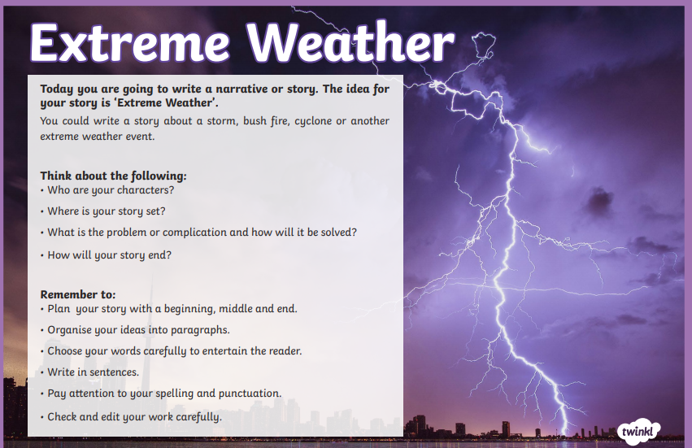
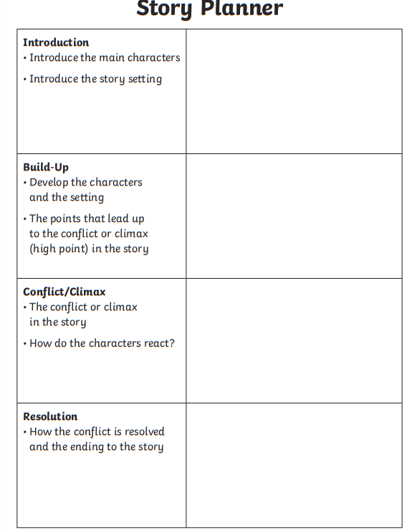

SESE – Research and write 5 facts about bees and 5 facts about butterflies. Draw a picture to go with each.

Music – revise graduation songs
- Dabbledoo

Art – This week the theme is “What you have started noticed around you during our time at home” Remember to email your art work to website.nketns@gmail.com

PE
- Continue with 2k a day, if you wish.
- lots of core exercises (you know what to do)
- GoNoodle
- Walking/Running/Cycling
- PE with Joe, The Body Coach TV 9am live on YouTube
- Dance
- Active Week activities

LT/Wellbeing/SPHE
- Try making a gratitude jar. Everyday write something you are grateful for on a slip of paper and put it in a jar.
- Help in the garden
- Play board games or cards
- Jigsaws
- Exercise
- Yoga
- Baking
- Helping at Home

Drama –
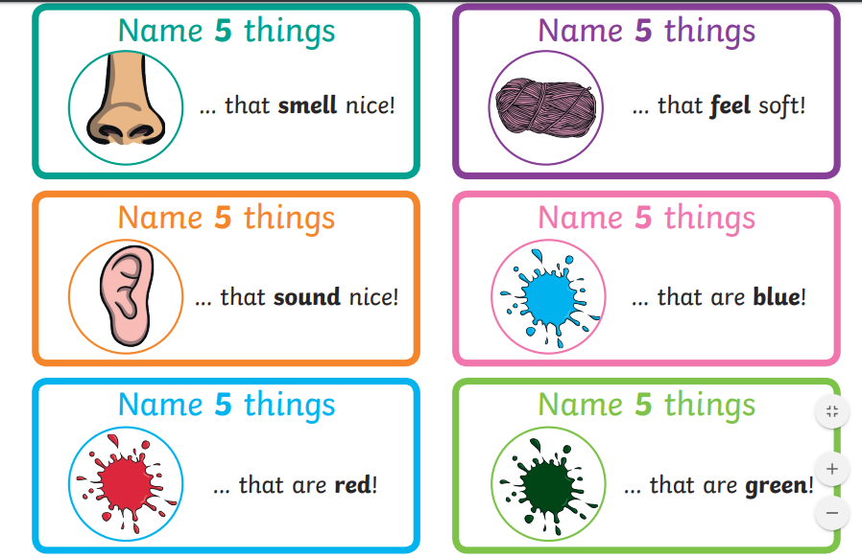

Useful Websites
- topmarks.co.uk
- Scoilnet.ie
- Séidéansí
- Twinkl
- GoNoodle
- Dabbledoo
- Website of the Day on school website
Answers to MM week 24, EIP Day 143-146 (p73+74), butterfly reading comprehension and the Maths pages are below.
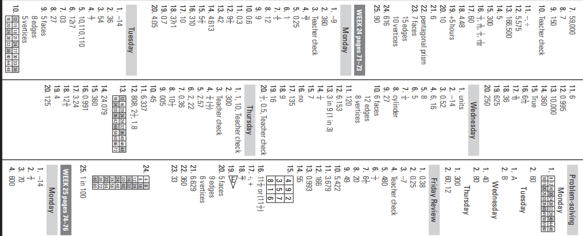
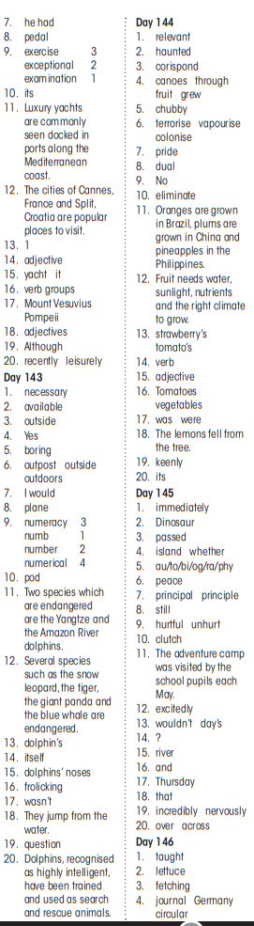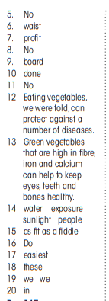

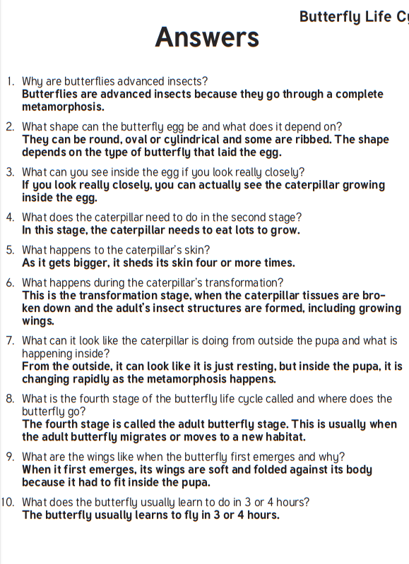

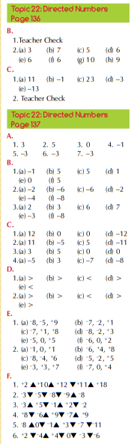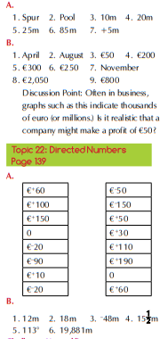

Abbreviations
The abbreviations in the first column below are often used as a short way to show subjects in a timetable. Fill in the full subject names in the second column.
NOTE: Sometimes teachers’ names are also included in an abbreviated form in a timetable.
SCI
HIS
GEO
FR
REL/RE
MTH/MAT
BUS/BST
HE
WW
MW
GAE
TG
CSPE
GER
MUS
IT
SPHE
ART
SP
PE
TECH
OPT 1/2/3

 | Monday | Tuesday | Wednesday | Thursday | Friday
8.55-9.05 | Tutor time | Tutor time | Tutor time | Tutor time | Tutor time
9.05-9.45 | ENG  Rm 33 | GAE  Rm51 | GAE  Rm51 | OPT 1 | PE  Gym
9.45-10.25 | SCI  Rm28 | RE  Rm 34 | SCI  Lab | OPT 3 | IT  Computer Room
10.25-11.05 | HIS  Rm31 | MTH  Rm24 | SCI  Lab | GAE  Rm51 | MTH  Rm24
11.05-11.20 | BREAK | BREAK | BREAK | BREAK | BREAK
11.20-12.00 | GAE  Rm51 | ENG  Rm 33 | MTH  Rm24 | GEO  Rm 19 | HIS  Rm31
12.00-12.40 | RE  Rm 34 | HIS  Rm31 | ENG  Rm 33 | ENG  Rm 33 | GAE  Rm51
12.40-1.20 | SPHE  Rm 44 | PE  Gym | CSPE  Rm42 | MTH  Rm24 | ENG  Rm 33
1.20-2.00 | LUNCH | LUNCH | LUNCH | LUNCH | LUNCH
2.00-2.40 | MTH  Rm24 | OPT 3 | OPT 1 | OPT 2 | GEO  Rm 19
2.40-3.20 | OPT 1 | OPT 3 | OPT 2 | OPT 2 | OPT 1
3.20-4.00 | GEO  Rm 19
Options 1: FR (Rm 21), SP (Rm 8), GER (Rm 14)
Options 2: HE (Rm 7), WW (Rm 3), MUS (Music Room), BST (Rm 42), MW (Rm 16)
Options 3: ART (Rm 13), BST (Rm 42), TG (Rm 11), TECH (Rm 18)
TIP: At the beginning of the year colour code your timetable and your books and copies
 | Monday | Tuesday | Wednesday | Thursday | Friday
8.30-8.50 | Caomhnoir | Caomhnoir | Caomhnoir | Caomhnoir | Caomhnoir
8.50-9.50 | SCI  Rm28 | CSPE  Rm42 | SCI  Lab | ENG  Rm 33 | PE  Gym
9.50-10.50 | HIS  Rm31 | MTH  Rm24 | SCI  Lab | MTH  Rm24 | GEO  Rm 19
10.50-11.00 | BREAK | BREAK | BREAK | BREAK | BREAK
11.00-12.00 | GAE  Rm51 | ENG  Rm 33 | MTH  Rm24 | HIS  Rm31 | OPT 1
12.00-1.00 | OPT 1 | OPT 2 | ENG  Rm 33 | OPT 3 | GAE  Rm51
1.00-1.40 | SPHE  Rm 44 | OPT 2 | GAE  Rm51 | OPT 3 | IT  Computer Room
1.40-2.40 | LUNCH | LUNCH | LUNCH | LUNCH | LUNCH
2.40-3.40 | GEO  Rm 19 | OPT 1 | PE  Gym

Options 1: FR (Rm 21), SP (Rm 8), GER (Rm 14)
Options 2: HE (Rm 7), WW (Rm 3), MUS (Music Room), BST (Rm 42), MW (Rm 16)
Options 3: ART (Rm 13), BST (Rm 42), TG (Rm 11), TECH (Rm 18)
TIP: At the beginning of the year colour code your timetable and your books and copies

