Tuesday | Maths:  - Planet Maths – p104 & 105 – Spatial Awareness.  - Rapid Fire Tables game. Challenge your opponent to a tables match. You see how many tables sums (addition or subtraction) you can correctly answer in 30 seconds and then see how many they can answer in the same time  - Try this online tables practice game. https://www.topmarks.co.uk/maths-games/hit-the-button  - Make a hopscotch outside with chalk on the ground and play hopscotch  English:  - Activity A – Alphabetical Order (at the end of the work list)  - Reading time – Read aloud to a parent for 5 minutes and read by yourself for 20 minutes.  Gaeilge:  - Abair Liom p 89 – Fill in the th words and try your best to pronounce them.  - See what you would like to buy from the toy shop (Siopa Bréagáin) on page 90 and 91. Maybe you could make a list of your favourite toys in Irish.  PE:  - Pick 3 physical activities to create your own PE lesson either inside or outside. You can choose things like stretches, games (like ship sea shore or cat and mouse), dances, running or jumping activities, throwing activities, gymnastics, yoga, etc.
Wednesday | Maths:  - Planet Maths pages 106, 107 and 108  English:  - Have a spelling Bee. Pick some spellings from the past few weeks. Maybe choose around 30 but don’t pick the really easy ones. Challenge yourself to learn them well and get someone to ask you them like a spelling competition. Maybe you could make yourself a medal or trophy for when you have completed it.  - Have some quiet reading time  SESE:  - Create a quiz for your family. Look up some questions and answers or make up your own. Maybe you could host your quiz with family or friends on zoom.
Thursday | Maths:  - Planet Maths P113  - Play a card game with your family  English:  - Write a short story about anything you like in your spare copy. You can choose your own ideas or pick from one of these:  - A space mission to another planet.  - The day I met my hero.  - What would I do if I was the president of Ireland?  Gaeilge:  - Abair Liom – page 95 Fill in the ua words and colour the pictures  - Activity B: At the end of the work list. Practice writing the days of the week in Irish
Friday | Maths:  - Planet Maths P114  - Practice telling the time, months of the year and days of the week.  English:  - Reading time – Read aloud to a parent for 5 minutes and read by yourself for 20 minutes.  - Put the following words into sentences:  - Flowers, supermarket, temperature, chair, grass, garage.  - Write an acrostic poem about yourself using the letters of your name (Example below)  - J - Just loves to have fun  - A – All day in the sun  - C- Crazy good at chess  - K – kicks with the right foot best  Music:  - Listen to some of your favourite songs.  - Play musical statues.  - Make up a dance to the music.
Additional  activities | Art Exhibition: The theme for the art exhibition this week is “Here Comes the Sun”. It is very appropriate for the weather we have been having.  Possible extra activities  - Do some gardening.  - Help cooking dinner.  - Play a game of charades with your family.  - Do a poster project on a topic of your choice.

Activity A: Alphabetical Order
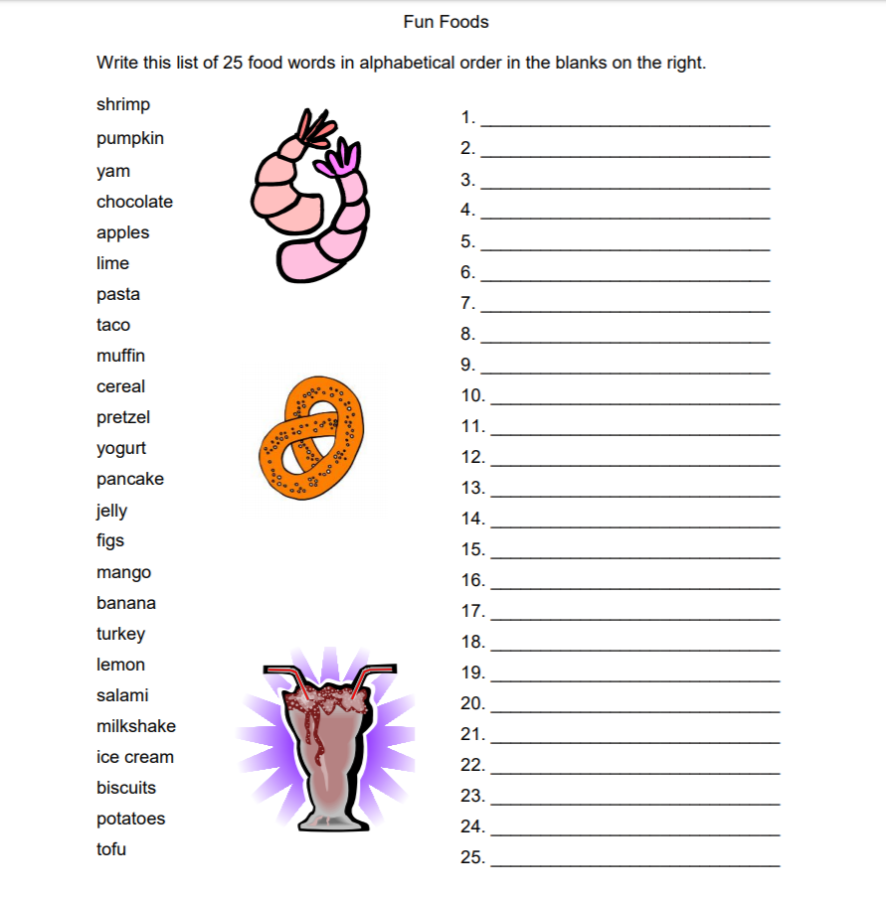

Activity B: Days of the week in Irish

