Monday  Hi everyone, I hope you all have a lovely bank holiday weekend. As it is a bank holiday, you have the day off work on Monday! Enjoy! Do something fun, something relaxing or just take a break. Well done to everyone who finished their New Zealand projects. It seems many of you enjoyed learning about this nation. The mountains and volcanoes were a popular topic of interest for many. Please continue to send me your news this week if you can. It’s great to hear how everyone is doing. If it’s a nice day you might decide to do less work or take the day off. That is ok! It’s great for you to get outside, play games, explore nature and have fun, especially if the weather is nice. I know there might be too much work here for some of you so I have highlighted in bold tasks you could do each day if you want to make them your priority or else keep doing what you have been doing. You may like the look of something else on the worklist and that is perfectly fine to do instead. Be kind to yourself and just do what you can and keep having fun! Have a lovely week boys and girls, you’re all doing wonderful things! Grace. | Bank Holiday – have fun!
Tuesday | Maths:  - Tables: https://www.timestables.com/ Select a table that you want to revise and complete the activities. Keep scrolling as there are a few activities to do.  - M.M week 26 Tuesday + Problem Solving page 79 (answers below)  - Operations Chapter 25 page 154-155 (can complete over the week) We have done a lot of practice multiplying and dividing numbers so a lot of this is revision for you and a chance to keep practicing these skills. (answers below)  English:  - E.P Day 76  - Spellings Week 29. L.S.C.W.C. Do a T.T.T activity this week.  - Reading: Summer wishes poem. (see below) Memorise v. 1 today  Email Task: Sun shape poem/ story/ word web. Create a poem or story about the sun or write words that you think of when you hear the word sun. Write any of these in a sun shape. Examples below.  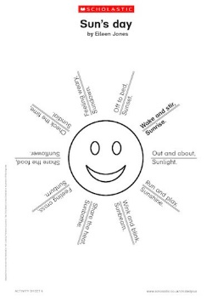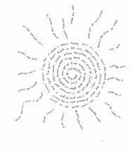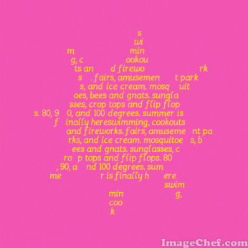  Gaeilge: Caitheamh Aimsire  - Léamh: Lch 151 Comhrá. The boys are playing football. Read the conversation, highlight and look up any words you don’t understand. Complete the activity at the end of the page where the verb has to be put first then the noun/ adverb etc. When the verb is used on its own “Tabhair pas dom,” it becomes an order “Pass it to me.” “Rith go tapa,” “Run quickly,” etc.  - mí-ádh ort- unlucky you/ hard luck  - bá bheag ná scóráil tú pointe- you missed a point  - beir ar an liathróid- catch the ball  Music  - Listen and sing to The Beatles classic 1969 song “Here Comes the Sun.” The songs name is our website gallery theme for the week!  https://youtu.be/xUNqsfFUwhY (lyrics below)
Wednesday | Maths:  - Tables: https://www.timestables.com/ Select a different table to practice today  - M.M week 26 Wednesday + Problem Solving page 79  - Operations Chapter 25 page 154-155 (can complete over the week) (answers below)  English:  - E.P Day 77  - Spellings Week 29. L.S.C.W.C. T.T.T  - Reading: Summer wishes poem. (see below) Memorise v. 2+3 today  - Handwriting Practice. Next 2 pages in your handwriting book. Only use pen if you are confident to.  Gaeilge:  - Lch 150 C. Remember “is___,” means the most or the greatest amount.  - Is tapa- the quickest/ the fastest  - Is sine- the oldest  - Is óige- the youngest  - Is fuaire- the coldest  - Is teo- the hottest  - Lch 150 D.  - I bpreabadh na súl (in the blink of an eye)  - ruaille buaille ( mayhem/ bedlam)  Wellbeing:  - Continue to write in your gratitude journal: Write 3 things (full sentences) that you are grateful for this week and explain why.  - Kitchen paper towel mindful colouring. Have fun using different textures of kitchen towel/ toilet roll to create some beautiful mindful pieces of art by colouring in the indentations.
Thursday | Maths:  - Tables: https://www.timestables.com/ Select a different table to practice today  - M.M week 26 Thursday + Problem Solving page 79  - Operations Chapter 25 page 154-155 (can complete over the week)  English:  - E.P Day 78  - Spellings Week 28. L.S.C.W.C. T.T.T  - Reading: Summer wishes poem. (see below) Memorise v. 4 today  - Listen to this week’s audio again where I read Chapter 6 and 7 of “Sideways Stories at Wayside School.” Answer the comprehension questions below based on this chapter.  Gaeilge: Lch 154 or lch 155. Read Caitheamh Aimsire Aoife agus Dhaithí. Read scéal Aoife. Then you can choose to fill in Daithí’s scéal or do your own on lch 155.  Science: Stem – Forces  - Water pushes upwards with a force called ‘upthrust’. (You can feel this if you try to push a light object such as a balloon under water). The shape of a ‘boat’ affects the weight (passengers/cargo) it can hold. The more water that the boat displaces the more it will float and therefore the more weight it can take.  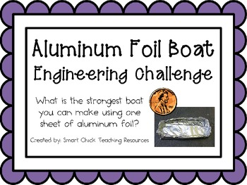  - Using only tinfoil see how strong you can make your boat by adding as many coins, lego etc. to it before it possibly sinks.
Friday | Maths:  - Tables: Give yourself a Friday test using the tables you covered this week (e.g. x7, x8, x9, x12)  - M.M week 26 Friday Review pg. 79  - Operations Chapter 25 page 154-155 (can complete over the week) (answers below)  English:  - E.P Day 79  - Spellings Week 28. Type your spelling words for your test (write if you can’t type).  - Reading: Summer wishes poem. (see below) Recite it all today (4 verses.)  - Reading and comprehension: Why Drink (see below)  Gaeilge:  - Briathra worksheet below. Use your briathra book to help. Remember to check the verb, the tense and the person before writing your answers.  - Continue with Duolingo today. Topics to explore are: Basics 1, Basic 2, Phrases, Food, Animals, Plurals, Clothing  S.P.H.E:  - “Food and my Body,” worksheet (see below) Our bodies are precious machines and it is so important that we fuel our bodies with a balanced diet. Create a healthy menu for the day for yourself. I’d love to see what you come up with, so send me your menus or photos of what you make for the day.
Websites to explore:  Topmarks: Play numeracy and literacy games (7-11 years) e.g. division, multiplication, spelling, reading games etc.  National Geographic kids  Séideánsí.ie  Cúla4  GoNoodle  Storylineonline  Cosmicyoga  Nketns.ie |  | Additional Activities:  - Baking/ cooking  - Make slime  - Mindful Colouring / Painting  - Create a drama  - Write a script  - Free play with sand/ water etc.  - Play board games  - Do puzzles  - Lego  - Tidy bedrooms/ playrooms
Tic Tac Toe
ABC ORDER: Write all your spellings in alphabetical order | X3: Write all spellings 3 times each. | Rainbow Spelling: :​  : Write spelling words in large print. Trace the words 3 times in different colored crayon | Definitions: Write 8 spelling definitions
Synonyms or Antonyms:​ Write 8 spelling words. For each one write a synonym or antonym for that word (for example, enormous- huge) | Illustrations:​ Choose 8 spelling words and draw a picture that illustrates the meaning of each word. Write the word below the picture | Making words: Choose 3 spelling words and write them across the top of your paper. List at least 15 words you can make using only the letters from the 3 spelling words. | Short Story:​ Write a story that uses 10 spelling words. Underline each spelling word you use.
Silly Sentences: Write a sentence for 8 spelling words, using alliteration. Underline the spelling words. For example: The purple porcupine played painfully with the possum in Polly Park. | Pretest:​ Have an adult read each spelling word for you and give you a “spelling test.” Then correct it. The adult who gave you the spelling test must sign the paper. | Word search: Make a word search that contains at least 8 spelling words. | Type it:​ Type all spelling words on your computer and print it out.
Acrostic:​ Choose a spelling word and write an acrostic poem using its letters. | Cut-Ups:​ Make 8 spelling words out of cut-up newspaper and magazine letters. | Sailboat:​ Choose 10 spelling words. Write them in a sail shape. E.g.  t  th  thi  this | Red and Blue:​ Write all words. Use a red for the vowels and a blue for the consonants.
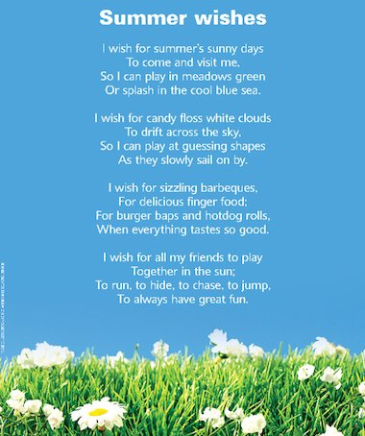
English: Poetry

Music: Here Comes the Sun Lyrics

English: Sideways Stories from Wayside School Comprehension Questions for Chapter 6, Bebe and 7,Calvin
- Describe Bebe in your own words using the information given in chapter 6.
- How many pictures had Bebe drawn in art class?
- Where did Calvin have to go with the note? What was the problem with the note?
- What advice did Louis give Calvin?
- What was the message for Miss Zarves? What did Calvin receive as a reward for being the messenger?
- Explain what you would have done with the “note,” if you were Calvin.
Gaeilge: Briathra
An chéad réimniú
- We will leave (fág) _________________________________ _______an dioscó ar a deich a chlog.
- I stay (fan) _______________________________________________ sa leaba gach Satharn!
- They will write (scríobh) ________________________________________ litir chugat amárach.
- He fills (líon) ________________________________________ ________an buicéad gach lá.
- We didn’t run (rith) _________________________________ sa chlós ag am lóin.
Briathra neamhrialta :
Be careful here. Remember these are IRREGULAR VERBS. They don’t follow either of your glance card rules. They are verbs we need to be familiar with and eventually learn off. Use your briathra book to help.

- I heard (clois) __________ ______________________________an madra ag tafann inné.
- We will hear (clois) __________________________________ an amhrán amárach.
- I hear (clois) _____________________________________ na héin ag canadh gach maidin.
- I was (bí) __________________________________________________ ag snámh inné.
The aimsir láithreach for the verb (bí) has two options.

- Use tá for the verb “to be right now.” Tá ocras orm anois. I am hungry now.
- Use bí when you are saying “to be all the time.” Bím ocras gach lá. I am hungry every day.

- I am (bí) _____________________________________________ i mo chónaí i gCill Droichead anois (now)

English: Comprehension- Why Drink?

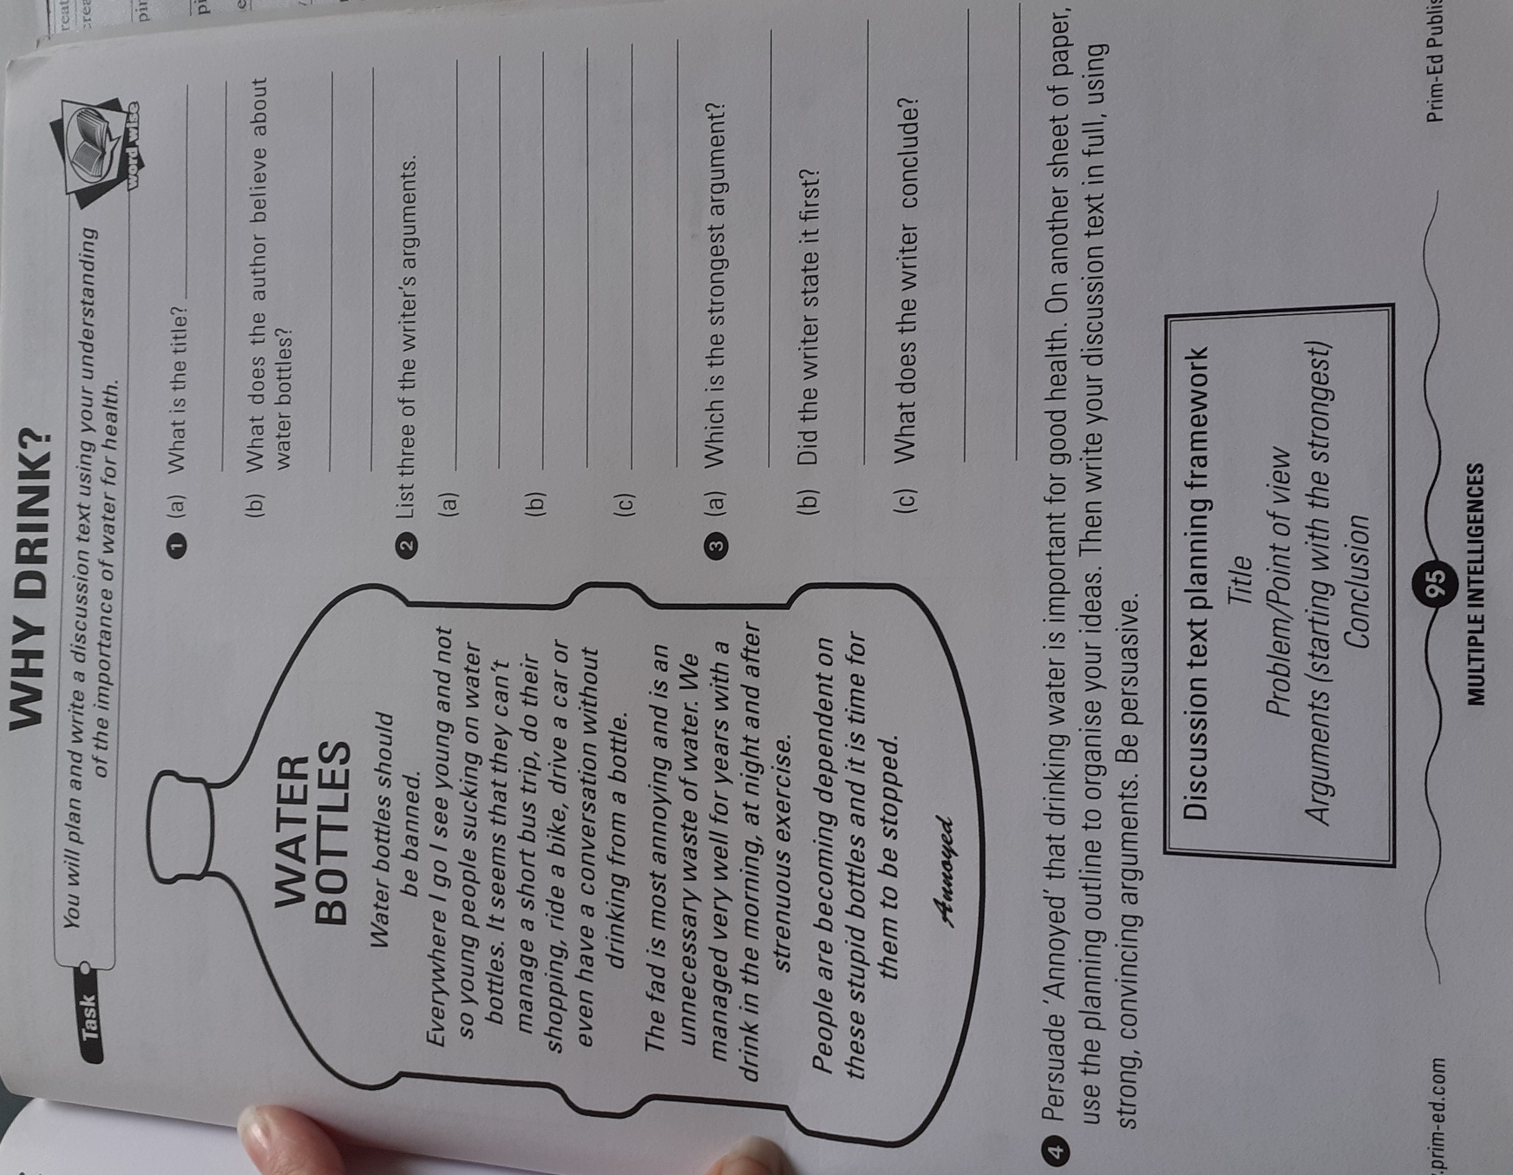

S.P.H.E:
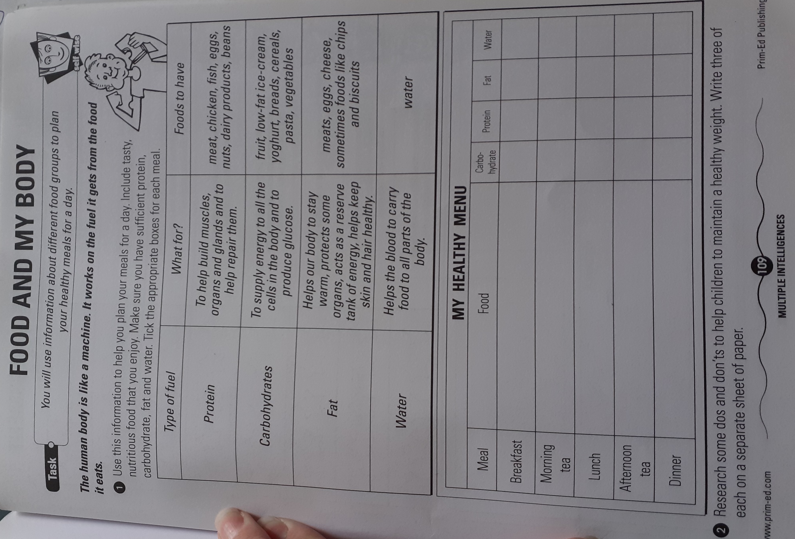

Maths Chapter 25 Answers:
English: Sideways Stories from Wayside School Comprehension Questions for Chapter 6, Bebe and 7,Calvin Answers
1. Bebe Gunn is a girl with brown hair, a little beebee nose, totally tiny toes, and big brown eyes. She was the fastest drawer in Mrs. Jewls’s class. She could draw a cat in less than forty-five seconds, a dog in less than thirty seconds and a flower in less than eight seconds.
2. Bebe drew three hundred and seventy-eight pictures in art class.
3. Clavin had to go to Miss Zarves on the nineteenth floor with the note. The problem with the note was that there was no note.
4. Louis told Calvin “You are not supposed to take no notes to no teachers. You already haven’t done it.”
5. The note for Miss Zarves was to tell Miss Zarves not to meet Miss Jewls for lunch. Calvin got a Tootsie Roll pop as a reward.
6. (own choice)
Gaeilge: Briathra Answers

An Chéad Réimniú
1. Fágfaimid | 2. Fanaim | 3. Scríobhfaidh siad | 4. Líonann sé | 5. Níor ritheamar
Briathra neamhrialta :

1. Chuala mé | 2. Cloisfimid | 3. Cloisim | 4. Bhí mé | 5. Tá mé

M.M answers

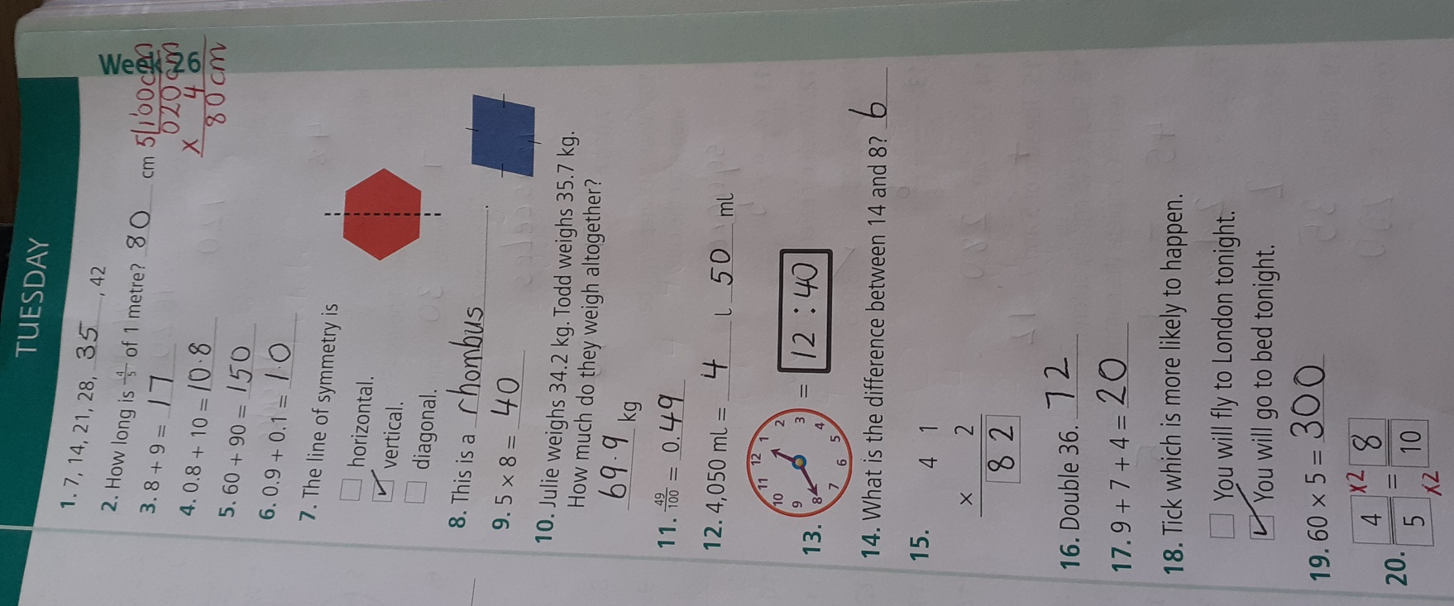

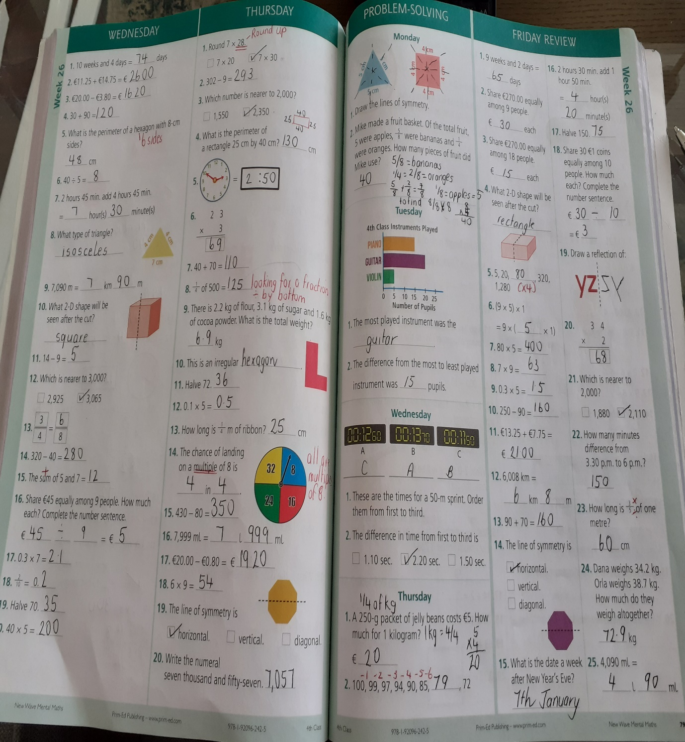

E.P Answers

