Week 9
Hi Everyone,
Hope you are all well and keeping busy. This week I have used book pages as you have your books at home now. This week I would like you to send me your favourite recipe from your time at home and the speech you would like for graduation. (English and Speeches) The art topic for the gallery website is “Here comes the Sun” (Art) Remember to send your pictures to website.nketns@gmail.com I’m looking forward to seeing them in the gallery. I have included a worksheet for transition to secondary school this week and the timetables (you can use which one suits best) If you have any questions about secondary transition, let me know in your emails. Have a good week.
Take care and keep safe
Arlene

Mental Maths – Week 26 English in Practice – p. 77 & 78 (Revision) Spelling – Week 30 Tic Tac Toe – do any 3 from tic tac toe sheet in blue home copy or any previous Tic Tac Toe

Gaeilge – use resources on Folens website Abair Liom H – An bhliainiris
- Abair Liom lth 144 + 145
- Briathra – AC/AL/AF – Abair/Beir/Bí (use worksheets and p.128)
- Abair Liom lth 128 (Bí)
- Two worksheets (Abair agus Beir)
- This is revision
- An Aimsir Chaite – inné (past, yesterday, last night, last week, last month, last year)
- An Aimsir Láithreach – gach lá (present, every day)
- An Aimsir Fháistineach – amárach (future, tomorrow, next week, next month, next year)
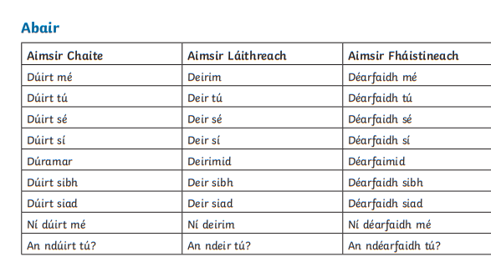
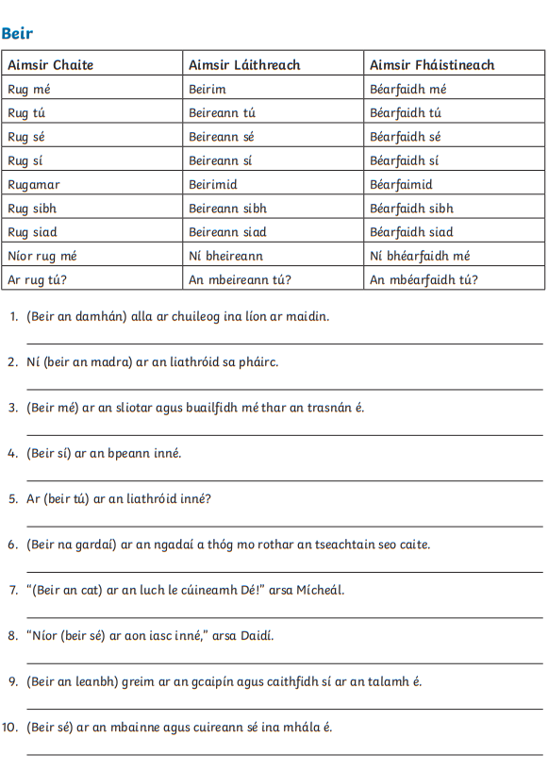

Maths
Do you remember averages? Add all the numbers together and divide by how many digits(numbers) there are
What is the average? 6, 9, 8, 2, 5
6+9+8+2+5 = 30 then, 30 ÷ 5 = 6 The average is 6
Try p. 174-176
Remember you don’t have to do them all, do a few from each section
For example, p.174 B1 a,d,g B2 a,c,e B3 and so on
Do you remember these ones? P.174 Q1
The average of 3 numbers is 20. 2 of the numbers are 16 and 21. What is the third number?
This means that 16 + 21 + ? = 60 Where did I get the 60 from? If the average of 3 numbers is 20 then the total of the 3 numbers added together must be 60 because 60 ÷ 3 = 20 (see blue part above)
16 + 21 + ? = 60
37 + ? = 60
? = 23, the third number is 23
If you would like a challenge, try p.177 (optional)

English
This week I would like you to write out your favourite recipe from your time at home and send it to me, Our Lockdown Cookbook
Remember
- Ingredients
- Method
- Picture

SESE – 10 facts about summer
Music – revise graduation songs
- Dabbledoo

Art – This week the theme is “Her comes the Sun” Summer time art. You could use the summer art we did before or a new picture. Remember to email your art work to website.nketns@gmail.com for display in the school gallery.
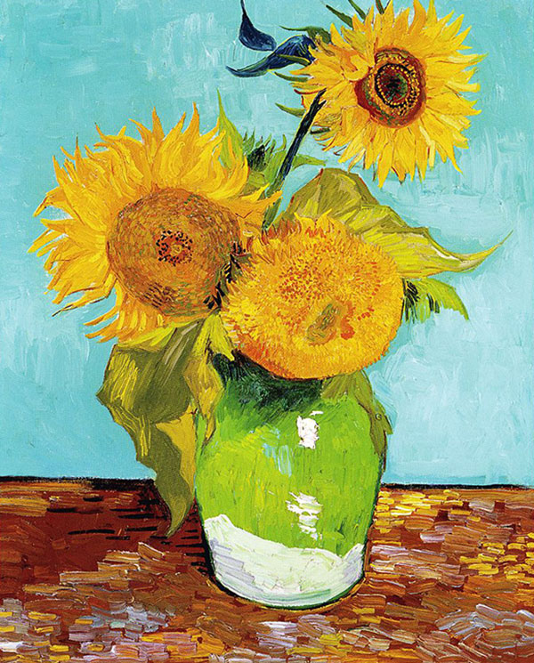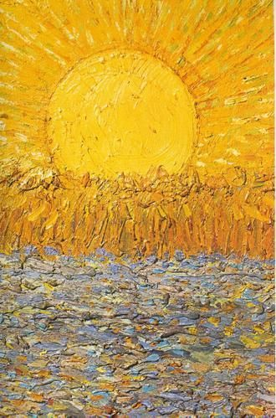
Sunflowers La semeur
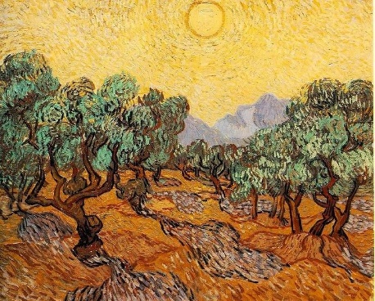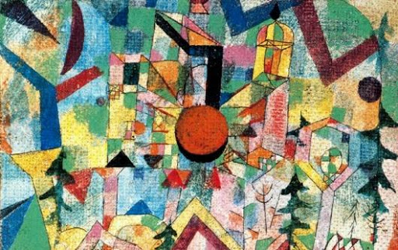
Olive trees with yellow sky and sun Castle with setting sun
PE
- Continue with 2k a day, if you wish.
- lots of core exercises (you know what to do)
- GoNoodle
- Walking/Running/Cycling
- PE with Joe, The Body Coach TV 9am live on YouTube
- Dance
- Active Week activities

LT/Wellbeing/SPHE
Transition worksheet – timetables are at the end
Reading a Timetable
- At what time does school start?
- How long are classes?
- At what time does first break begin?
- How long have you got for first break?
- At what time does lunch break begin?
- How long is lunch break?
- At what time does school finish?
- Are there any “early finishes”?
- How many days a week do you have Irish?
- On what day(s) do you need to bring your PE gear?
- Are all Science lessons in the lab?
- Which subject(s) beside Science has a double class?
- What will you need to collect from your locker on Monday at first break to be fully ready for the classes that follow?
- What will you need to collect from your locker on Wednesday at first break to be fully ready for the classes that follow?
- What will you need to collect from your locker on Thursday at lunch to be fully ready for the classes that follow?
- What will you need to bring on a Tuesday? What books will you leave in your locker in the morning?
- At what time do you need to arrive at school?
- If you are studying French, Woodwork and Business Studies, when will you have Business Studies?
- How many teachers are you likely to have in any one day?

- Try making a gratitude jar. Everyday write something you are grateful for on a slip of paper and put it in a jar.
- Help in the garden
- Play board games or cards
- Jigsaws
- Exercise
- Yoga
- Baking
- Helping at Home

Speeches – Please choose one you would like to do (I’ll do my best)
SRG / Green Schools/ Sports Day/ Mini Scientist / Active Flag / Amber Flag/ Peace Proms / Football/ Athletics/School Tours/ Concerts/ Graduation Art Project/ 2nd Class Play/ Niall de Búrca/ World Food Day
Useful Websites
- topmarks.co.uk
- Scoilnet.ie
- Séidéansí
- Twinkl
- GoNoodle
- Dabbledoo
- Website of the Day on school website
Answers to MM week 25, EIP Day 147-150 (p75+76), Maths textbook and the Maths worksheets pages are below.

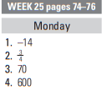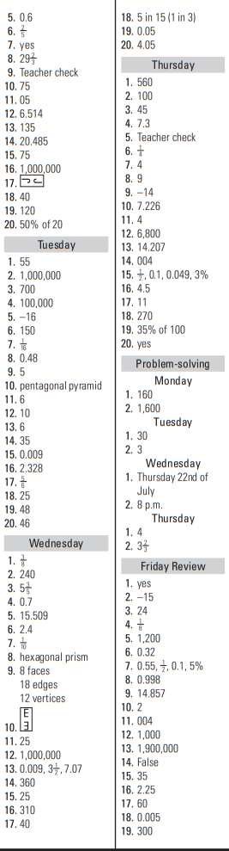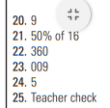
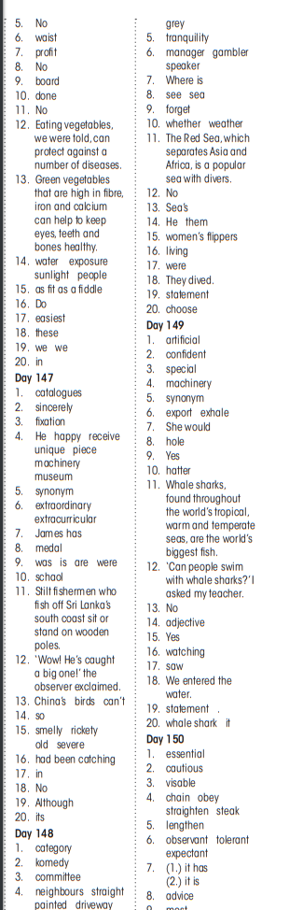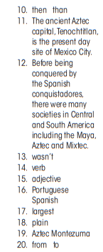
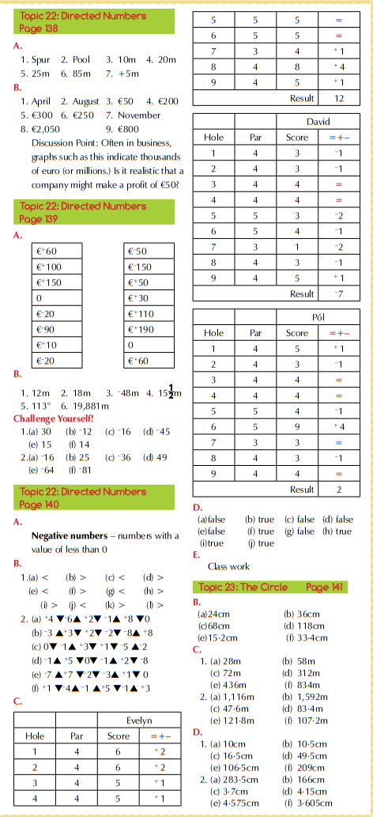
Worksheets
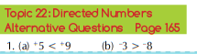
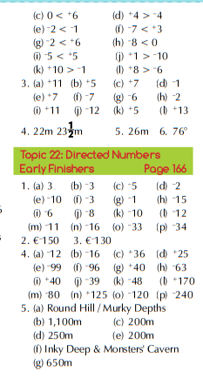

 | Monday | Tuesday | Wednesday | Thursday | Friday
8.55-9.05 | Tutor time | Tutor time | Tutor time | Tutor time | Tutor time
9.05-9.45 | ENG  Rm 33 | GAE  Rm51 | GAE  Rm51 | OPT 1 | PE  Gym
9.45-10.25 | SCI  Rm28 | RE  Rm 34 | SCI  Lab | OPT 3 | IT  Computer Room
10.25-11.05 | HIS  Rm31 | MTH  Rm24 | SCI  Lab | GAE  Rm51 | MTH  Rm24
11.05-11.20 | BREAK | BREAK | BREAK | BREAK | BREAK
11.20-12.00 | GAE  Rm51 | ENG  Rm 33 | MTH  Rm24 | GEO  Rm 19 | HIS  Rm31
12.00-12.40 | RE  Rm 34 | HIS  Rm31 | ENG  Rm 33 | ENG  Rm 33 | GAE  Rm51
12.40-1.20 | SPHE  Rm 44 | PE  Gym | CSPE  Rm42 | MTH  Rm24 | ENG  Rm 33
1.20-2.00 | LUNCH | LUNCH | LUNCH | LUNCH | LUNCH
2.00-2.40 | MTH  Rm24 | OPT 3 | OPT 1 | OPT 2 | GEO  Rm 19
2.40-3.20 | OPT 1 | OPT 3 | OPT 2 | OPT 2 | OPT 1
3.20-4.00 | GEO  Rm 19
Options 1: FR (Rm 21), SP (Rm 8), GER (Rm 14)
Options 2: HE (Rm 7), WW (Rm 3), MUS (Music Room), BST (Rm 42), MW (Rm 16)
Options 3: ART (Rm 13), BST (Rm 42), TG (Rm 11), TECH (Rm 18)
TIP: At the beginning of the year colour code your timetable and your books and copies
 | Monday | Tuesday | Wednesday | Thursday | Friday
8.30-8.50 | Caomhnoir | Caomhnoir | Caomhnoir | Caomhnoir | Caomhnoir
8.50-9.50 | SCI  Rm28 | CSPE  Rm42 | SCI  Lab | ENG  Rm 33 | PE  Gym
9.50-10.50 | HIS  Rm31 | MTH  Rm24 | SCI  Lab | MTH  Rm24 | GEO  Rm 19
10.50-11.00 | BREAK | BREAK | BREAK | BREAK | BREAK
11.00-12.00 | GAE  Rm51 | ENG  Rm 33 | MTH  Rm24 | OPT 3 | OPT 1
12.00-1.00 | OPT 1 | OPT 1 | ENG  Rm 33 | OPT 3 | GAE  Rm51
1.00-1.30 | LUNCH | LUNCH | LUNCH | LUNCH | LUNCH
1.30-2.30 | SPHE  Rm 44 | OPT 2 | GAE  Rm51 | HIS  Rm31 | ENG  Rm 33
2.30-3.30 | GEO  Rm 19 | OPT 2 | PE  Gym

Options 1: FR (Rm 21), SP (Rm 8), GER (Rm 14)
Options 2: HE (Rm 7), WW (Rm 3), MUS (Music Room), BST (Rm 42), MW (Rm 16)
Options 3: ART (Rm 13), BST (Rm 42), TG (Rm 11), TECH (Rm 18)
TIP: At the beginning of the year colour code your timetable and your books and copies

